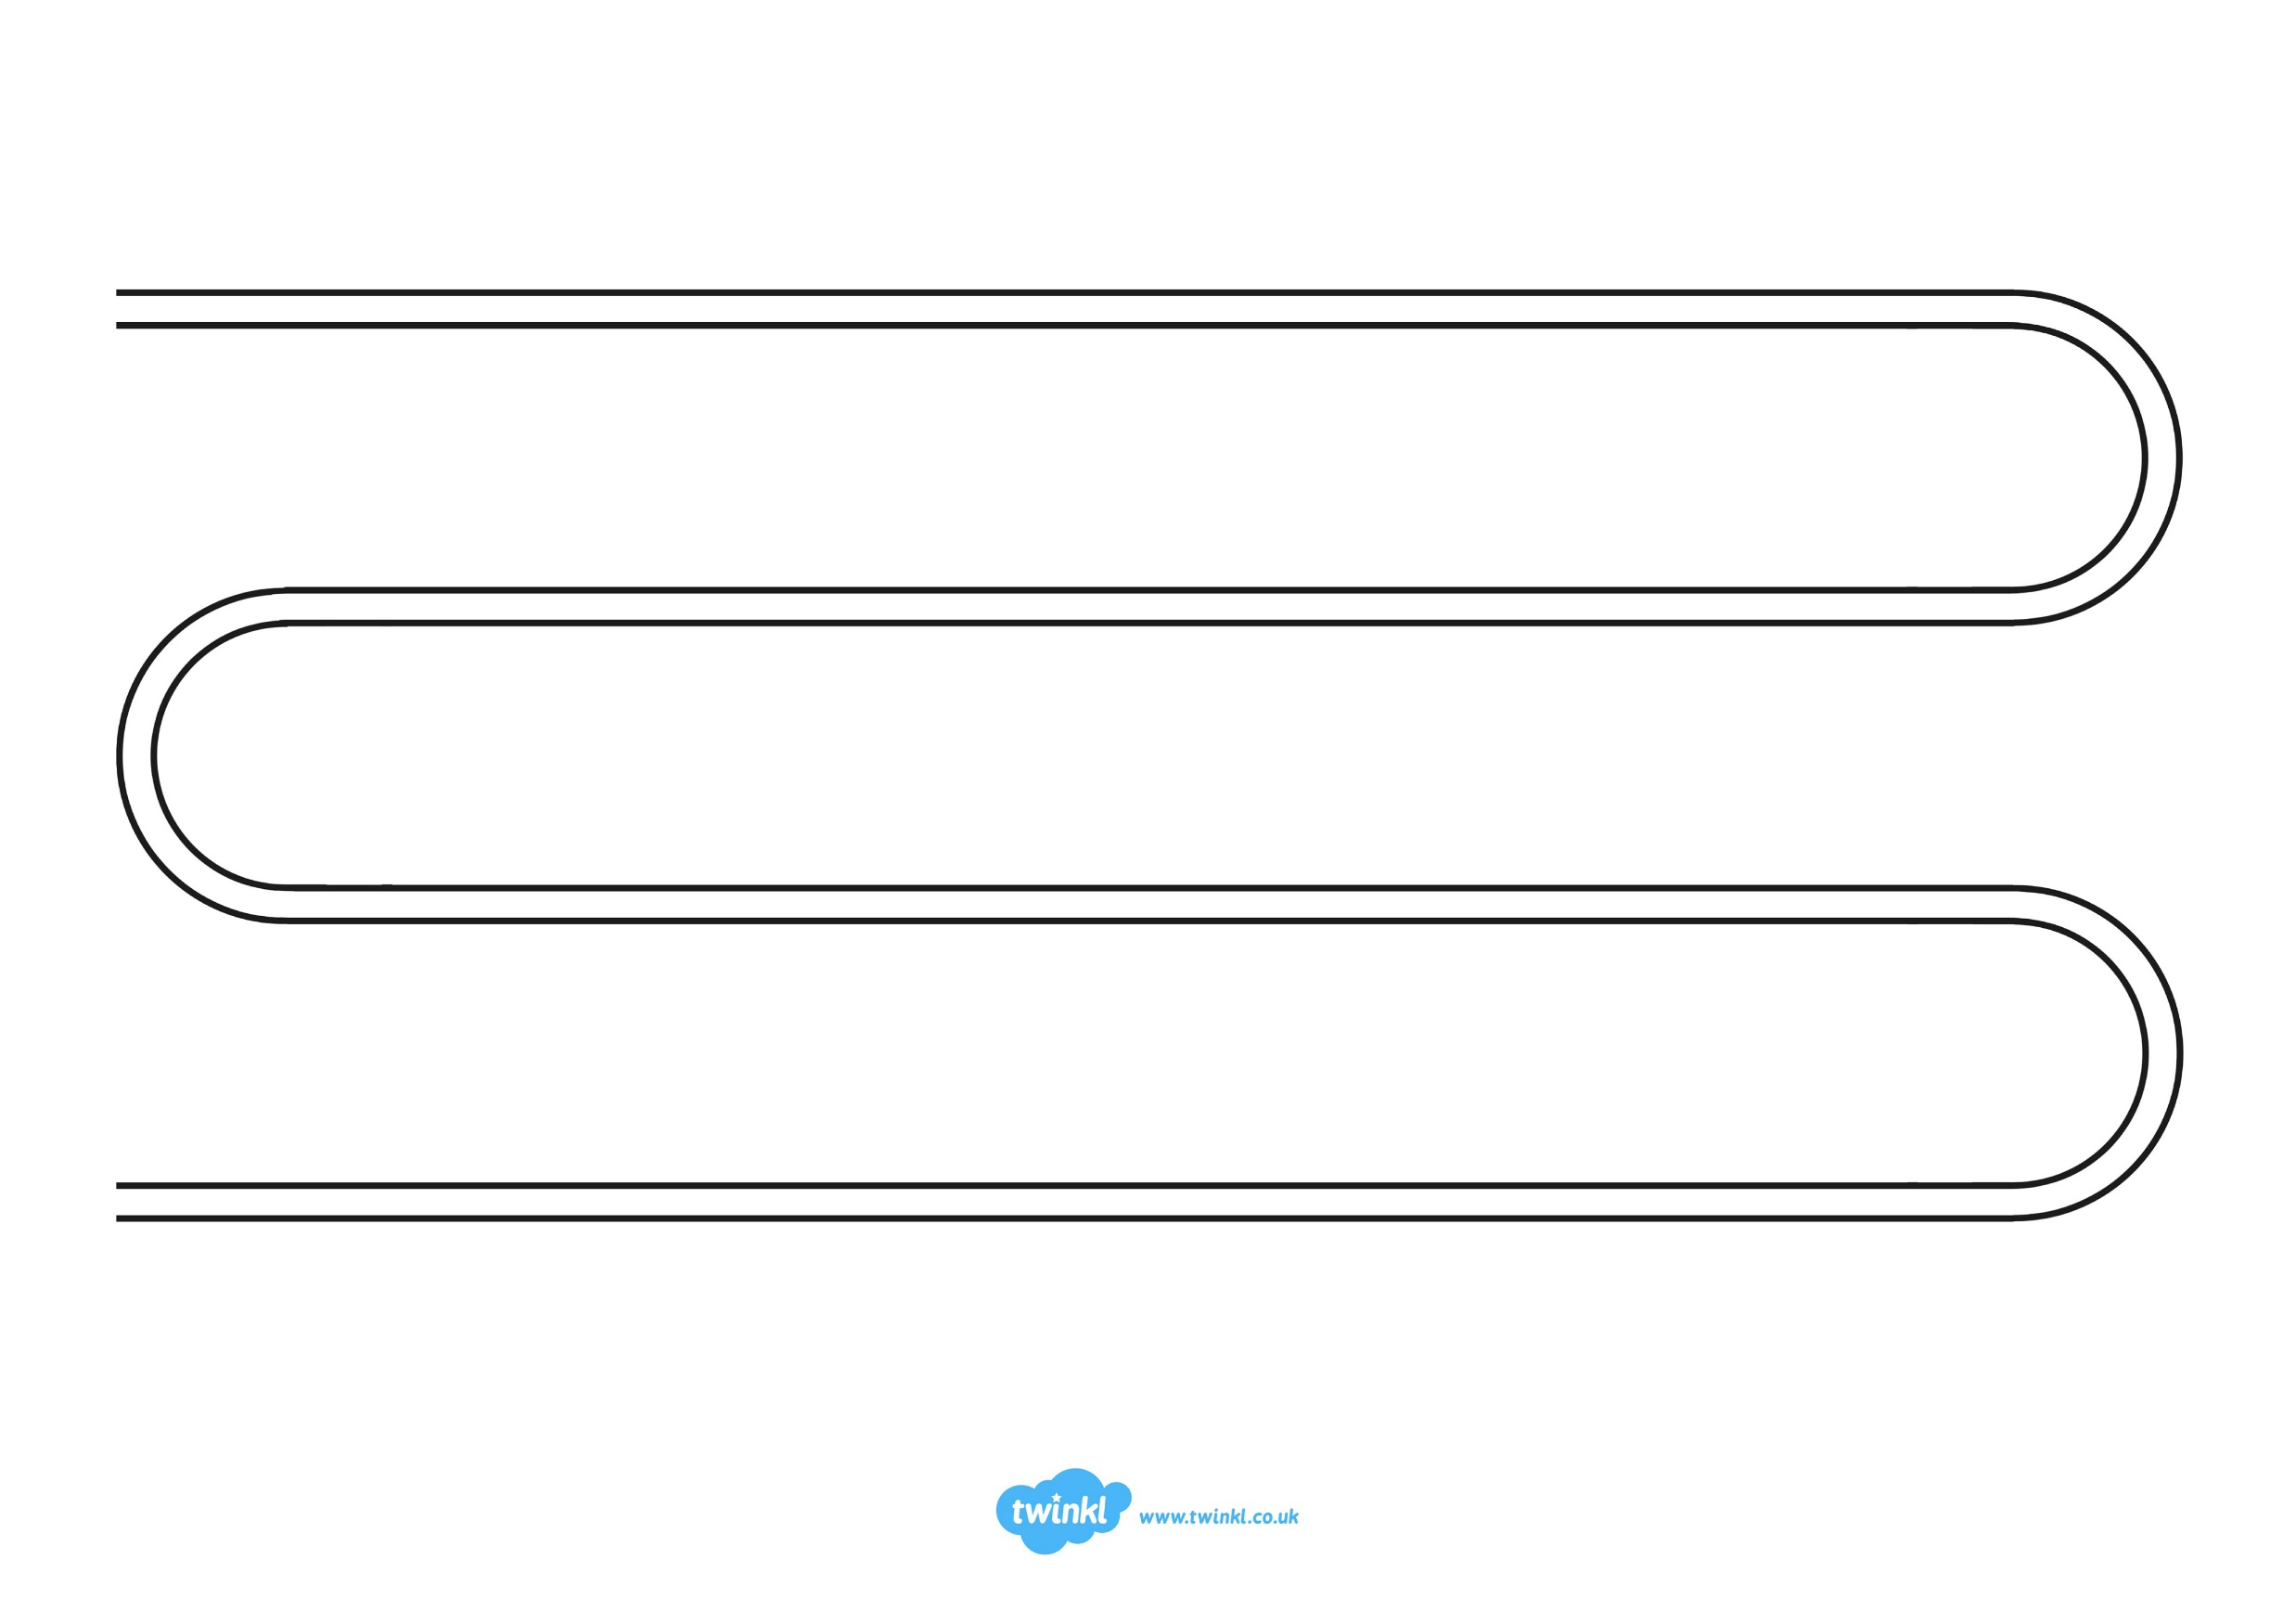

Present Day
Mary
Seacole
is born
Norton
Priory
established
Castle building began in Britain
1066 AD
Approximately
8,000-10,000 BC
First structures built
1939 AD
1485 AD
Henry VII
becomes
King

Anne
becomes
Queen

Charles I
becomes
King

1702 AD
1625 AD
1509 AD
Henry VIII
Becomes
King
Industrial
Revolution
begins

WW2
begins
1820 AD
1805 AD
1760 AD
500 BC
First toy made

Year R
Year 1
Year 4
Year 2
Year 6
Vikings
invade
Britain

Maya
Civilisation
begins
Anglo-Saxons
invade
Britain

Ancient Greek
Civilisation
begins
700 BC
2200 BC
Stone Age
begins

Romans
invade
Britain

Dynastic
Egypt
begins
750 BC
793 AD
1115 AD
1605 AD
Year 3
Iron Age
begins

Roman Empire
begins

Our History Journey – Year 6
3100 BC
0
BC/AD
43 AD
410 AD
Florence
Nightingale
is born
Gunpowder
Plot
1832 AD
Lewis
Carroll born
2000 BC
Year 5
Key
Key
Key
Key
Key
Enter text here
Enter text here
Enter text here
Enter text here
Key
Enter text here
Enter text here
Enter text here
Enter text here

