Year 6 | French
 | Autumn 1 topic: At School | Autumn 2 topic: Planets
National curriculum statements | - speak in sentences, using familiar vocabulary, phrases and basic language structures  - broaden their vocabulary and develop their ability to understand new words that are introduced into familiar written material  - listen attentively to spoken language and show understanding by joining in and responding  - answer questions; express opinions and respond to those of others; seek clarification and help. | - broaden their vocabulary and develop their ability to understand new words that are introduced into familiar written material  - present ideas and information orally to a range of audiences  - read carefully and show understanding of words, phrases and simple writing
Retrieval  (to support new learning) | Y4 in the classroom  Y3,4 & 5 asking questions | Language introduced from Early Language and Intermediate units such as:  'Presenting Myself', ' – Y4  My Home', - Y4 and  'Clothes' –Y5
Knowledge statements | I will learn the nouns and determiners for 10 classroom objects in French.  I will learn how to create a short phrase in French in a subject using I like and I do not like.  I will learn how to answer the question ‘Quelle heure est-il ?’ (What time is it?) on the hour in French.  I will learn how to say at what time I study a particular subject in French.  I will use all my new knowledge from the unit to present my school preferences to the class in spoken and/or written form | I will improve my range of vocabulary by learning 10 key elements of the Solar System in French and will be able to label them on a map.  I will learn how to apply my increasing knowledge of adjectival agreement to describe the Solar System in French.  I will extend my sentences by using conjunctions and intensifiers to create more complex descriptions in French.  I will learn how to ask key questions in French to be able to conduct an interview with an astronaut.  I will learn how to present myself as an astronaut by answering the questions in French and learn how to describe my qualities/character
Vocabulary | 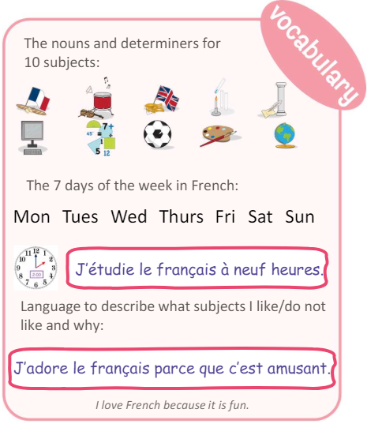 | 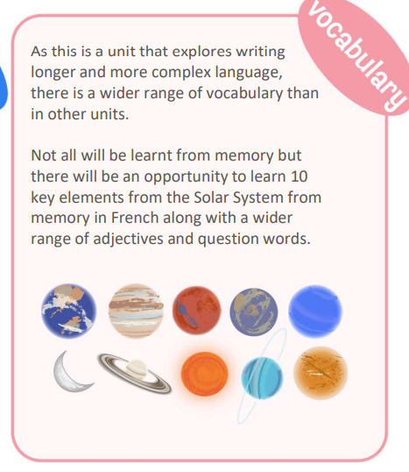
Year 6 | French
 | Spring 1: At the weekend | Spring topic 2: World War II
National curriculum statements | - speak in sentences, using familiar vocabulary, phrases and basic language structures  - broaden their vocabulary and develop their ability to understand new words that are introduced into familiar written material  - listen attentively to spoken language and show understanding by joining in and responding | - speak in sentences, using familiar vocabulary, phrases and basic language structures  - broaden their vocabulary and develop their ability to understand new words that are introduced into familiar written material  - listen attentively to spoken language and show understanding by joining in and responding
Retrieval  (to support new learning) | Y3 & 4 nouns and determiners. | Language introduced from Early Learning and Intermediate units  How to listen to and approach longer text in French having completed units such as 'The Olympics’ – Y5
Knowledge statements | - I will learn how to tell the time around the clock in French.  - I will learn 10 activities in French that I may do at the weekend.  - I will consolidate my learning and focus on the spellings in French for the 10 activities.  - I will integrate ‘at…’ plus a time into my spoken and written work about weekend activities.  I will use all my new knowledge from the unit to present to the class in spoken and/or written form. | I will improve my reading and listening skills by learning how to decode unknown language in longer pieces of French.  I will learn the French for a selection of countries and languages involved in WWII.  I will improve my listening and reading skills by listening to the story of Ralph (an evacuee) in French.  I will improve my range of vocabulary by learning key words and phrases relating to the countryside and the city.  I will use all my new knowledge to compare life in the city and countryside during WWII.
Vocabulary | 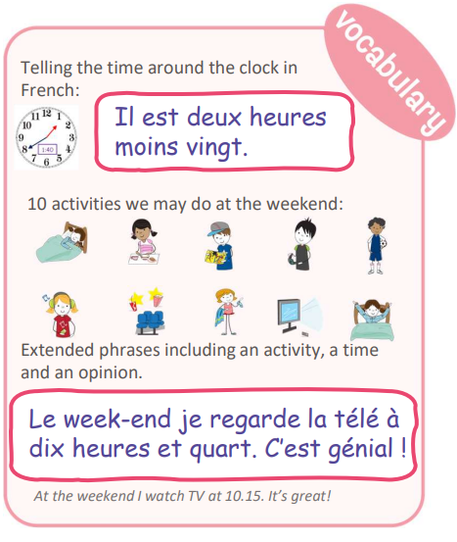 | 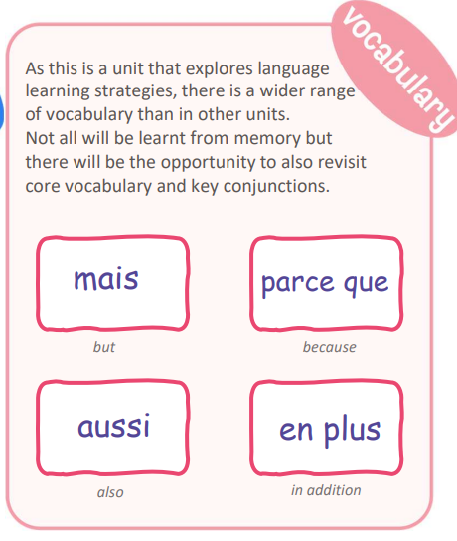

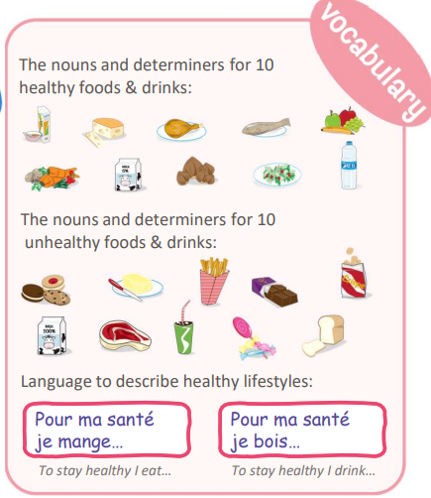
Year 6 | French
 | Summer 1: Healthy Lifestyles | Summer 2: Me in the World
National curriculum statements | - speak in sentences, using familiar vocabulary, phrases and basic language structures  - broaden their vocabulary and develop their ability to understand new words that are introduced into familiar written material  - listen attentively to spoken language and show understanding by joining in and responding | - broaden their vocabulary and develop their ability to understand new words that are introduced into familiar written material  - present ideas and information orally to a range of audiences  - read carefully and show understanding of words, phrases and simple writing
Retrieval  (to support new learning) | Y3 & 4 nouns and determiners. | Y3 & 4 & 5key phrases  Y3 & 4 using verbs & nouns
Knowledge statements | - I will improve my range of vocabulary by learning 10 new nouns and determiners for healthy foods/drinks.  - I will further improve my range of vocabulary by learning 10 more nouns and determiners for unhealthy foods/drinks.  - I will consolidate all the new language and focus on the partitive article (some) in French as seen in this unit.  - I will improve my range of vocabulary by also learning key phrases for healthy and unhealthy habits.  - I will learn to follow a healthy recipe in French and create my own using my new knowledge. | - I will learn more about the 4 characters in the unit and the Francophone world.  - I will learn more about the different celebrations celebrated in the Francophone world.  - I will learn more about 2 different religious celebrations celebrated in the Francophone world.  - I will improve my cultural awareness of Paris in France and Port-au-Prince in Haiti.  - I will learn how the 4 characters are more responsible global citizens by doing more to protect the planet.
Vocabulary |  | 