Year 5 | French
 | Autumn 1 topic: Date | Autumn 2 topic: At the tea room
National curriculum statements | - speak in sentences, using familiar vocabulary, phrases and basic language structures  - read carefully and show understanding of words, phrases and simple writing  - broaden their vocabulary and develop their ability to understand new words that are introduced into familiar written material | - speak in sentences, using familiar vocabulary, phrases and basic language structures  - broaden their vocabulary and develop their ability to understand new words that are introduced into familiar written material  - listen attentively to spoken language and show understanding by joining in and responding
Retrieval  (to support new learning) | Y3 numbers to 10 | Y3 & 4 nouns and determiners  Y3 & Y5 numbers
Knowledge statements | I will learn to recognise and recall the 7 days of the week in French.  I will learn to recognise and recall the 12 months of the year in French.  I will learn to recognise and recall numbers 1-31 in French.  I will learn how to ask and answer the question ‘Quelle est la date aujourd’hui ?' (What is the date today?) in French.  I will learn how to ask and answer the question ‘C’est quand ton anniversaire ?' (When is your birthday?) in French. | I will learn 20 different foods, snacks and drinks in French with the correct indefinite article/determiner. article/determiner.  I will learn some key phrases to help me perform a role-play in the French salon de thé.  I will learn some more key phrases to help me perform a role-play in the French salon de thé.  I will learn about French currency and will use my knowledge of numbers to help calculate the bill in French.
Vocabulary | 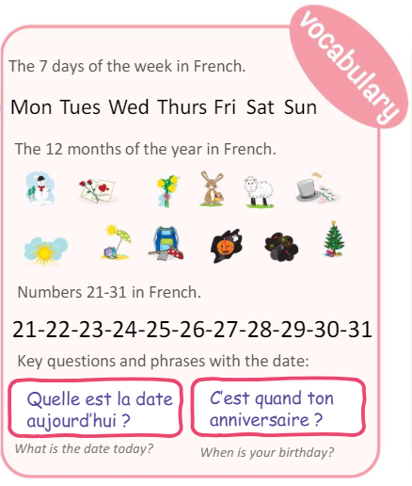 | 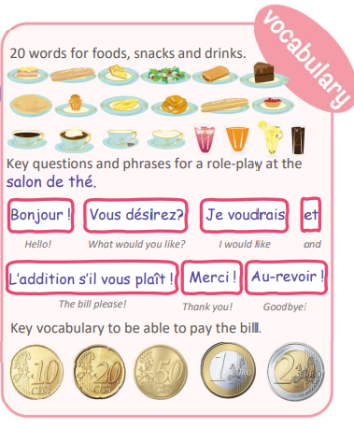
Year 5 | French
 | Spring topic 1: Do you have a pet? | Spring topic 2: What is the weather?
National curriculum statements | - speak in sentences, using familiar vocabulary, phrases and basic language structures  - broaden their vocabulary and develop their ability to understand new words that are introduced into familiar written material  - listen attentively to spoken language and show understanding by joining in and responding  - engage in conversations; ask and answer questions; express opinions and respond to those of others; seek clarification and help. | - speak in sentences, using familiar vocabulary, phrases and basic language structures  - broaden their vocabulary and develop their ability to understand new words that are introduced into familiar written material  - listen attentively to spoken language and show understanding by joining in and responding  - answer questions; express opinions and respond to those of others; seek clarification and help.
Retrieval  (to support new learning) | Y3 & 4 asking questions  Y4 conjunctions | Y3, 4 & 5 asking questions  Y4 seasons
Knowledge statements | Repeat, recognise and attempt to spell the eight nouns (including the correct article for each) for pets in French.  Tell somebody in French if they have or do not have a pet.  Ask somebody else in French if they have a pet.  Tell somebody in French the name of their pet.  Attempt to create a longer phrase using the conjunctions et (“and”) or mais (“but”). | Repeat and recognise the vocabulary for weather in French.  Ask and say what the weather is like today.  Create a French weather map.  Describe the weather in different regions of France using a weather map with symbols.
Vocabulary | 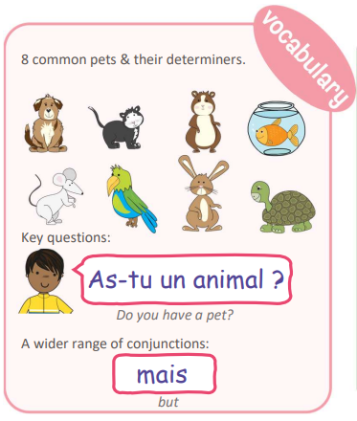 | 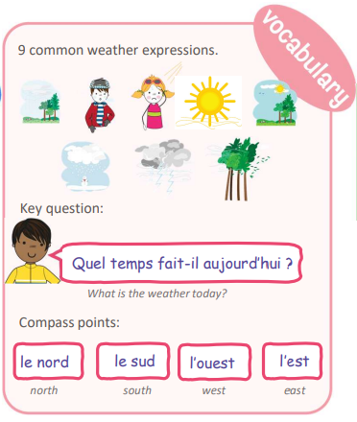

Year 5 | French
 | Summer 1: my home | Summer 2: Habitats
National curriculum statements | - speak in sentences, using familiar vocabulary, phrases and basic language structures  - broaden their vocabulary and develop their ability to understand new words that are introduced into familiar written material  - listen attentively to spoken language and show understanding by joining in and responding | - broaden their vocabulary and develop their ability to understand new words that are introduced into familiar written material  - present ideas and information orally to a range of audiences  - read carefully and show understanding of words, phrases and simple writing
Retrieval  (to support new learning) | Y3 & 4 nouns and determiners. | Y3 & 4 key phrases  Y3 & 4 using verbs & nouns
Knowledge statements | - I will learn how to say where I live using the first person high frequency verb ‘j’habite’ (I live).  - I will learn 10 nouns and their determiners for rooms of the house.  - I will learn how to say I do not have a particular room in the house using a key negative structure.  - I will use all my new knowledge in French to describe where I live. | - I will learn the essential things plants and animals need to survive in French.  - I will learn about 5 key habitats around the world in French.  - I will learn to use the verb ‘pousser’ (to grow) to express which plants grow in these habitats.  - I will learn to use the verb ‘habiter’ (to live) to express which animals live in these habitats.  - I will use all my new knowledge to prepare a presentation for the class.
Vocabulary | 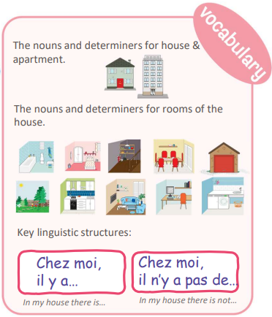 | 