Year 4 | French
 | Autumn 1 topic: Seasons | Autumn 2 topic: Vegetables
National curriculum statements | - speak in sentences, using familiar vocabulary, phrases and basic language structures  - read carefully and show understanding of words, phrases and simple writing  - broaden their vocabulary and develop their ability to understand new words that are introduced into familiar written material | - speak in sentences, using familiar vocabulary, phrases and basic language structures  - broaden their vocabulary and develop their ability to understand new words that are introduced into familiar written material  - listen attentively to spoken language and show understanding by joining in and responding
Retrieval  (to support new learning) | Y3 determiners | Y3 conjunctions, nouns and determiners  Y4 Autumn 1 determiners
Knowledge statements | I will learn the 4 seasons in French with their determiners.  I will learn a short phrase about winter in French.  I will learn a short phrase about spring in French.  I will learn a short phrase about summer in French.  I will learn a short phrase about autumn in French. | I will learn and become familiar with 5 vegetable nouns and their plural determiner in French.  I will learn and become familiar with 5 more vegetable nouns and their plural determiner in French.  I will learn how to ask for a kilo or half a kilo of a vegetable in French.  I will learn how to use the structure ’je voudrais’ (I would like) when buying vegetables.  I will learn how to use the conjunction ‘et’ (and) when buying more than one vegetable option.
Vocabulary | 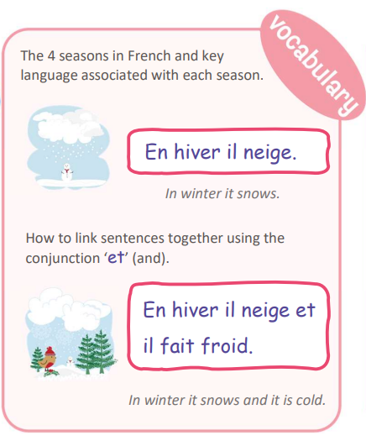 | 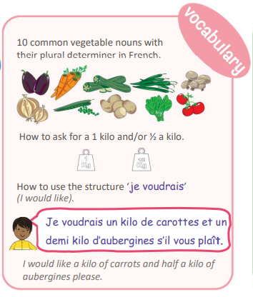
Year 4 | French
 | Spring topic 1: Presenting myself | Spring topic 2: My family
National curriculum statements | - speak in sentences, using familiar vocabulary, phrases and basic language structures  - broaden their vocabulary and develop their ability to understand new words that are introduced into familiar written material  - listen attentively to spoken language and show understanding by joining in and responding  - engage in conversations; ask and answer questions; express opinions and respond to those of others; seek clarification and help. | - speak in sentences, using familiar vocabulary, phrases and basic language structures  - broaden their vocabulary and develop their ability to understand new words that are introduced into familiar written material  - listen attentively to spoken language and show understanding by joining in and responding  - answer questions; express opinions and respond to those of others; seek clarification and help.
Retrieval  (to support new learning) | Y3 Greetings, numbers | Nouns and determiners Y3 & 4
Knowledge statements | I will use basic greetings in French, ask somebody how they are feeling and reply when asked to me.  I will ask somebody their name in French and reply when asked to me.  I will recall numbers 1-10 and count from 11-20 in French.  I will learn how to ask somebody how old they are in French and reply when asked to me.  I will learn how to ask somebody where they live in French and reply when asked to me.  I will learn how to express my nationality in French and understand basic gender agreement rules. | I will learn the nouns and determiners for several family members in French.  I will learn how to move from using the determiner ‘a’ with a family member noun to using a possessive adjective ‘my’ in French.  I will learn to answer the question ‘As–tu des frères et sæurs ?’ (Do you have any brothers or sisters?)  I will learn how to introduce family members, learning to use ‘il/elle s’appelle’ (he/she is called).  I will use my knowledge of larger numbers to be able to describe the age of family members.
Vocabulary | 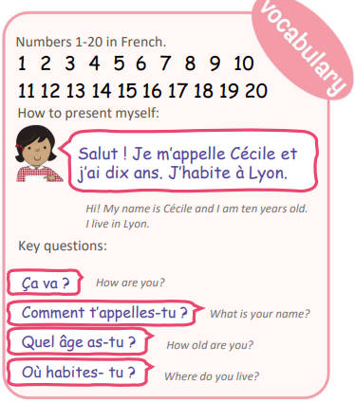 | 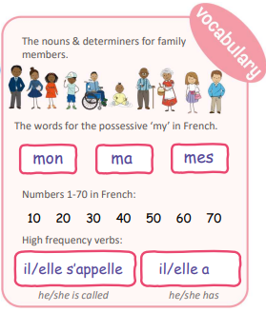

Year 4 | French
 | Summer 1: At the tea room | Summer 2: In the classroom
National curriculum statements | - broaden their vocabulary and develop their ability to understand new words that are introduced into familiar written material  - present ideas and information orally to a range of audiences  read carefully and show understanding of words, phrases and simple writing | - speak in sentences, using familiar vocabulary, phrases and basic language structures  - broaden their vocabulary and develop their ability to understand new words that are introduced into familiar written material  - listen attentively to spoken language and show understanding by joining in and responding
Retrieval  (to support new learning) | Y3 & 4 key phrases  Y3 & 4 using correct determiners | Y3 & 4 nouns and determiners.
Knowledge statements | I will learn 20 different foods, snacks and drinks in French with the correct indefinite article/determiner.  I will learn some key phrases to help me perform a role-play in the French salon de thé.  I will learn some more key phrases to help me perform a role-play in the French salon de thé.  I will learn about French currency and will use my knowledge of numbers to help calculate the bill in French. | I will learn the nouns and determiners for 6 classroom objects in French.  I will learn 6 more nouns and their determiners for classroom objects in French.  I will learn how to answer the question ‘Qu’est-ce qu’il y a dans ta trousse ?’ (What do have in your pencil case?)  I will learn how to move from an indefinite determiner (a) to a possessive adjective (my) in French.  I will learn the negative response and use all my new knowledge to say what I have/do not have in my pencil case.
Vocabulary | 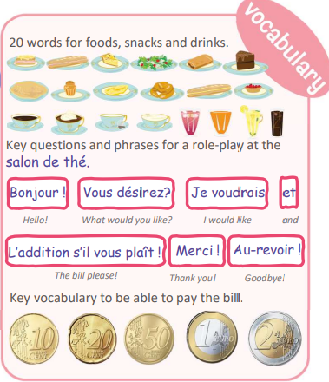 | 