St. Martin’s Catholic Primary School
History Policy

Statement of Intent
At St. Martin’s, we believe that children should be taught to have an in depth and chronological understanding of time periods, people and events that have helped to change and shape their local area as well as their country. We also believe it is important for children to learn about ancient civilisations whose lasting impact has shaped the world to be that which children experience today.
We have designed our curriculum to ensure that there is intelligent repetition of key knowledge throughout the school. In EYFS and Key Stage 1 they are introduced to the concept of the past related to their own timeline as well as changes in the more recent past, before beginning to look at history in terms of a wider timeline.
We intend for our history curriculum to be progressive with prior learning being revisited in later years ensuring a depth of knowledge is developed.
Alongside the aims and expectations set out in the National Curriculum, our History curriculum also offers opportunities for the children to:
- Be curious and feel inspired to know more about the past.
- Think critically, weigh evidence, construct arguments and come to their own judgements.
- Develop their ability to ask perceptive questions.
- Understand the complexity of people’s lives.
- Understand how change happens and the impact this has on the future.
- Experience the diversity of different societies.
- To understand their own identity and the history of their locality.

Statement of Implementation
For our history curriculum, we have selected 5 substantive concepts that act as ‘Golden Threads’ throughout to ensure that there is intelligent repetition of learning throughout their history journey. This allows children to make links to previous learning and enables them to gain a deeper understanding of these historical concepts. Our substantive concepts are:
- Civilisation
- Monarchy
- Conflict
- Transport
- Religion
Throughout the year, history is taught in blocks to help children to achieve depth in their learning. In Early Years and Key Stage 1, the initial focus is on history of the more recent past, familiarising the children with the language of the past, before moving on to looking at change over time, as well as people and events that are significant to the United Kingdom.
In Key Stage 2, year groups begin to look in depth at periods of British history, ancient civilisations, as well as a studying times and events that are significant to their own local history.
Our topics have been chosen to not only engage and excite our children about history, but also to ensure that what they learn is relevant to their lives and the area that they live in. We feel it is important for children to understand that the changes, events and people that they are learning about in history, have shaped the world that they live in today. We value developing children’s cultural capital and we do this through a variety of means such as using historical artefacts, written sources, oral accounts, trips, visitors, and historical stories.
We also feel that it is important for children to understand the disciplinary concepts that are crucial to historical enquiry. These concepts are those which make history a unique subject and therefore we ensure that are children have experience of and are encouraged to look at the following concepts throughout their history journey at St. Martin’s:
- Change and continuity
- Cause and consequence
- Similarity and difference
- Historical significance
- Sources of evidence
- Historical interpretation
Through keeping all of these concepts central to our curriculum, this allows us to ensure children are taught to think like historians.

Statement of Impact
At St. Martin’s, our history curriculum is driven by the acquisition of historical knowledge and we believe that it is important that historical knowledge is revisited to ensure retention is successful. To be able to do this, we have ensured that our topics are progressive and that there are links throughout our history topics to previously taught historical knowledge as well as other subjects. Through teaching progressively, we can also ensure that we can continue to assess previously taught knowledge to ensure that it has been retained for the long term.
To be able to monitor the impact of teaching, we undertake rigorous assessment to ensure that knowledge is embedded. Children are assessed after each unit with the focus being on the knowledge statements set out in our history subject progression documents. These are key pieces of knowledge that all children should have retained throughout the unit of work. Children who are able to retain these pieces of knowledge are assessed as being at the expected level. Those children whose depth of knowledge is greater than these statements are assessed as being at Greater Depth, with those unable to retain them being assessed as Working Towards.
As well as historical knowledge, we also ensure that historical skills are developed throughout each unit. These underpin all of our history teaching with these skills being used to guide and aide the children in their learning of historical knowledge. Skills such as chronological understanding, historical investigation and interpretation, presenting, organising and communication, as well as understanding historical vocabulary are all used to help children develop their historical knowledge and retain it for the long term.

Appendix 1
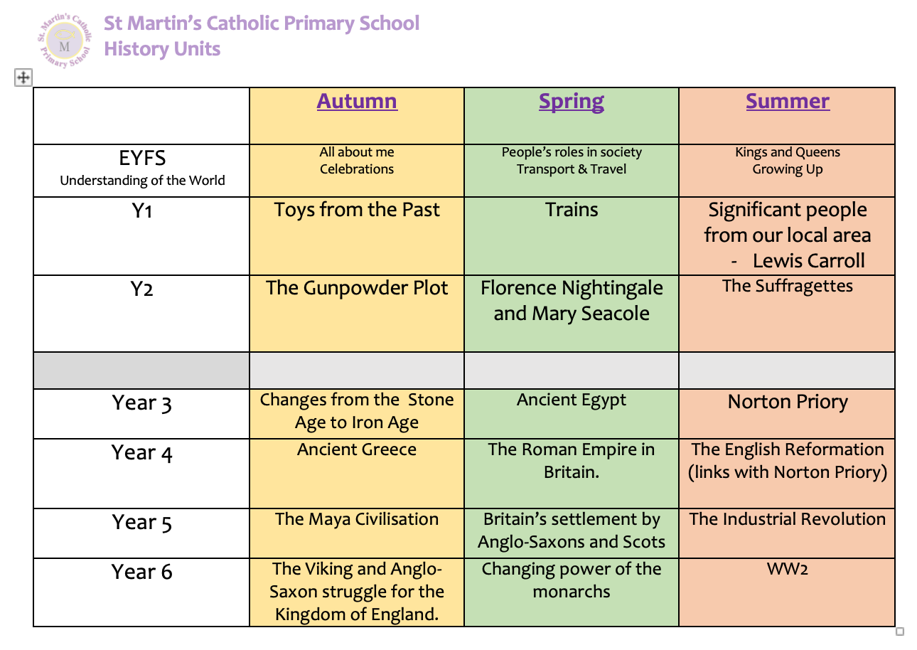
History Units taught within each year group

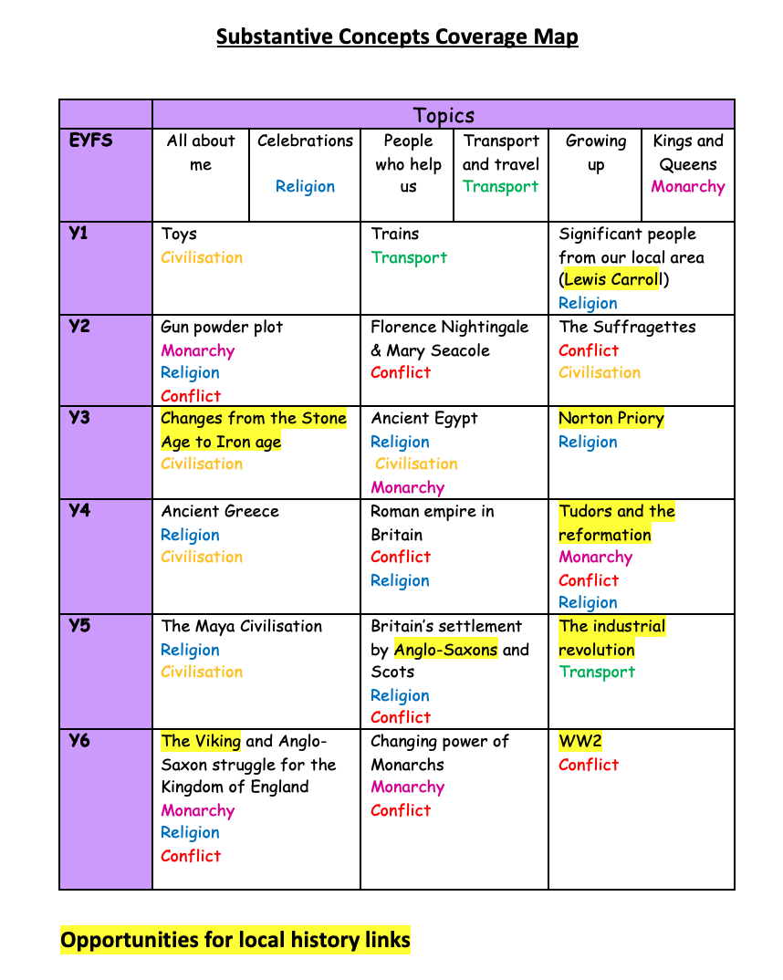
Appendix 2

