Covid-19 Feedback Survey Results July 2020
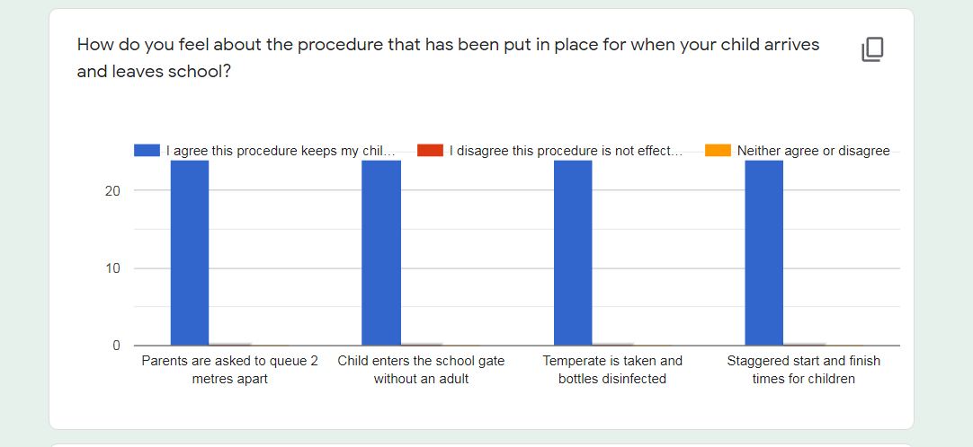
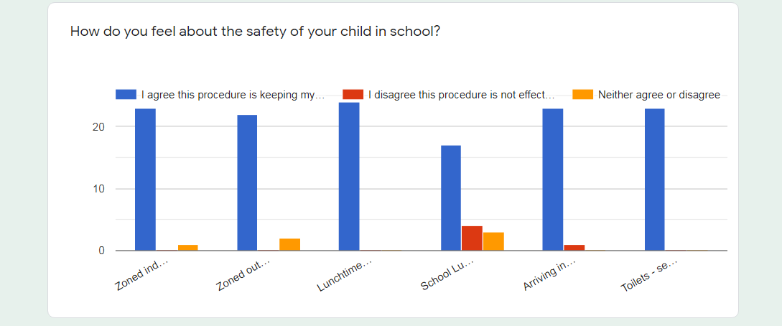
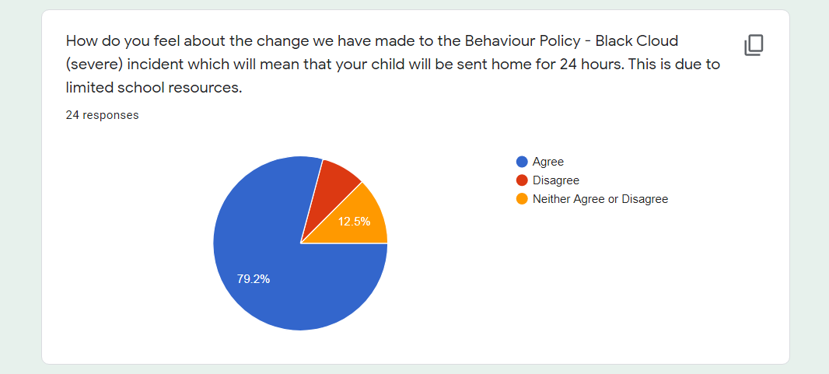
Comments from Parents

Can a video or photos be shown as to what has been done? See how class rooms are laid out due to new procedures etc?
Excellent idea! We have started posting videos on the school website and in September we can add a video of how things are in school.

Pupils that are able and willing to wear face masks could be encouraged a little more as a preventative measure reducing droplet exposure to staff and pupils alike.
We appreciate your concerns about face masks. We are following Government guidance with relation to Covid-19 and at the moment they are recommending that pupils do not wear face masks. This may change in the future and if it does we will let parents know.

I feel really safe with (my child) going to school throughout this pandemic. I am so happy I made the decision to let (them) return! Thank you for all the support and allowing me to have peace of mind whilst (they are) at school. I feel like the rules all set in place are spot on 👍🏻
Thank you. We really appreciate your comments. We have tried our best to keep up with all of the current guidance whilst trying to keep the school a safe place for our pupils.

