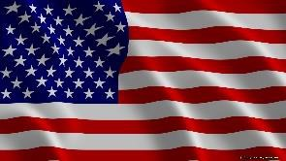



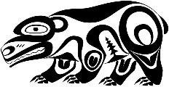
- Research, using online sources, to create a timeline of Native American history. Decide which events are most important and write a caption to go with each date and explain what is happening.
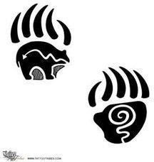
- Native American symbols can vary in meaning from one tribe to another and across different regions. Symbols were used for a variety of reasons and are depicted on numerous objects. What can you find out about this mysterious language?
- Find out about the Battle of Little Big Horn. Why is it such an important historic event?
- What were the Beaver Wars? Write a historical account that includes who fought, why beaver fur was so important and what happened.
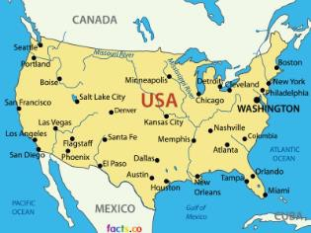
- There have been many US Presidents over the last 100 years. How many can you find? Write a short biography about one of them.
- Write a speech for a tribal chief to make to his tribe. It could be to get them ready to fight a gainst another tribe, or to announce a forthcoming marriage.
- Create an advertisement to sell the cupboard that makes toys come to life in the story ‘The Indian in the Cupboard’ by Lynne Reid Banks.
- Make a playlist of different American songs you could listen to on your road trip. Make sure you have a song from a range of genres, such as blues, jazz, country, rock, hip hop, rock and roll.
- Plan a second road trip, this time around South America. Plan your route on a digital map and write an itinerary.
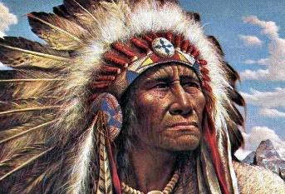
- Help prepare a United States-themed evening meal by writing a shopping list for parents and carers. Report back to others using video or photographic
evidence! What did you have to eat?
- Research the significance of words and phrases such as harmony, nature, spirit, natural, soul, force of nature, orenda, dream and
vision to the Iroquois culture. Use drawings, photographs and text to create a digital presentation to record and share your findings.

