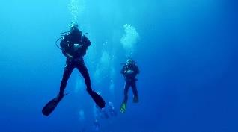



- Why is the ocean blue? Go on… find out!
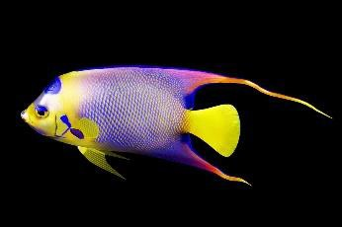
- How many amazing shark facts can you find? Build them into a PowerPoint presentation to show the rest of the class. Remember to include images and perhaps some video clips too.
- Write a ‘True or False’ quiz with fascinating facts about creatures and plants under the sea.
- Create Top Trumps-style fact cards about creatures of the Great Barrier Reef.
- Create a picture dictionary of plants and creatures of the ocean.
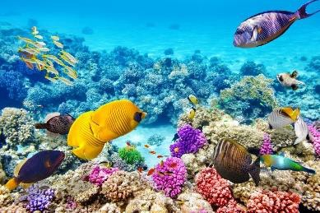
- Visit your local library and find non-fiction books about the oceans and seas. Use them to find out about sea creatures of the world. Look for information using contents, glossary and index pages. Write down any new facts you have learnt and share them with your class.
- Use the web with an adult to find out about famous undersea explorers, such as Robert Ballard, Sylvia Earle, William Beebe and James Cameron. Record your information to share with the class
- .Draw the view of the ocean you might see if looking through the window of a submersible.
- Design an ‘Under the Sea’ board game. What creatures might your counters represent?
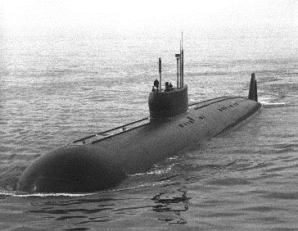
- Write a story about a diver’s exploration of a coral reef.
- Learn The Beatles’ song, ‘Yellow Submarine’, and write a new verse of your own.
- Write a poem about the creatures living in the blue abyss. It might be an acrostic, shape, haiku, cinquain or free verse poem.
- Research how to scuba dive and write a set of instructions for a new diver.
- Make a tourist leaflet for people visiting Australia’s Great Barrier Reef.

