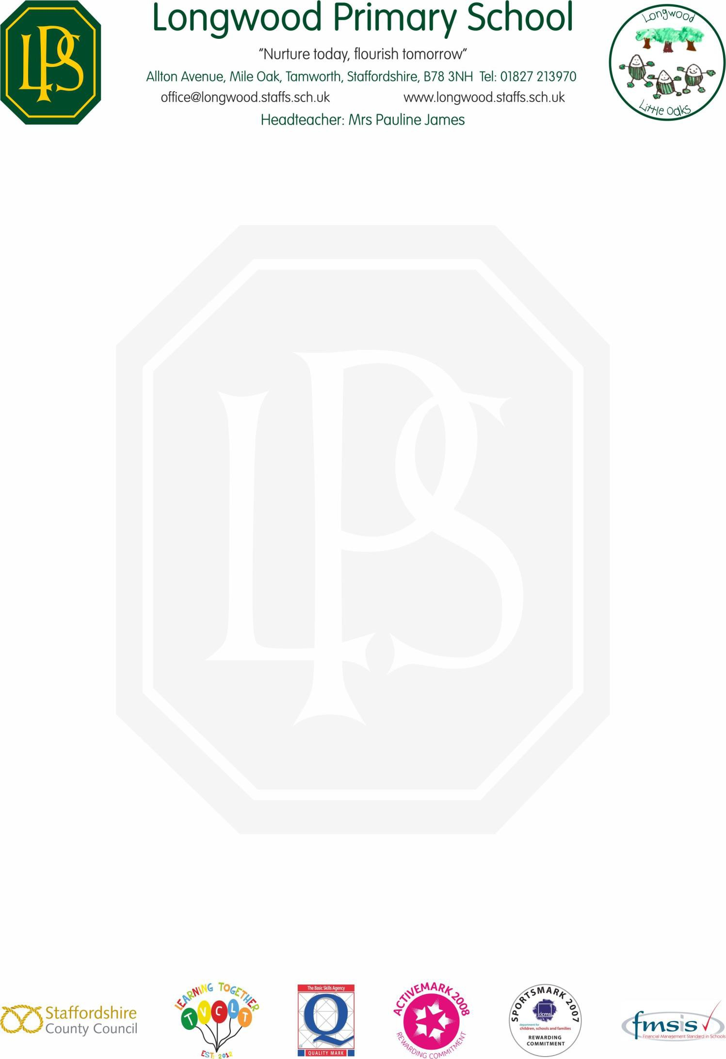

Permission to Travel Home Alone for YR5 & YR 6 Pupils

Your child’s safety is most important to us. Whilst we do not promote that pupils walk home from school alone, we recognise that some parents may need their child to travel home on their own.
We are not willing to allow children to travel home alone from school without your written consent and therefore require your permission. By signing below you give your permission for your child to travel home independently.
In the interests of child safety:
- If you have not completed this form, your child will NOT be allowed to go home alone.
- If your child goes home alone, they are NOT allowed to take responsibility for younger brothers and sisters.
We will ensure your child’s safety at school and as parents/carers you understand that certain dangers are present when travelling home alone.
Please sign and date below that you give permission for your child to travel home alone. Thank you for supporting us in caring for your child.
Yours Sincerely

Mrs P James Headteacher
My child has my permission to travel home alone from Longwood Primary School at the end of the school day. I therefore take responsibility for the safety and wellbeing of my child from 2.50pm onwards.
Child’s Name: ………………………………………………………………………………………………… Child’s Class: ………………………………………………………………………………………………… Date: ………………………………………………………………………………………………… Parent / Carer Signature: ………………………………………………………………………………………………… Parent Name (printed): ………………………………………………………………………………………………..

