

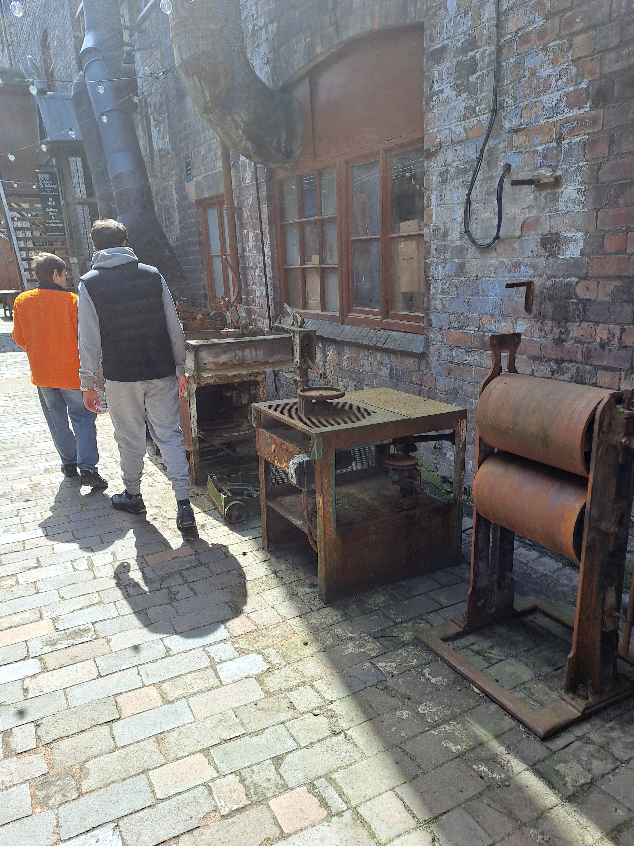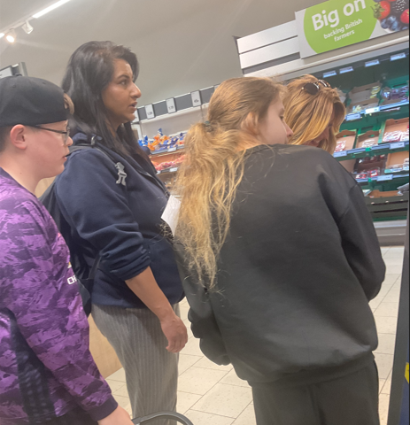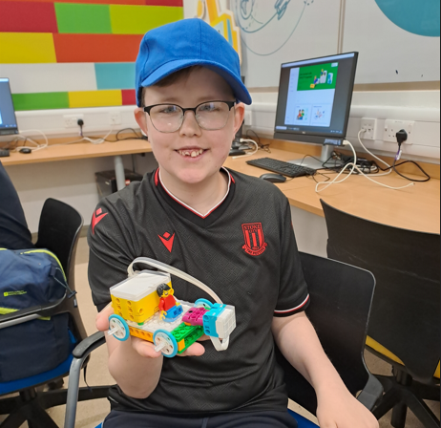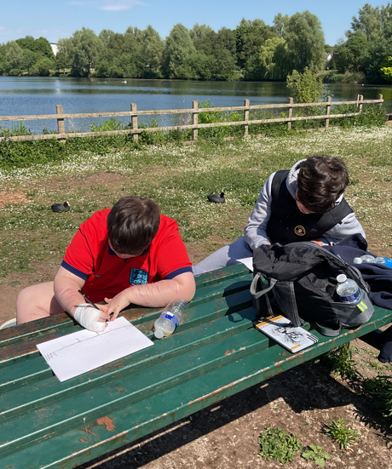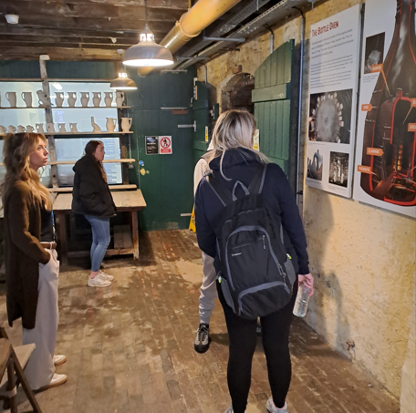
Trips and events from this term!
Middleport Pottery Westport Lake Lidl
Lego Club @ Newcastle college

NEWSLETTER MAY 2025

IMPORTANT DATES
School closed: Monday 26th May 2025 – Friday 3oth May 2025.
School open: Monday 2nd June 2025.
NSPCC Charity Walk: Tuesday 24th June 2025.
School closed for staff training: Thursday 3rd July 2025.
School Closed: Monday 21st July 2025- Friday 29th August 2025.
School open: Monday 1st September 2025.

Diamond Families Farm Half Term Fun Activities…
Saturday 24th May, 10am-12pm: SEND Friendly Weekend Wellies Club.
27th and 28th May, 11am-2pm: Diamond Families Holiday Club.
Thursday 29th May, 11am-2pm: SEND Family Fun Day Celebration.
Friday 30th May, 11am-2pm: SEND Friendly Diamond Families Holiday Club.
For more information on prices and how to book contact: 07496672456
or email; manager@diamond-families.org.uk



Wishing the Year 11 students all of the luck in the world, for the exams they are going to be taking between May and June.  
GOOD LUCK!!



More fun to come….
As we are approaching the end of the school year, Intuition students have some fun filled days ahead.
Year 10/11’s have their end of year trip to Alton Towers.
Westport Lake.
Year 11 leavers afternoon.
NSPCC charity fun walk... parents are invited too! Watch this space.
Diamond Families Summer Fair- July 10th 12pm-2pm.

Please see the attached letter from Staffordshire police, regarding increased knife crime in this country. Students will learn about this in more depth at an appropriate level to give them awareness.

