Area of Learning | Autumn 1 (6.5 Weeks)  Wednesday 4th September – Friday 18th October | Autumn 2 (8 weeks)  Monday 28th October –  Friday 20th December |  | Spring 1 (6 weeks)  Monday 6th January –  Friday 14th February | Spring 2 (8 weeks)  Tuesday 25th February –  Thursday 17th April |  |  | Summer 1 (4 weeks)  Monday 28th April –  Friday 23rd May |  |  | Summer 2 (6 weeks)5  Monday 9th June –  Friday 18th July
Possible Themes/Interests/Lines of Enquiry | Settling In  All About Me  God’s World  Autumn | Autumn  Light and Dark. Fireworks.  Bears  Teddy Bears Picnic  Woodland  Christmas  Remembrance Day |  | Dinosaurs  Winter  Valentine’ Day  Chinese New Year  Little Red Riding Hood | Pancake Day  Superheroes/People who help us  Mother’s Day  Easter  Billy Goats Gruff |  |  | Growing  New Life  Farm  Buddhism |  |  | Father’s Day  Shark in the park (mapping)  Transport  Transition
Focus Texts with taught vocabulary | (4th Sept) Theme: Settling in  Lulu’s First Day by Anna McQuinn  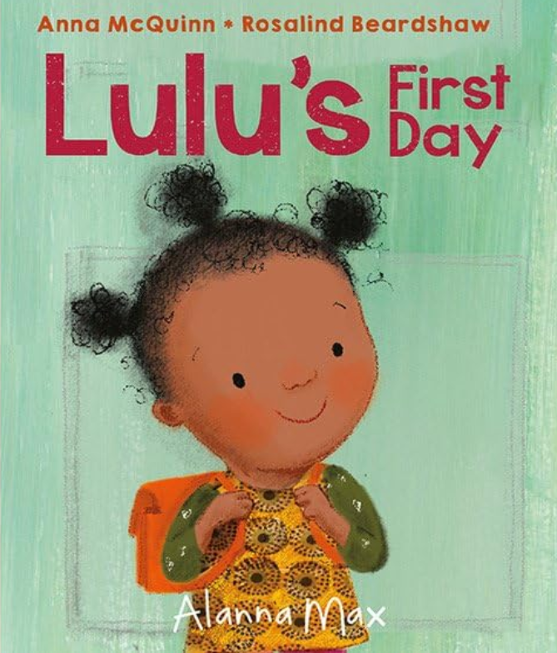school  morning  early  goodbye  morning  exhausting | (28th Oct) Theme: Autmn  Hello Autumn by Jo Lindley  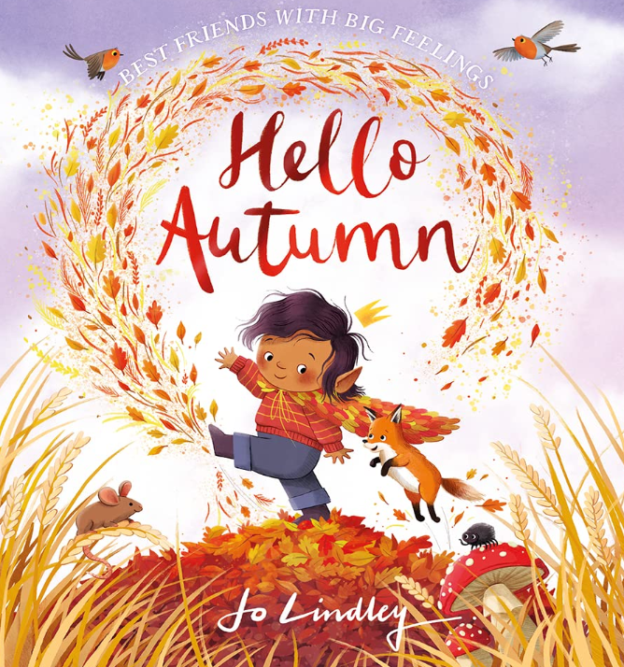 |  | (6th and 13th Jan) Theme: Dinosaurs Dinosaur Roar by Paul & Henrietta Strickland  Dinosaur  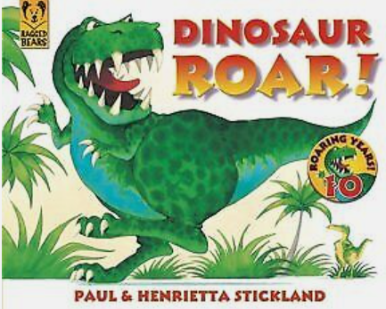Roar  Squeak  Fierce  weak  Strong | (25th Feb) Theme: Around the world.  My Granny went to market by Stella Blackstone  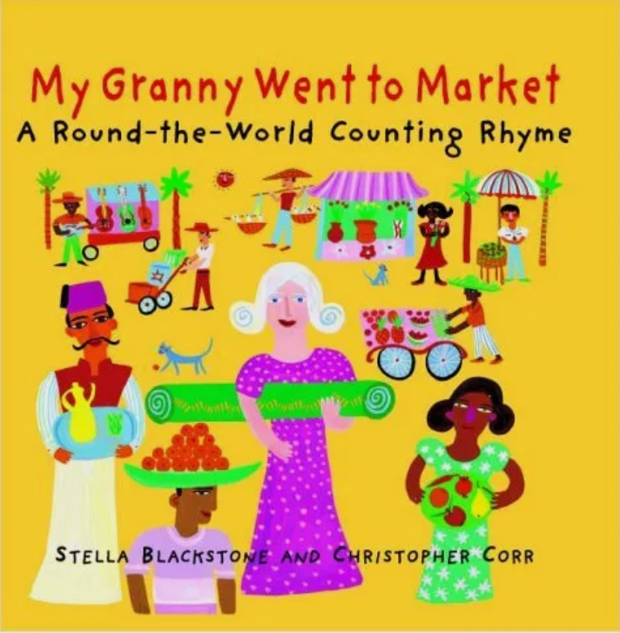market  cowbells  shimmied  boomerangs  fluttered  llamas |  |  | (28th April and 5th May) Theme: Growing. Jasper’s Beanstalk by Nick Butterworth  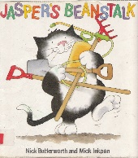  Bean seed  Beanstalk  Rake  Hoe  Lawnmower  Slug/Snails |  |  | (9th and 16th June) Theme: Farm.  What the ladybird heard by Julia Donaldson  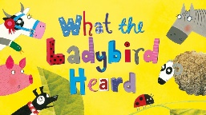  Cow  Goose  Hen  Horse  Sheep  Hog  Ladybird
Focus Texts with taught vocabulary | (9th Sept) Theme: Settling in  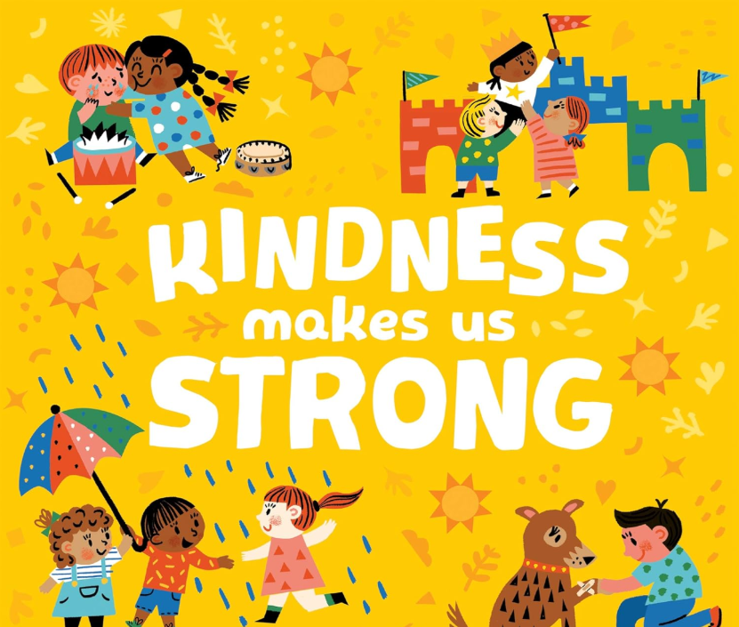Kindness makes us strong by Sophie Beer  Kindness  Patient  Cheering  Trading  Boost  Comfort | (4th Nov) Theme: Bonfire Night Sparks in the Sky by Twinkl  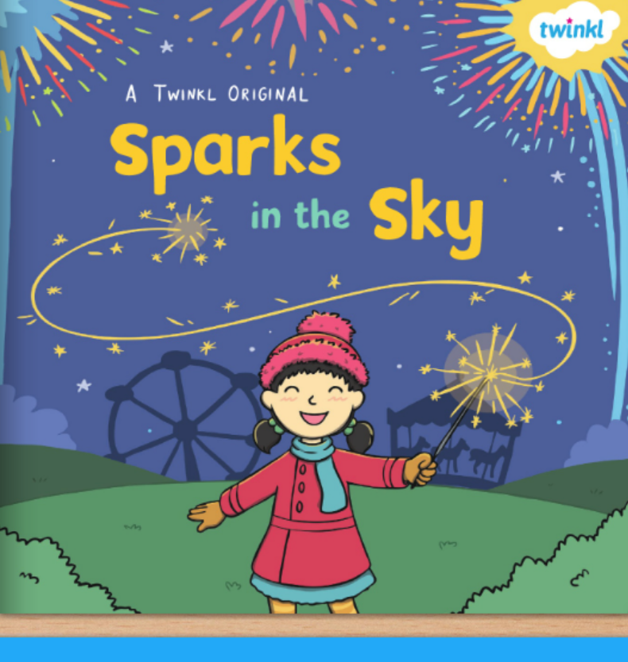Bonfire night  Firework  Exploding  Crash  Bang  Patterns |  | 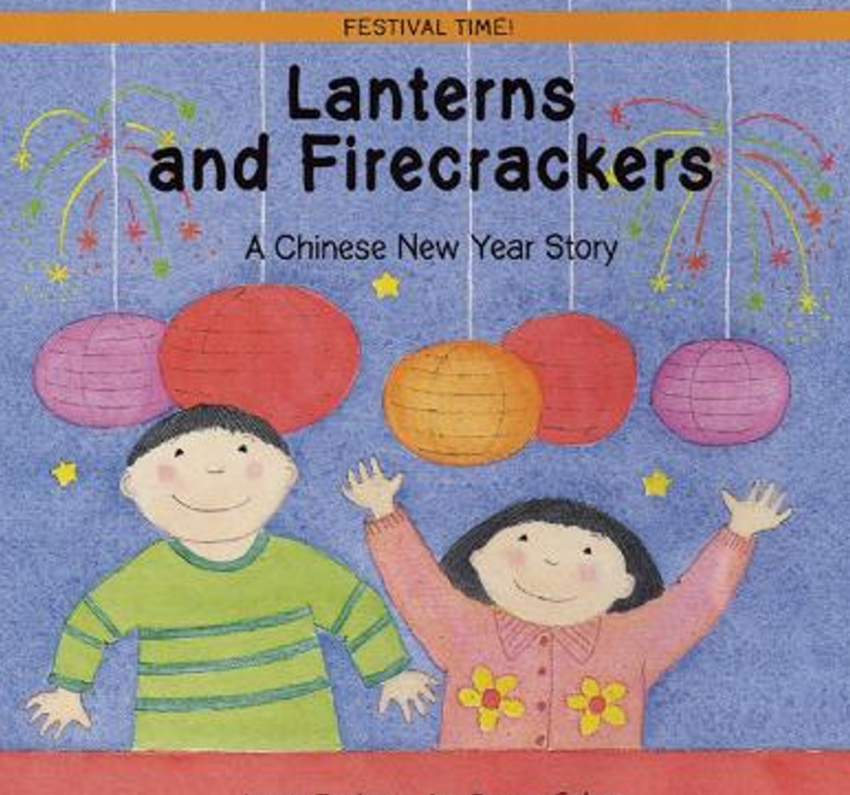(20th Jan) Theme: Chinese New Year Lanterns and firecrackers by Jonny Zucker | (3rd March) Theme: Pancakes  The Big Pancake  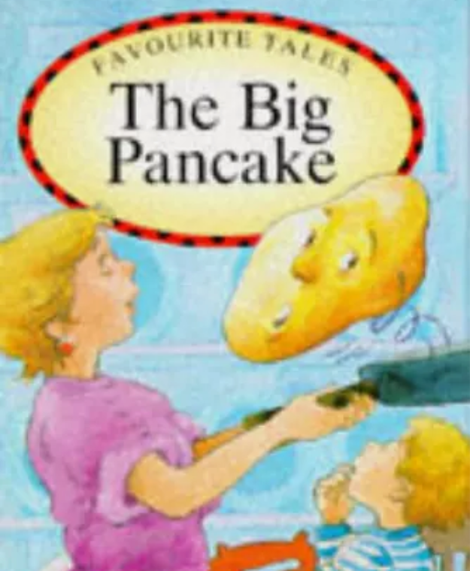 |  |  | (12th and 19th May) Theme: Minibeasts. Aaaarrgghh. Spider! By Lydia Monks  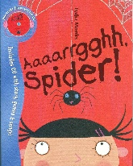  Lonely  Pet  Spider  Webs  Clean  Family |  |  | (23rd and 30th June) Theme: Transport. The Naughty Bus by Jan and Jerry Oke  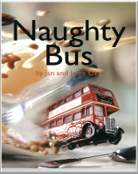  London  Traffic  Passengers  Roads  Reflection  Winch
Focus Texts with taught vocabulary | (16th Sept) Theme: Colours  How do you make a rainbow? By Caroline Crowe  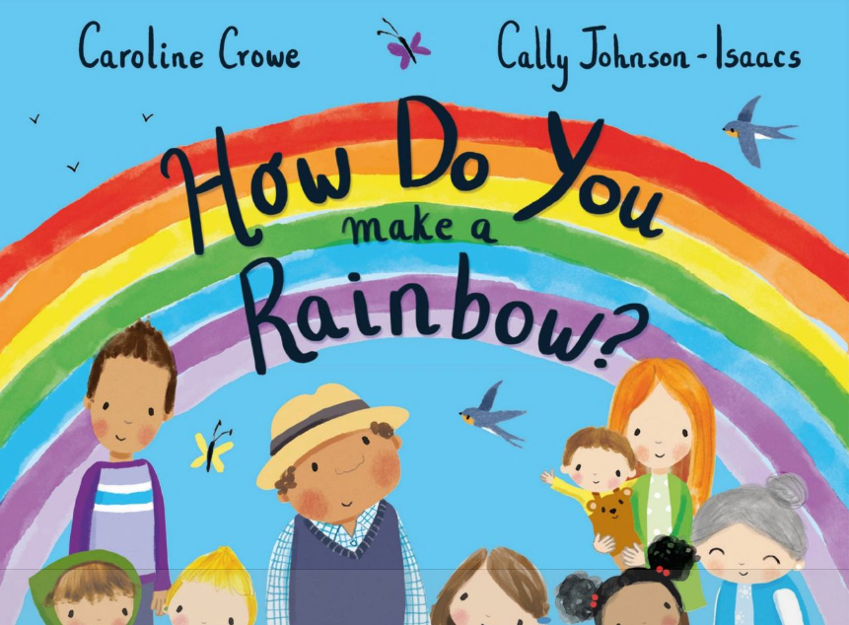 | (11th Nov and 18th Nov) Theme: Bears. We’re going on a Bear Hunt by Michael Rosen  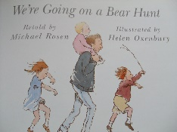  Scared  Through  River  Forest  Snowstorm gloomy cave |  | (27th Jan) Theme: Animals Dear Zoo by Rod Campbell  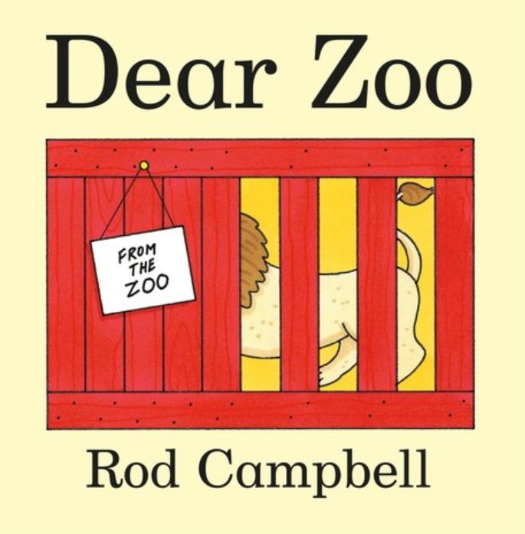zoo  tall  fierce  grumpy  scary  jumpy | (10th and 17th March) Theme: People who help us. A superhero like you by Dr. Ranj Singh  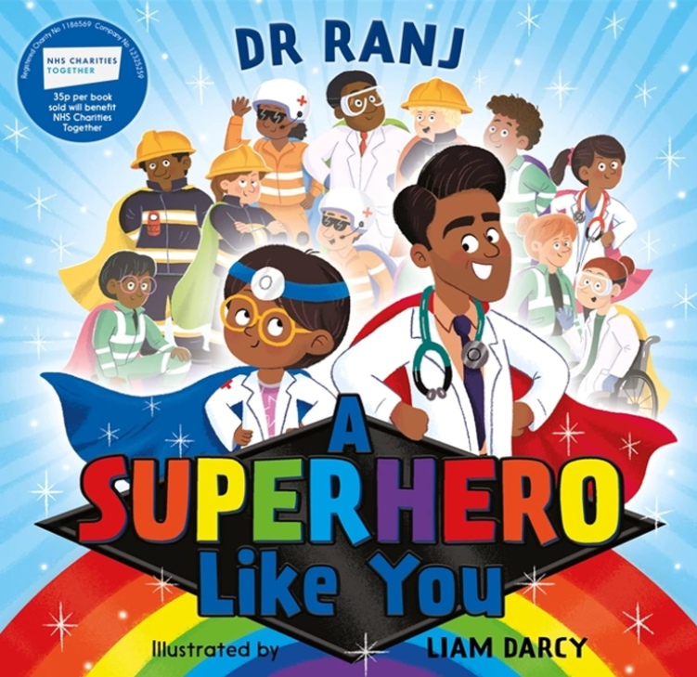doctor  firefighter  teacher  air ambulance  carer  recycling truck driver |  |  |  |  |  | (7th and 14th July) Theme: Park.  Shark in the park by Nick Sharratt  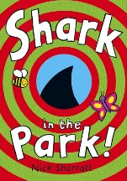  Shark  Park  Left  Right  crow  Telescope
Focus Texts with taught vocabulary | (23rd Sept and 30th Sept) Theme: Bears  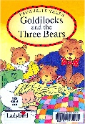  Goldilocks and The Three Bears by Favourite Tales  Forest  Porridge  Mischievous  Big,  Medium-sized  small | (25th Nov and 2nd Dec) Theme: Animals. The Grufffalo by Julia Donaldson  Tusks  Claws  Jaws  Poisonous  Prickles  Knees |  | 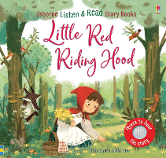  (3rd and 10th Feb) Theme: Traditional Tales Little Red Riding Hood  Grandmother  Wolf  Teeth  Axe  Woodcutter  Sneaky | 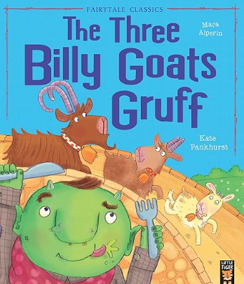(24th and 31st March) Theme: Traditional Tales Billy Goats Gruff by Kate Pankhurst  Goats  River  Troll  Bridge  Valley  Hooves
Focus Texts with taught vocabulary | (7th Oct) Theme: Autumn/Home  Owl Babies by Martin Waddell  Trunk  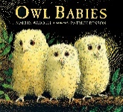  Feathers  Hunting  Owl  Branch  Flapped | (9th Dec) Theme: Christmas  Dear Santa by Rod Campbell  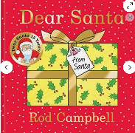  Santa  Wrapped  Small  Big  Bouncy  Noisy  Scary |  |  | 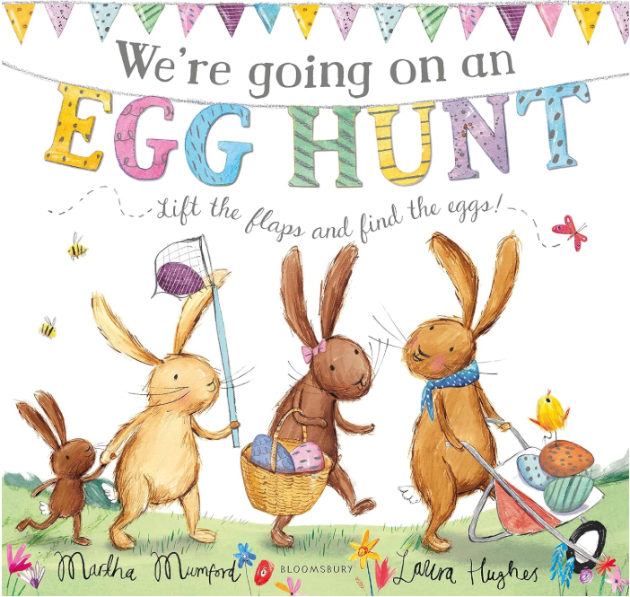(7th April) Theme: Easter  We’re going on an egg hunt by Martha Mumford
Focus Texts with taught vocabulary | 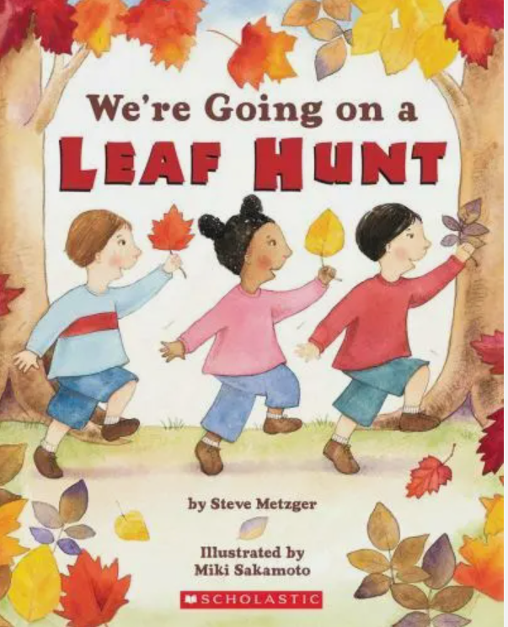(14th Oct) We’re going on a leaf hunt by Steve Metzger  Colourful  Forest  Mountain  Waterfall  Lake  Skunk | 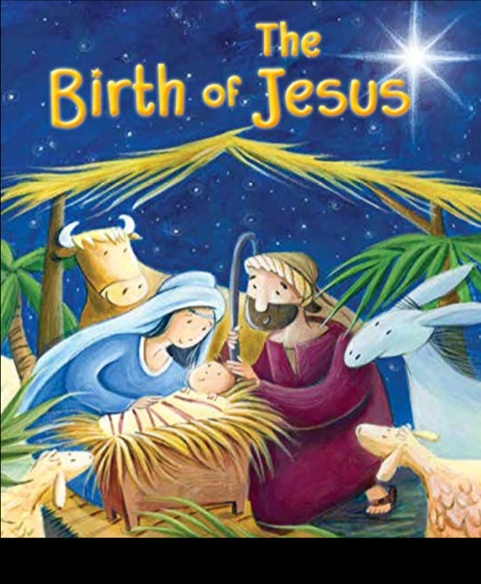(16th Dec) Theme: Christmas  The Nativity Story  Mary  Joseph  Jesus  Bethlehem  Shepherds  Kings
Experiences | Transition over 3 weeks to settle Nursery children  Making Porridge  Autumn Walk  Visiting Church  Pray, stay and play sessions | Posting letters to the post box. Sending and receiving letters.  Teddy Bears Picnic  Harvest Festival.  Nativity play.  Visiting Church  Pray, stay and play sessions. |  | Chinese New Year Party - Dragon Dancing, tasting Chinese food.  Winter Walk  Building Snowmen  Visiting Church  Pray, stay and play sessions. | Making Pancakes  Visiting Church  Mother’s Day Assembly  Baking Easter Nests  Pray, Stay and Play |  |  | Growing Beans  Visiting Church  Father’s Day Stay & Play  Tasting Fruit  Pray, Stay, and Play  Farm school Trip |  |  | Visiting Church  Sports Day  Pray, stay and Play.
RE | God’s World  To know that God loves and cares for each one of us and reflect on this.  Hear about and respond to the things God created for us.  Know that God has asked us to care for the world. Think of ways in which we can help to do it. To know that God made each one of us different and special. Reflect on this. | God’s Family  Be aware that God made all the people in the world to be part of his family and that we are part of it too. Know that God made us to know and love him and to show our love for him by helping one another. To know that God has given us gifts so that we can show his love to others. To know that God’s greatest gift was to send his only son Jesus and respond to that gift. |  | Getting to Know Jesus  To know that Jesus has a great love for each one of us. Think of ways in which we can show our love for Jesus. Hear that Jesus cured people who were ill. Think of ways in which we can show our love for people who are ill. Begin to know that Jesus showed he was the son of God at the Wedding of Cana. Begin to think about what this means for us. | Sorrow and Joy  Understand that we are capable of hurting others and that we should always try to be kind to each other. Know that we can say sorry when we hurt someone but we need to ask Jesus to help us to do this. Know that Jesus forgave those who hurt him and know that we can forgive other people when they hurt us. Know that we need to ask Jesus to help us be kind to others. |  |  | New Life  Begin to understand that because Jesus rose from the dead we can experience Easter. Know the story of Jesus appearing to Mary Magdalene when he rose from the dead and begin to understand why this story is important. Begin to understand the special gift of joy and peace that Jesus gave to the disciples and can give to us. Know the story of Jesus going back to his Father in heaven. |  |  | The Church  Know that we call the church the family of God and that we can all belong to his family. Know that a church building is a holy place where we can all pray and are welcome. Know that Jesus is present in a special way in the tabernacle and we can visit him. Know and be thankful that lots of people help look after the church for us. Know why Sunday is a special day for us.
Ten Ten (RE and PSE) | Module 1: Created and Loved by God  Unit one: Religious Understanding  Unit two: Me, My Body, My Health | Module 1: Created and Loved by God  Unit three: Emotional Well-Being  Unit four: Life Cycles |  | Module 2: Created to Love Others  Unit one: Religious Understanding  Unit two: Personal Relationships | Module 2: Created to Love Others  Unit three: Life Online  Unit four: Keeping Safe |  |  | Module 3: Created to Live in Community  Unit one: Religious Understanding  Unit two: Living in the Wider World
RE Vocabulary | God, love, world, created, creation, world, beginning, care, light, sky, sea, land, sun, moon, animals, people, made, different, special, reflect, bible | God, family, made, people, special, love, helping, Elizabeth of Hungary, gifts, Jesus, Nativity, kings, shepherd, Angel Gabriel, angels, innkeeper, Bethlehem, Joseph, Mary, Christmas, Advent. bible |  | Jesus, love, show, children, disciples, cured, helped, ill, healed, miracle, Pool of Bethzatha, hospital, doctors, nurses, wedding of cana, wedding, Mary, Jesus, water, wine, bible | Jesus, forgive, forgiveness, kind, God, Father, sorry, hurt, Zacchaeus, share, feeding the 5,000, bible |  |  | Jesus, dead, Easter, Mary Magdalene, gift, joy, peace, Father, God, heaven, alive, good news, disciples, holy spirit, heaven, bible |  |  | Church, family, God, holy, special, tabernacle, Sunday, people, priest, altar, holy water, bible
British Values | Democracy – all decide together, all tidy together, all be friends together. | Rule of law – class rules, school rules, |  | Liberty – freedom of expression. Rights and responsibilities. | Respect and tolerance of difference. |  |  | Revisit democracy and rule of law. |  |  | Revisit liberty and respect of tolerance.
Communication and Language | To listen to a story every day and access the reading area.  To listen to an adult when I am busy in my play when the adult says my name.  To use a range of vocabulary, especially using key words from our key texts.  To sing a large repertoire of songs (see Nursery Rhyme list below)  To develop their communication but may continue to have problems with irregular tenses and plurals e.g. runned for run.  To develop their pronunciation buy may have problems saying sound sounds (r, j th, ch and sh) and multi-syllabic words such as hippopotamus.  To use sentences of three to four words.  To start a conversation with an adult or friend.  To express a point of view and to debate when they disagree with an adult or friend, using words as well as actions.  To use talk to organise themselves and their play: “Let’s go on a bus, you sit there, I’ll be the driver.” | To listen to a story every day and access the reading area.  To listen to an adult when I am busy in my play when the adult says my name.  To use a range of vocabulary, especially using key words from our key texts.  To sing a large repertoire of songs (see Nursery Rhyme list below)  To develop their communication but may continue to have problems with irregular tenses and plurals e.g. runned for run.  To develop their pronunciation buy may have problems saying sound sounds (r, j th, ch and sh) and multi-syllabic words such as hippopotamus.  To use sentences of three to four words.  To express a point of view and to debate when they disagree with an adult or friend, using words as well as actions.  To start a conversation with an adult or friend.  To use talk to organise themselves and their play: “Let’s go on a bus, you sit there, I’ll be the driver.” |  | To listen to a story every day and access the reading area.  To listen to an adult when I am busy in my play when the adult says my name.  To use a range of vocabulary, especially using key words from our key texts.  To understand ‘why’ questions.  To sing a large repertoire of songs (see Nursery Rhyme list below)  To talk about familiar books, and be able to tell a long story e.g. retell the key story  To develop their communication but may continue to have problems with irregular tenses and plurals e.g. runned for run.  To express a point of view and to debate when they disagree with an adult or friend, using words as well as actions.  To develop their pronunciation buy may have problems saying sound sounds (r, j th, ch and sh) and multi-syllabic words such as hippopotamus.  To use longer sentences of four to six words.  To start a conversation with an adult or friend and continue it for many turns.  To use talk to organise themselves and their play: “Let’s go on a bus, you sit there, I’ll be the driver.” | To listen to a story every day and access the reading area.  To listen to an adult when I am busy in my play when the adult says my name.  To use a range of vocabulary, especially using key words from our key texts.  To understand ‘why’ questions.  To sing a large repertoire of songs (see Nursery Rhyme list below)  To talk about familiar books, and be able to tell a long story e.g. retell the key story.  To develop their communication but may continue to have problems with irregular tenses and plurals e.g. runned for run.  To develop their pronunciation buy may have problems saying sound sounds (r, j th, ch and sh) and multi-syllabic words such as hippopotamus.  To use longer sentences of four to six words.  To express a point of view and to debate when they disagree with an adult or friend, using words as well as actions.  To start a conversation with an adult or friend and continue it for many turns.  To use talk to organise themselves and their play: “Let’s go on a bus, you sit there, I’ll be the driver.” |  |  | To listen to a story every day and access the reading area.  To listen to an adult when I am busy in my play when the adult says my name.  To use a range of vocabulary, especially using key words from our key texts.  To understand ‘why’ questions.  To sing a large repertoire of songs (see Nursery Rhyme list below)  To talk about familiar books, and be able to tell a long story e.g. retell the key story.  To develop their communication but may continue to have problems with irregular tenses and plurals e.g. runned for run.  To express a point of view and to debate when they disagree with an adult or friend, using words as well as actions.  To develop their pronunciation buy may have problems saying sound sounds (r, j th, ch and sh) and multi-syllabic words such as hippopotamus.  To use longer sentences of four to six words.  To start a conversation with an adult or friend and continue it for many turns.  To use talk to organise themselves and their play: “Let’s go on a bus, you sit there, I’ll be the driver.” |  |  | To listen to a story every day and access the reading area.  To listen to an adult when I am busy in my play when the adult says my name.  To use a range of vocabulary, especially using key words from our key texts.  To understand ‘why’ questions.  To sing a large repertoire of songs (see Nursery Rhyme list below)  To talk about familiar books, and be able to tell a long story e.g. retell the key story.  To develop their communication but may continue to have problems with irregular tenses and plurals e.g. runned for run.  To develop their pronunciation buy may have problems saying sound sounds (r, j th, ch and sh) and multi-syllabic words such as hippopotamus.  To use longer sentences of four to six words.  To express a point of view and to debate when they disagree with an adult or friend, using words as well as actions.  To start a conversation with an adult or friend and continue it for many turns.  To use talk to organise themselves and their play: “Let’s go on a bus, you sit there, I’ll be the driver.”
Personal, Social and Emotional Development | To select and use activities and resources, with help when needed. This will help them to achieve a goal they have chosen, or one, which is suggested to them. (A range of resources/challenges will be increased outdoors and inside throughout the year). Model exciting new activities to encourage children to use them.  To develop their sense of responsibility and membership of a community e.g. giving children jobs such as getting the milk etc and tidy up teams.  Become more outgoing with unfamiliar people, in the safe context of their setting (visitors in school).  To show more confidence in new social situations e.g. church, whole-school assemblies.  Play with one other child.  To follow the rules in Nursery.  To remember rules without needing an adult to remind them.  To develop ways of being assertive.  To talk with others to solve conflicts.  To talk about their feelings using words like happy, sad, angry or worried.  To understand gradually how others might be feelings. To listen to an adult modelling ways to calm down such as stopping and taking a few deep breaths. To learn ways to calm yourself down. | To select and use activities and resources, with help when needed. This will help them to achieve a goal they have chosen, or one, which is suggested to them. (A range of resources/challenges will be increased outdoors and inside throughout the year). Model exciting new activities to encourage children to use them.  To develop their sense of responsibility and membership of a community e.g. giving children jobs such as getting the milk and tidy up teams.  Become more outgoing with unfamiliar people, in the safe context of their setting (visitors in school).  To show more confidence in new social situations e.g. church, whole-school assemblies.  Play with one other child extending pay ideas.  To increasingly follow rules.  To remember rules without needing an adult to remind them.  To develop ways of being assertive.  To talk with others to solve conflicts.  To talk about their feelings using words like happy, sad, angry or worried.  To understand gradually how others might be feelings. To listen to an adult modelling ways to calm down such as stopping and taking a few deep breaths. To learn ways to calm yourself down. |  | To select and use activities and resources, with help when needed. This will help them to achieve a goal they have chosen, or one, which is suggested to them. (A range of resources/challenges will be increased outdoors and inside throughout the year). Model exciting new activities to encourage children to use them.  To develop their sense of responsibility and membership of a community e.g. giving children jobs such as getting the milk and tidy up teams.  Become more outgoing with unfamiliar people, in the safe context of their setting (visitors in school).  To show more confidence in new social situations e.g. church, whole-school assemblies.  Play with one other child extending and elaborating on play ideas.  To increasingly follow rules.  To remember rules without needing an adult to remind them.  To develop ways of being assertive.  To talk with others to solve conflicts.  To talk about their feelings using words like happy, sad, angry or worried.  To understand gradually how others might be feelings. To listen to an adult modelling ways to calm down such as stopping and taking a few deep breaths. To learn ways to calm yourself down. | To select and use activities and resources, with help when needed. This will help them to achieve a goal they have chosen, or one, which is suggested to them. (A range of resources/challenges will be increased outdoors and inside throughout the year). Model exciting new activities to encourage children to use them.  Become more outgoing with unfamiliar people, in the safe context of their setting (visitors in school).  To develop their sense of responsibility and membership of a community e.g. giving children jobs such as getting the milk and tidy up teams.  To show more confidence in new social situations e.g. church, whole-school assemblies.  Play with one or more other children, extending and elaborating play ideas.  Find solutions to conflicts and rivalries e.g. accepting not everyone can be spider-man and suggest other ideas.  To increasingly follow rules and understand why they are important.  To remember rules without needing an adult to remind them.  To develop ways of being assertive.  To talk with others to solve conflicts.  To talk about their feelings using words like happy, sad, angry or worried.  To understand gradually how others might be feelings. To listen to an adult modelling ways to calm down such as stopping and taking a few deep breaths. To learn ways to calm yourself down. | To select and use activities and resources, with help when needed. This will help them to achieve a goal they have chosen, or one, which is suggested to them. (A range of resources/challenges will be increased outdoors and inside throughout the year). Model exciting new activities to encourage children to use them.  Become more outgoing with unfamiliar people, in the safe context of their setting (visitors in school).  To develop their sense of responsibility and membership of a community e.g. giving children jobs such as getting the milk and tidy up teams.  To show more confidence in new social situations e.g. church, whole-school assemblies.  Play with one or more other children, extending and elaborating play ideas.  Find solutions to conflicts and rivalries e.g. accepting not everyone can be spider-man and suggest other ideas.  To increasingly follow rules and understand why they are important.  To remember rules without needing an adult to remind them.  To develop ways of being assertive.  To talk with others to solve conflicts.  To talk about their feelings using words like happy, sad, angry or worried.  To understand gradually how others might be feelings. To listen to an adult modelling ways to calm down such as stopping and taking a few deep breaths. To learn ways to calm yourself down. |  |  |  |  | To select and use activities and resources, with help when needed. This will help them to achieve a goal they have chosen, or one, which is suggested to them. (A range of resources/challenges will be increased outdoors and inside throughout the year). Model exciting new activities to encourage children to use them.  Become more outgoing with unfamiliar people, in the safe context of their setting (visitors in school).  To develop their sense of responsibility and membership of a community e.g. giving children jobs such as getting the milk and tidy up teams.  To show more confidence in new social situations e.g. church, whole-school assemblies.  Play with one or more other children, extending and elaborating play ideas.  Find solutions to conflicts and rivalries e.g. accepting not everyone can be spider-man and suggest other ideas.  To increasingly follow rules and understand why they are important.  To remember rules without needing an adult to remind them.  To develop ways of being assertive.  To talk with others to solve conflicts.  To talk about their feelings using words like happy, sad, angry or worried.  To understand gradually how others might be feelings. To listen to an adult modelling ways to calm down such as stopping and taking a few deep breaths. To learn ways to calm yourself down.
Squiggle Whilst You Wiggle
(Physical Development: To use large muscle-movements to wave flappers)
Physical Development | To continue to develop their movement, balancing, riding (trim trail, scooters, trikes, balance bikes and bikes) and ball skills.  To go up steps and stairs or climb apparatus using alternate feet. Steps and stairs – home challenge. (climbing up blocks outside).  Skip, hop, stand on one leg and hold a pose for a game like musical statues.  Use large-muscle movements to wave flags and streamers, paint and make marks.  Start taking part in some group activities which they make up for themselves, or in teams.  Increasingly be able to use and remember sequences and patterns of movements, which are related to music and rhythm.  Match their developing physical skills to tasks and activities in their setting. E.g. to decide whether to crawl, walk or run across a plank depending on its length and width.  To choose the correct resources to carry out their own plan e.g. spade for a hole.  To collaborate with others to manage large items such as moving a long plank safely.  Use one-handed tools and equipment e.g. making snips in paper with scissors. Scissors, Rollers, stampers, cutters, spatulas, dough wheels, jugs, cups, water play containers, cotton buds, lego, stickle brix, mobile in CP throughout year.  Use a comfortable grip with good control when holding pens and pencils (see assessment sheet)  To show a preference for a dominant hand.  Be increasingly independent as they get dressed and undressed, for example, putting coats on and doing up zips. | To continue to develop their movement, balancing, riding (trim trail, scooters, trikes, balance bikes and bikes) and ball skills.  To go up steps and stairs or climb apparatus using alternate feet. Steps and stairs – home challenge. (climbing up blocks outside).  Skip, hop, stand on one leg and hold a pose for a game like musical statues.  Use large-muscle movements to wave flags and streamers, paint and make marks.  Start taking part in some group activities which they make up for themselves, or in teams.  Increasingly be able to use and remember sequences and patterns of movements, which are related to music and rhythm.  Match their developing physical skills to tasks and activities in their setting. E.g. to decide whether to crawl, walk or run across a plank depending on its length and width.  To choose the correct resources to carry out their own plan e.g. spade for a hole.  To collaborate with others to manage large items such as moving a long plank safely.  Use one-handed tools and equipment e.g. making snips in paper with scissors. Scissors, Rollers, stampers, cutters, spatulas, dough wheels, jugs, cups, water play containers, cotton buds, lego, stickle brix, mobile in CP throughout year.  Use a comfortable grip with good control when holding pens and pencils (see assessment sheet)  To show a preference for a dominant hand.  Be increasingly independent as they get dressed and undressed, for example, putting coats on and doing up zips. |  | To continue to develop their movement, balancing, riding (trim trail, scooters, trikes, balance bikes and bikes) and ball skills.  To go up steps and stairs or climb apparatus using alternate feet. Steps and stairs – home challenge. (climbing up blocks outside).  Skip, hop, stand on one leg and hold a pose for a game like musical statues.  Use large-muscle movements to wave flags and streamers, paint and make marks.  Start taking part in some group activities which they make up for themselves, or in teams.  Increasingly be able to use and remember sequences and patterns of movements, which are related to music and rhythm.  Match their developing physical skills to tasks and activities in their setting. E.g. to decide whether to crawl, walk or run across a plank depending on its length and width.  To choose the correct resources to carry out their own plan e.g. spade for a hole.  To collaborate with others to manage large items such as moving a long plank safely.  Use one-handed tools and equipment e.g. making snips in paper with scissors. Scissors, Rollers, stampers, cutters, spatulas, dough wheels, jugs, cups, water play containers, cotton buds, lego, stickle brix, mobile in CP throughout year.  Use a comfortable grip with good control when holding pens and pencils (see assessment sheet)  To show a preference for a dominant hand.  Be increasingly independent as they get dressed and undressed, for example, putting coats on and doing up zips. | To continue to develop their movement, balancing, riding (trim trail, scooters, trikes, balance bikes and bikes) and ball skills.  To go up steps and stairs or climb apparatus using alternate feet. Steps and stairs – home challenge. (climbing up blocks outside).  Skip, hop, stand on one leg and hold a pose for a game like musical statues.  Use large-muscle movements to wave flags and streamers, paint and make marks.  Start taking part in some group activities which they make up for themselves, or in teams.  Increasingly be able to use and remember sequences and patterns of movements, which are related to music and rhythm.  Match their developing physical skills to tasks and activities in their setting. E.g. to decide whether to crawl, walk or run across a plank depending on its length and width.  To choose the correct resources to carry out their own plan e.g. spade for a hole.  To collaborate with others to manage large items such as moving a long plank safely.  Use one-handed tools and equipment e.g. making snips in paper with scissors. Scissors, Rollers, stampers, cutters, spatulas, dough wheels, jugs, cups, water play containers, cotton buds, lego, stickle brix, mobile in CP throughout year.  Use a comfortable grip with good control when holding pens and pencils (see assessment sheet)  To show a preference for a dominant hand.  Be increasingly independent as they get dressed and undressed, for example, putting coats on and doing up zips. |  |  | To continue to develop their movement, balancing, riding (trim trail, scooters, trikes, balance bikes and bikes) and ball skills.  To go up steps and stairs or climb apparatus using alternate feet. Steps and stairs – home challenge. (climbing up blocks outside).  Skip, hop, stand on one leg and hold a pose for a game like musical statues.  Use large-muscle movements to wave flags and streamers, paint and make marks.  Start taking part in some group activities which they make up for themselves, or in teams.  Increasingly be able to use and remember sequences and patterns of movements, which are related to music and rhythm.  Match their developing physical skills to tasks and activities in their setting. E.g. to decide whether to crawl, walk or run across a plank depending on its length and width.  To choose the correct resources to carry out their own plan e.g. spade for a hole.  To collaborate with others to manage large items such as moving a long plank safely.  Use one-handed tools and equipment e.g. making snips in paper with scissors. Scissors, Rollers, stampers, cutters, spatulas, dough wheels, jugs, cups, water play containers, cotton buds, lego, stickle brix, mobile in CP throughout year.  Use a comfortable grip with good control when holding pens and pencils (see assessment sheet)  To show a preference for a dominant hand.  Be increasingly independent as they get dressed and undressed, for example, putting coats on and doing up zips. |  |  | To continue to develop their movement, balancing, riding (trim trail, scooters, trikes, balance bikes and bikes) and ball skills.  To go up steps and stairs or climb apparatus using alternate feet. Steps and stairs – home challenge. (climbing up blocks outside).  Skip, hop, stand on one leg and hold a pose for a game like musical statues.  Use large-muscle movements to wave flags and streamers, paint and make marks.  Start taking part in some group activities which they make up for themselves, or in teams.  Increasingly be able to use and remember sequences and patterns of movements, which are related to music and rhythm.  Match their developing physical skills to tasks and activities in their setting. E.g. to decide whether to crawl, walk or run across a plank depending on its length and width.  To choose the correct resources to carry out their own plan e.g. spade for a hole.  To collaborate with others to manage large items such as moving a long plank safely.  Use one-handed tools and equipment e.g. making snips in paper with scissors. Scissors, Rollers, stampers, cutters, spatulas, dough wheels, jugs, cups, water play containers, cotton buds, lego, stickle brix, mobile in CP throughout year.  Use a comfortable grip with good control when holding pens and pencils (see assessment sheet)  To show a preference for a dominant hand.  Be increasingly independent as they get dressed and undressed, for example, putting coats on and doing up zips.
Literacy | Copy actions from popular Nursery Rhymes.  Listen and learn well-known 10 Nursery Rhymes.  Begin to be aware of print in the environment.  To recognise familiar logos in the local environment.  To recognise the initial letter in their name and other letters in your name. To say the sound they make.  To know the difference between print and an illustration/picture/photo A wide range of books available in the reading area.  To know which word we start reading from and where to start reading a book first. A wide range of books/text in the reading area.  To know that print carries meaning.  To begin to recognise some letter shapes in print.  To look at picture books holding the book the correct way up. Lots of opportunities for children to look at books. Teacher to model reading books daily.  To know that we read English text from left to right and top to bottom.  To know the names of the different parts of a book. Front cover, back cover, title  To use vocabulary that is associated with the story.  To join in with repeated refrains. Planned texts to use with repeated refrains. Goldilocks and the three bears, peace at last, bear hunt, The gruffalo, little red riding hood, Billy Goats Gruff, and Shark in the Park.  To share a book with an adult. To listen to stories.  To turn the pages in the book one at a time.  To enjoy drawing freely.  To talk about their marks with an adult or another child.  To talk to an adult about what they want to write with an adult saying their sentence out loud.  To make marks with a pencil.  To write some or all of their name.  To make marks independently based on their interested. To tell an adult about their marks. | Copy actions from popular Nursery Rhymes.  Listen and learn well-known 10 Nursery Rhymes.  Begin to be aware of print in the environment.  To recognise familiar logos in the local environment.  To recognise the initial letter in their name and other letters in your name. To say the sound they make.  To know the difference between print and an illustration/picture/photo A wide range of books available in the reading area.  To know which word we start reading from and where to start reading a book first. A wide range of books/text in the reading area.  To know that print carries meaning.  To begin to recognise some letter shapes in print.  To look at picture books holding the book the correct way up. Lots of opportunities for children to look at books. Teacher to model reading books daily.  To know that we read English text from left to right and top to bottom.  To know the names of the different parts of a book. Front cover, back cover, title  To use vocabulary that is associated with the story.  To join in with repeated refrains. Planned texts to use with repeated refrains. Goldilocks and the three bears, peace at last, bear hunt, The gruffalo, little red riding hood, Billy Goats Gruff, and Shark in the Park.  To share a book with an adult. To listen to stories.  To turn the pages in the book one at a time.  To enjoy drawing freely.  To talk about their marks with an adult or another child.  To talk to an adult about what they want to write with an adult saying their sentence out loud.  To make marks with a pencil.  To write some or all of their name.  To make marks independently based on their interested. To tell an adult about their marks. |  | Copy actions from popular Nursery Rhymes.  Listen and learn well-known 10 Nursery Rhymes.  Begin to be aware of print in the environment.  To recognise familiar logos in the local environment.  To recognise the initial letter in their name and other letters in your name. To say the sound they make.  To know the difference between print and an illustration/picture/photo A wide range of books available in the reading area.  To know which word we start reading from and where to start reading a book first. A wide range of books/text in the reading area.  To know that print carries meaning.  To begin to recognise some letter shapes in print.  To look at picture books holding the book the correct way up. Lots of opportunities for children to look at books. Teacher to model reading books daily.  To know that we read English text from left to right and top to bottom.  To know the names of the different parts of a book. Front cover, back cover, title  To use vocabulary that is associated with the story.  To join in with repeated refrains. Planned texts to use with repeated refrains. Goldilocks and the three bears, peace at last, bear hunt, The gruffalo, little red riding hood, Billy Goats Gruff, and Shark in the Park.  To share a book with an adult. To listen to stories.  To turn the pages in the book one at a time.  To enjoy drawing freely.  To talk about their marks with an adult or another child.  To talk to an adult about what they want to write with an adult saying their sentence out loud.  To make marks with a pencil.  To write some or all of their name.  To make marks independently based on their interested. To tell an adult about their marks. | Copy actions from popular Nursery Rhymes.  Listen and learn well-known 10 Nursery Rhymes.  Begin to be aware of print in the environment.  To recognise familiar logos in the local environment.  To recognise the initial letter in their name and other letters in your name. To say the sound they make.  To know the difference between print and an illustration/picture/photo A wide range of books available in the reading area.  To know which word we start reading from and where to start reading a book first. A wide range of books/text in the reading area.  To know that print carries meaning.  To begin to recognise some letter shapes in print.  To look at picture books holding the book the correct way up. Lots of opportunities for children to look at books. Teacher to model reading books daily.  To know that we read English text from left to right and top to bottom.  To know the names of the different parts of a book. Front cover, back cover, title  To use vocabulary that is associated with the story.  To join in with repeated refrains. Planned texts to use with repeated refrains. Goldilocks and the three bears, peace at last, bear hunt, The gruffalo, little red riding hood, Billy Goats Gruff, and Shark in the Park.  To share a book with an adult. To listen to stories.  To turn the pages in the book one at a time.  To enjoy drawing freely.  To talk about their marks with an adult or another child.  To talk to an adult about what they want to write with an adult saying their sentence out loud.  To make marks with a pencil.  To write some or all of their name.  To make marks independently based on their interested. To tell an adult about their marks. |  | Copy actions from popular Nursery Rhymes.  Listen and learn well-known 10 Nursery Rhymes.  Begin to be aware of print in the environment.  To recognise familiar logos in the local environment.  To recognise the initial letter in their name and other letters in your name. To say the sound they make.  To know the difference between print and an illustration/picture/photo A wide range of books available in the reading area.  To know which word we start reading from and where to start reading a book first. A wide range of books/text in the reading area.  To know that print carries meaning.  To begin to recognise some letter shapes in print.  To look at picture books holding the book the correct way up. Lots of opportunities for children to look at books. Teacher to model reading books daily.  To know that we read English text from left to right and top to bottom.  To know the names of the different parts of a book. Front cover, back cover, title  To use vocabulary that is associated with the story.  To join in with repeated refrains. Planned texts to use with repeated refrains. Goldilocks and the three bears, peace at last, bear hunt, The gruffalo, little red riding hood, Billy Goats Gruff, and Shark in the Park.  To share a book with an adult. To listen to stories.  To turn the pages in the book one at a time.  To enjoy drawing freely.  To talk about their marks with an adult or another child.  To talk to an adult about what they want to write with an adult saying their sentence out loud.  To make marks with a pencil.  To write some or all of their name.  To make marks independently based on their interested. To tell an adult about their marks. |  |  |  | Copy actions from popular Nursery Rhymes.  Listen and learn well-known 10 Nursery Rhymes.  Begin to be aware of print in the environment.  To recognise familiar logos in the local environment.  To recognise the initial letter in their name and other letters in your name. To say the sound they make.  To know the difference between print and an illustration/picture/photo A wide range of books available in the reading area.  To know which word we start reading from and where to start reading a book first. A wide range of books/text in the reading area.  To know that print carries meaning.  To begin to recognise some letter shapes in print.  To look at picture books holding the book the correct way up. Lots of opportunities for children to look at books. Teacher to model reading books daily.  To know that we read English text from left to right and top to bottom.  To know the names of the different parts of a book. Front cover, back cover, title  To use vocabulary that is associated with the story.  To join in with repeated refrains. Planned texts to use with repeated refrains. Goldilocks and the three bears, peace at last, bear hunt, The gruffalo, little red riding hood, Billy Goats Gruff, and Shark in the Park.  To share a book with an adult. To listen to stories.  To turn the pages in the book one at a time.  To enjoy drawing freely.  To talk about their marks with an adult or another child.  To talk to an adult about what they want to write with an adult saying their sentence out loud.  To make marks with a pencil.  To write some or all of their name.  To make marks independently based on their interested. To tell an adult about their marks.
Mark Making Opportunities
Adult Focused Activities | Autumn 1  - Making marks freely | Autumn 2  - Making marks freely  - Lines and circles |  | Spring 1  - Making marks freely  - Lines and circles  - Drawing a face | Spring 2  - Making marks freely  - Lines and circles  - Drawing a face  - Drawing a face and a body |  |  | Summer 1  - Making marks freely  - Lines and circles  - Drawing a face  - Drawing a face and a body  - Writing initial letter | Summer 2  - Making marks freely  - Lines and circles  - Drawing a face  - Drawing a face and a body  - Writing intial letter  - Writing some or all of their letters in their name
Progression of Sounds | Settling in | s,a,t,p,i,n  To hear the same initial sound for words and names of objects. |  | m d g o c k e  To identify initial sounds of words and names of objects.  To distinguish different sounds. | u r h b f l j  To identify initial sounds of words and names of objects.  To articulate sounds correctly – including playing with voice sounds |  |  | v w y z qu ch  to identify initial sounds words and names of objects |  |  | ck x sh ch th ng nk  to identify the final sounds of words and objects
Oral Blending Focus | Settling in | Teach children to blend CVC words using oral blending and objects. |  | Teach children to blend a wider range of CVC words using oral blending. | Teach children to blend a wider range of words using oral blending. |  |  | Teach children to blend a wider range of words using oral blending.
Recognising their name | Settling in | Teach children to find their name using their picture. |  | Teach children to recognise the initial sound of their name. | Teach children to recognise the capital letter that starts their name. |  |  | Teach children to match their name to their picture.
Mathematics | Recognise the colour red.  Recognise the colour blue.  Recognise the colour yellow.  Recognise the colour green.  Recognise the colour purple.  Recognise colours.  Recognise matching buttons.  Recognise matching shoes.  Recognise and create matching towers.  Match number shapes.  Match the same size.  Match prints.  Sort by size.  Sort by colour.  Sort by shape.  Sorting – what do you notice?  Sorting – guess my rule? | Number 1 – Subitising  Number 1 – Counting  Number 1 – Numeral Matching  Number 2 – Subitising dice patterns  Number 2 – Subitising different patterns  Number 2 – subitising different sizes and patterns  Number 2 – counting – saying one number for each item  Number 2 – Link Numeral and Amounts  Colour AB Patterns  Extend AB Patterns – Outdoor Objects  Extend AB Patterns – Movement  Fix My Pattern (AB Patterns)  Extend ABC Colour Patterns  Outdoor ABC Patterns  Consolidation – Sorting and Matching. Counting. Pattern. |  | Subitising 3 – Dice Patterns  Subitising 3 – Different Patterns  Subitising 3  Counting 3  Numeral 3  Composition of 3  Recognise triangles  Counting 4  Numeral 4  Recognise squares and rectangles  Composition of 4  Counting 5  Numeral 5  Recognise pentagons  Composition of 5 | Consolidation – Subitising  Consolidation – Counting  Consolidation – Numerals  Counting 6  Counting 6 – Ten Frame  Tall and Short  Long and Short  Tall/Long or Short  Mass- Introducing Balance Scales  Mass – Lighter  Mass – Heavier or Lighter  Capacity – Full or empty  Capacity – Nearly Full or Nearly Empty  Capacity – Comparing Containers  Consolidation – Length  Consolidation – Mass  Consolidation – Capacity |  |  | Sequencing  Position – On and Under  Position – In and Out  Position – Infront and Behind  Comparing Groups – More Than  Comparing Groups – Fewer Than  Comparing Groups – More Than and Fewer Than  2D Shapes – Circles  2D Shapes – Triangles  2D Shapes – Rectangles  3D Shapes – Cubes and Cuboids  3D Shapes – Cylinders  3D Shapes – Spheres  Consolidation – Sequecing  Consolidation – Position  Consolidation – More or Fewer |  |  | Composition of 3  Composition of 4  Number Composition  What comes after?  What comes before?  Numbers to 5  Consolidation – Shape Patterns  Children describe patterns made up of 2D and 3D Shapes  Consolidation- More or Fewer  Consolidation – What comes before or after ?  Consolidation – Composition
Nursery Rhyme List (Matched to Maths Curriculum) | 1,2,3,4,5 Once I caught a fish alive  1 potato, 2 potato, 3 potato  5 little speckled frogs  5 little ducks went swimming one day  6 currant buns  5 sausages | 1 finger, 1 thumb  1,2 Buckle my shoe  2 little Dickie birds  Head, Shoulders, Knees and Toes  Zoom, Zoom, Zoom  Consolidation |  | Three Blind Mice  Three Little Kittens  5 Snowmen  4 Teddy Bears  5 Fingers  Alice the Camel | Consolidation  Sing a Song of Sixpence  I’m a Little Bean  5 Cheeky Monkeys Swinging through the trees  When Goldilocks went to the house of the bears  Consolidation |  |  | 5 Little Men in a Flying Saucer  Humpty Dumpty Sat on a Wall  One Elephant Went out to Play  Ring – a roses |  |  | London Bridge is Falling Down  Consolidation  One Big Hippo  Sleeping Bunnies  5 Cheeky Monkeys Jumping on a Bed  5 Little Apples  Consolidation
Understanding the World
Science | Humans  Can name main body parts/function  head, neck, tummy, back, bottom, legs, knees, feet, hands, toes, face, hair All About Me  Name some simple facial expressions.  Happy, sad, cross, angry, scared  Identify immediate family.  Mum, dad, sister, brother, house All about me  Senses -Uses senses in hands on exploration.  mouth, nose, hands, ears, eyes All about me  Can talk about their 5 senses. taste, smell, touch, hear, see  Materials  Explore collections of materials, identifying similar and different properties.  shiny, smooth, rough, hard, soft, crunchy, spiky  Seasons  Understands that the weather and seasons change.  hot, cold, chilly, far away, close, country, weather, snow, rain, wind, cloudy, sunny  Begin to understand the need to respect and care for the natural environment  Pick up rubbish, put it in the bin, tidy toys, bin, rubbish, tidy, clean  Forces  Talk about the different forces they can feel.  Feel forces, explore how things work.  Explore how objects/materials are affected by forces.  push, pull, squash, squeeze, roll, stretch, twist (with playdough & malleable etc)  Sound  Listen to sounds. Make sounds  noise,noisy, loud, quiet, fast, slow | Humans  Understand growth and change from being a baby and how they am unique.  Birth, baby, toddler, nappy, toileting, little, big, cry My family  Can talk about their 5 senses. taste, smell, touch, hear, see  Materials  Explore collection of materials.  hot, cold, melting, ice  Changing materials Solid, liquid, mix, stir, microwave, change  Seasons  Understands that the weather and seasons change.  hot, cold, chilly, far away, close, country, weather, snow, rain, wind, cloudy, sunny  Can identify what you need to wear for each season and why. (Learn how to take care of themselves)  winter hat, gloves, scarves, jumpers, coats, boots, wellies, tights,  Forces  Talk about the different forces they can feel.  Feel forces, explore how things work.  Explore how objects/materials are affected by forces.  push, pull, squash, squeeze, roll, stretch, twist (with playdough & malleable etc)  Sound  Listen to sounds. Make sounds  noise,noisy, loud, quiet, fast, slow  Light  Explore light sources. Shine light on or through different materials.  light, torch, dark, bright, shine, shiny, night, reflective |  | Humans  Can talk about their 5 senses. taste, smell, touch, hear, see  Seasons  Understands that the weather and seasons change.  hot, cold, chilly, far away, close, country, weather, snow, rain, wind, cloudy, sunny  Can identify what you need to wear for each season and why. (Learn how to take care of themselves) winter hat, gloves, scarves, jumpers, coats, boots, wellies, tights,  Forces  Talk about the different forces they can feel.  Feel forces, explore how things work.  Explore how objects/materials are affected by forces.  push, pull, squash, squeeze, roll, stretch, twist (with playdough & malleable etc)  Sound  Listen to sounds. Make sounds  noise,noisy, loud, quiet, fast, slow | Humans  Can talk about their 5 senses. taste, smell, touch, hear, see  Seasons  Understands that the weather and seasons change.  hot, cold, chilly, far away, close, country, weather, snow, rain, wind, cloudy, sunny  Can identify what you need to wear for each season and why. (Learn how to take care of themselves) sun hat, sun glasses, swimming costumes, t-shirts, sunscreen  Plants  Plants seeds and care for growing plants with support.  Seed, plant, leaf, root, stem, petal, flower, soil, grow  Forces  Talk about the different forces they can feel.  Feel forces, explore how things work.  Explore how objects/materials are affected by forces.  push, pull, squash, squeeze, roll, stretch, twist (with playdough & malleable etc)  Sound  Listen to sounds. Make sounds  noise,noisy, loud, quiet, fast, slow |  |  | Humans  Can talk about their 5 senses. taste, smell, touch, hear, see  Seasons  Understands that the weather and seasons change.  hot, cold, chilly, far away, close, country, weather, snow, rain, wind, cloudy, sunny  Can identify what you need to wear for each season and why. (Learn how to take care of themselves) sun hat, sun glasses, swimming costumes, t-shirts, sunscreen  Plants  Plants seeds and care for growing plants with support.  Seed, plant, leaf, root, stem, petal, flower, soil, grow  Animals-excluding humans  Begin to understand the need to respect and care for living things-animals  Can name and talk about farm animals eg cow, sheep, goat, chicken, duck, horse, bird, webbed feet  Can explain the life cycle of hen  Egg,chick,hen  Forces  Talk about the different forces they can feel.  Feel forces, explore how things work.  Explore how objects/materials are affected by forces.  push, pull, squash, squeeze, roll, stretch, twist (with playdough & malleable etc)  Sound  Listen to sounds. Make sounds  noise,noisy, loud, quiet, fast, slow |  |  | Humans  Can talk about their 5 senses. taste, smell, touch, hear, see  Seasons  Understands that the weather and seasons change.  hot, cold, chilly, far away, close, country, weather, snow, rain, wind, cloudy, sunny  Forces  Talk about the different forces they can feel.  Feel forces, explore how things work.  Explore how objects/materials are affected by forces.  push, pull, squash, squeeze, roll, stretch, twist (with playdough & malleable etc)  Sound  Listen to sounds. Make sounds  noise,noisy, loud, quiet, fast, slow
Geography | To know that we live in Eccles.  (All about me)  Street, road, Eccles, school  To know what type of  property they live in.  (All About Me)  House , Flat, Bungalow  Can explain features of homes. (All about me. Peace at last) Lounge, Kitchen, Bedroom, Hall, Garden, Stairs,  Talk about what they see in their own environment (school/home) using a wide range of vocabulary. (Progressive throughout the year: Natural world, seasonal changes, planting activities, harvest, farm, birds, minibeasts etc). | To know that there are different countries in the world, we live England.  England, live, Names of countries depending on nationalities in class e.g. Poland.  (Christmas) Christmas around the world  Talk about what they see in their own environment (school/home) using a wide range of vocabulary. (Progressive throughout the year: Natural world, seasonal changes, planting activities, harvest, farm, birds, minibeasts etc). |  | To know that there are different countries in the world, we live England.  England, live, Names of countries depending on nationalities in class e.g. Poland.  (Chinese New Year) China  Talk about what they see in their own environment (school/home) using a wide range of vocabulary. (Progressive throughout the year: Natural world, seasonal changes, planting activities, harvest, farm, birds, minibeasts etc). | Explains how life may be different for other children. (RE: Cafod)  same, different. Poor, hungry, thirsty.  Talk about what they see in their own environment (school/home) using a wide range of vocabulary. (Progressive throughout the year: Natural world, seasonal changes, planting activities, harvest, farm, birds, minibeasts etc). |  |  | Talk about what they see in their own environment (school/home) using a wide range of vocabulary. (Progressive throughout the year: Natural world, seasonal changes, planting activities, harvest, farm, birds, minibeasts etc). |  |  | Talk about what they see in their own environment (school/home) using a wide range of vocabulary. (Progressive throughout the year: Natural world, seasonal changes, planting activities, harvest, farm, birds, minibeasts etc).
History | Able to say who they are and who they live with. (All about me) mum, dad, brother, sister, baby, hair colour, skin colour, boy, girl  Can sequence family members by size and name and understand their own life sequence from baby, toddler and child. (All About Me)  baby, child, adult, big, small, tiny, little, medium, middle, first, then, now  Talks about people who help them in their immediate area, i.e. in school and around the school grounds. (All About Me)  lollipop person, caretaker, office staff, dinner lady.  Shares likes and dislikes. (All about me) Progressive throughout the year.  I like, I do not like, yes, no, my favourite | Able to say who they are and who they live with. (All about me: RE) mum, dad, brother, sister, baby, hair colour, skin colour, boy, girl  Shares likes and dislikes. (All about me) Progressive throughout the year.  I like, I do not like, yes, no, my favourite |  | Shares likes and dislikes. (All about me) Progressive throughout the year.  I like, I do not like, yes, no, my favourite | Shows an interest in different occupations.(Superheroes/People who help us) nurse, doctor, police, fire, paramedic  Shares likes and dislikes. (All about me) Progressive throughout the year.  I like, I do not like, yes, no, my favourite  To recognise vehicles that we may see on the road.(Superheroes/People who help us)  bus, car, bike, ambulance, fire engine, police car  Comments on historical figures or objects in non-fiction texts.  Florence Nightingale (Spring 2: People who help us), Rosa Parkes (Transport Summer 2) |  |  | Shares likes and dislikes. (All about me) Progressive throughout the year.  I like, I do not like, yes, no, my favourite |  |  | Shares likes and dislikes. (All about me) Progressive throughout the year.  I like, I do not like, yes, no, my favourite  To recognise vehicles that we may see on the road.(Summer 2: The Naughty Bus) bus, car, bike, ambulance, fire engine, police car  Comments on historical figures or objects in non-fiction texts. Rosa Parkes (Transport Summer 2)
Expressive Arts and Design

Music | I can join in with Nursery rhymes with my teacher. Twinkle Twinkle Little Star, The Wheels on the bus, Baa Baa Black Sheep, Wind the Bobbin up.  Enjoys listening to music. Responds to music. (eg by movement/dance/ clapping/tapping etc) Happy, sad, clapping, dancing, moving, tapping.  Explores instruments and is beginning to name them Drum, tambourine, maracas, triangle, glockenspiel, guitar, violin, ukulele.  Moves to music. Copies basic actions.  To enjoy moving to music.  Beginning to watch performances for short periods of time.  Remember and sing entire songs.  Create own songs, or improvise –eg nursery rhymes. | I can join in with Nursery rhymes with my teacher. Twinkle Twinkle Little Star, The Wheels on the bus, Baa Baa Black Sheep, Wind the Bobbin up.  Enjoys listening to music. Responds to music. (eg by movement/dance/ clapping/tapping etc) Happy, sad, clapping, dancing, moving, tapping.  Explores instruments and is beginning to name them Drum, tambourine, maracas, triangle, glockenspiel, guitar, violin, ukulele.  Moves to music. Copies basic actions.  To enjoy moving to music.  Beginning to watch performances for short periods of time.  Remember and sing entire songs.  Create own songs, or improvise –eg nursery rhymes. |  | I can join in with Nursery rhymes with my teacher. Twinkle Twinkle Little Star, The Wheels on the bus, Baa Baa Black Sheep, Wind the Bobbin up.  Enjoys listening to music. Responds to music. (eg by movement/dance/ clapping/tapping etc) Happy, sad, clapping, dancing, moving, tapping.  Explores instruments and is beginning to name them Drum, tambourine, maracas, triangle, glockenspiel, guitar, violin, ukulele.  Moves to music. Copies basic actions.  To enjoy moving to music.  Beginning to watch performances for short periods of time.  Remember and sing entire songs.  Create own songs, or improvise –eg nursery rhymes. | I can join in with Nursery rhymes with my teacher. Twinkle Twinkle Little Star, The Wheels on the bus, Baa Baa Black Sheep, Wind the Bobbin up.  Enjoys listening to music. Responds to music. (eg by movement/dance/ clapping/tapping etc) Happy, sad, clapping, dancing, moving, tapping.  Explores instruments and is beginning to name them Drum, tambourine, maracas, triangle, glockenspiel, guitar, violin, ukulele.  Moves to music. Copies basic actions.  To enjoy moving to music.  Beginning to watch performances for short periods of time.  Remember and sing entire songs.  Create own songs, or improvise –eg nursery rhymes. |  |  | I can join in with Nursery rhymes with my teacher. Twinkle Twinkle Little Star, The Wheels on the bus, Baa Baa Black Sheep, Wind the Bobbin up.  Enjoys listening to music. Responds to music. (eg by movement/dance/ clapping/tapping etc) Happy, sad, clapping, dancing, moving, tapping.  Explores instruments and is beginning to name them Drum, tambourine, maracas, triangle, glockenspiel, guitar, violin, ukulele.  Moves to music. Copies basic actions.  To enjoy moving to music.  Beginning to watch performances for short periods of time.  Remember and sing entire songs.  Create own songs, or improvise –eg nursery rhymes. |  |  | I can join in with Nursery rhymes with my teacher. Twinkle Twinkle Little Star, The Wheels on the bus, Baa Baa Black Sheep, Wind the Bobbin up.  Enjoys listening to music. Responds to music. (eg by movement/dance/ clapping/tapping etc) Happy, sad, clapping, dancing, moving, tapping.  Explores instruments and is beginning to name them Drum, tambourine, maracas, triangle, glockenspiel, guitar, violin, ukulele.  Moves to music. Copies basic actions.  To enjoy moving to music.  Beginning to watch performances for short periods of time.  Remember and sing entire songs.  Create own songs, or improvise –eg nursery rhymes.
DT Baking Opportunities | Porridge |  | Edible sparklers/smores  Decorated Christmas biscuits | Chinese New Year | Pancakes |  |  | Eggs  Bean Pods  Beans |  | Fruity Jelly (Party – baking muffins)
Termly Famous Artists | Kandinksy – circles and triangles |  |  | Yayoi Kusama  Polka dot art |  |  |  | Arcimboldo – Imaginative Portraits
Art & DT | Draw- Create closed shapes with continuous lines , and use it to represent objects (Draw a face using a circle, some vertical lines and horizontal lines to represent limbs) Draw with increasing complexity & detail- eyes, nose, mouth, hair  Draw happy, sad, grumpy faces,  Draw letter like shapes.  (Autumn 1 – All about me. Portrait) Eyes, nose, mouth, hair, head, hair, happy, sad  (All year – squiggle while you wiggle portrait drawing every half term) Eyes, nose, mouth, hair, head, hair, happy, sad  Explore different materials freely, eg fold and bend paper, create simple paper curls- pencil technique.  (All year – continuous provision)  Fold, bend, curls, pencil  Paint- Load a brush with paint, mark make, experimenting with the brush. Explore a range of brush sizes to create different thicknesses of strokes, Experiment with a range of tools and materials to create different effects, such as stampers, sponges, rollers, scrapers/spatulas, spreaders, cotton buds, natural resources such as shells, sticks leaves etc  (All year – continuous provision. Paints accessible to children on Easel and creative table) | Draw- Create closed shapes with continuous lines , and use it to represent objects (Draw a face using a circle, some vertical lines and horizontal lines to represent limbs) Draw with increasing complexity & detail- eyes, nose, mouth, hair  Draw happy, sad, grumpy faces,  Draw letter like shapes. (All year – squiggle while you wiggle portrait drawing every half term) Eyes, nose, mouth, hair, head, hair, happy, sad  Explore different materials freely, eg fold and bend paper, create simple paper curls- pencil technique.  (All year – continuous provision)  Fold, bend, curls, pencil  Paint- Load a brush with paint, mark make, experimenting with the brush. Explore a range of brush sizes to create different thicknesses of strokes, Experiment with a range of tools and materials to create different effects, such as stampers, sponges, rollers, scrapers/spatulas, spreaders, cotton buds, natural resources such as shells, sticks leaves etc  (All year – continuous provision. Paints accessible to children on Easel and creative table) (Autumn. Leaf printing) |  | Draw- Create closed shapes with continuous lines , and use it to represent objects (Draw a face using a circle, some vertical lines and horizontal lines to represent limbs) Draw with increasing complexity & detail- eyes, nose, mouth, hair  Draw happy, sad, grumpy faces,  Draw letter like shapes. (All year – squiggle while you wiggle portrait drawing every half term) Eyes, nose, mouth, hair, head, hair, happy, sad  Explore different materials freely, eg fold and bend paper, create simple paper curls- pencil technique.  (All year – continuous provision)  Fold, bend, curls, pencil  Paint- Load a brush with paint, mark make, experimenting with the brush. Explore a range of brush sizes to create different thicknesses of strokes, Experiment with a range of tools and materials to create different effects, such as stampers, sponges, rollers, scrapers/spatulas, spreaders, cotton buds, natural resources such as shells, sticks leaves etc  (All year – continuous provision. Paints accessible to children on Easel and creative table) (Spring 1: Little Red Riding Hood. Using a range of different tools (to create a hood for little red riding hood to wear) | Draw- Create closed shapes with continuous lines , and use it to represent objects (Draw a face using a circle, some vertical lines and horizontal lines to represent limbs) Draw with increasing complexity & detail- eyes, nose, mouth, hair  Draw happy, sad, grumpy faces,  Draw letter like shapes.  (Spring 2 – Mother’s Day Portrait) Eyes, nose, mouth, hair, head, hair, happy, sad (All year – squiggle while you wiggle portrait drawing every half term) Eyes, nose, mouth, hair, head, hair, happy, sad  Explore different materials freely, eg fold and bend paper, create simple paper curls- pencil technique.  (All year – continuous provision)  Fold, bend, curls, pencil  Paint- Load a brush with paint, mark make, experimenting with the brush. Explore a range of brush sizes to create different thicknesses of strokes, Experiment with a range of tools and materials to create different effects, such as stampers, sponges, rollers, scrapers/spatulas, spreaders, cotton buds, natural resources such as shells, sticks leaves etc  (All year – continuous provision. Paints accessible to children on Easel and creative table) (Spring 2: Mother’s Day Portrait Painting)  (Summer 1: Farm – potato/fruit and veg printing)  (Summer 2: Shark in the Park - painting something you see in the park or the shark) |  |  | Draw- Create closed shapes with continuous lines , and use it to represent objects (Draw a face using a circle, some vertical lines and horizontal lines to represent limbs) Draw with increasing complexity & detail- eyes, nose, mouth, hair  Draw happy, sad, grumpy faces,  Draw letter like shapes. (All year – squiggle while you wiggle portrait drawing every half term) Eyes, nose, mouth, hair, head, hair, happy, sad  Explore different materials freely, eg fold and bend paper, create simple paper curls- pencil technique.  (All year – continuous provision)  Fold, bend, curls, pencil  Paint- Load a brush with paint, mark make, experimenting with the brush. Explore a range of brush sizes to create different thicknesses of strokes, Experiment with a range of tools and materials to create different effects, such as stampers, sponges, rollers, scrapers/spatulas, spreaders, cotton buds, natural resources such as shells, sticks leaves etc  (All year – continuous provision. Paints accessible to children on Easel and creative table) (Summer 1: Farm – potato/fruit and veg printing)  (Summer 2: Shark in the Park - painting something you see in the park or the shark) |  |  | Draw- Create closed shapes with continuous lines , and use it to represent objects (Draw a face using a circle, some vertical lines and horizontal lines to represent limbs) Draw with increasing complexity & detail- eyes, nose, mouth, hair  Draw happy, sad, grumpy faces,  Draw letter like shapes. (All year – squiggle while you wiggle portrait drawing every half term) Eyes, nose, mouth, hair, head, hair, happy, sad  Explore different materials freely, eg fold and bend paper, create simple paper curls- pencil technique.  (All year – continuous provision)  Fold, bend, curls, pencil  Paint- Load a brush with paint, mark make, experimenting with the brush. Explore a range of brush sizes to create different thicknesses of strokes, Experiment with a range of tools and materials to create different effects, such as stampers, sponges, rollers, scrapers/spatulas, spreaders, cotton buds, natural resources such as shells, sticks leaves etc  (All year – continuous provision. Paints accessible to children on Easel and creative table)  (Summer 2: Shark in the Park - painting something you see in the park or the shark)

