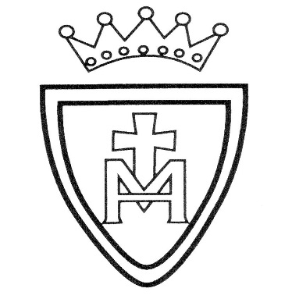
L
In Religion,
children explore Lent as a special time for reflection, repentance, and making better choices. They learn about Jesus’ temptation in the desert and what this teaches Christians about resisting temptation and growing in faith. Pupils also study key practices such as Ash Wednesday, prayer, fasting and generosity, understanding how these help believers prepare for Easter. Throughout the unit, they reflect on their own actions and consider ways they can show kindness, self-discipline and compassion towards others.

English:
We will be reading a range of texts about life during the Second World War, exploring personal experiences and key historical events. Children will use these accounts to inspire their own writing, including:
- Diary entries showing the thoughts and feelings of people living through wartime events
- Newspaper reports describing significant moments with clarity and accuracy
- Explanation texts about life on the Home Front and how people adapted to challenging conditions
They will focus on using powerful and historically appropriate vocabulary, linking ideas clearly, and writing sentences that flow smoothly while reflecting the tone of the period.

Maths: translation, algebra, time problems, mental and written methods for addition, subtraction, multiplication and division shape and ratio. SATs revision

Science: The Heart and circulatory system
St. Mary’s R.C. Primary School Learning Plan
Year 6 Spring 2

- History – World War II
- Why World War II started
- How the war affected people’s lives
- The Battle of Britain
- Evacuation and what it meant for families
- Local history: Eccles during the Second World War

Art
Children will explore World War II fashion and develop their drawing skills by:
Observing details closely
Using different textures
Showing depth and space in their work
Choosing lines, tones, shapes, and colours to show movement Music Children will continue learning an instrument as part of the MAPAS wider opportunity project.
Home Learning Opportunities
- Research the Second World War
- Practise all your times tables and spellings
- Practise Year 5/6 Spelling List words.
- Classroom Secrets Kids
