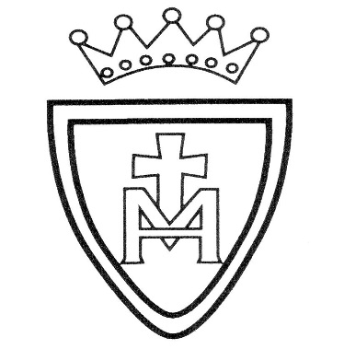
St. Mary’s R.C. Primary School Learning Plan
Year 4 Spring 2

RE: Desert to Garden. The children will explore and recall the words and actions of Jesus at The Last Supper. They will make links with his words and actions in the miracle of loaves and Mass. We will be looking at how Eucharist is the meeting point, where God gives himself to communicants as food to become more united in our faith.
English: Within our poetry, we will be looking at poems around the theme of ‘school’. Children will learn to use a varied and rich vocabulary when crafting their own poems around this theme. They will explore how to perform poetry and use their voice in different ways. We will also be reading and discussing, ‘The Last Bear’ by Hannah Gold. Children will learn how to create their own non-chonological report about polar bears and creative varying types of narratives around setting descriptions and characters within the book.
Maths: Children will learn about place value. They will work on addition, subtraction and division both written and mental calculations. Children will learn about time and solving problems involving time. Children will learn about different measurements of length.
Science: Sound. Children will identify how sounds are made, recognise vibrations from sounds travel through a medium to the ear and find patterns between volume of a sound and strength of the vibrations that produced it. Children will learn to find patterns between the pitch of a sound and features of the object that produced it.

Topic: Anglo- Saxons and Scots- History. Children will learn who Anglo-Saxons and Scots were. They will learn when and why they invaded Britain. They will learn key features of life in Anglo-Saxon Britain. They will learn all about different artefacts that have been discovered.

PE: Swimming. The children will develop their confidence in swimming and skills.

Art: Painting. Children will learn how to mix different colours and shades in paint. Children will create their own printed design. Children will learn about designers such as Orla Kiely throughout this unit.

RHE: Emotional Wellbeing. Children will learn about the difference between feelings and actions, how to manage them and what they can do to help themselves stay emotionally healthy.
https://www.tentenresources.co.uk/parent-portal/life-to-the-full-plus/what-am-i-feeling/
https://www.tentenresources.co.uk/parent-portal/life-to-the-full-plus/what-am-i-looking-at/
https://www.tentenresources.co.uk/parent-portal/life-to-the-full-plus/i-am-thankful/

https://www.tentenresources.co.uk/parent-portal/life-to-the-full-plus/what-am-i-feeling/ | https://www.tentenresources.co.uk/parent-portal/life-to-the-full-plus/what-am-i-looking-at/ | https://www.tentenresources.co.uk/parent-portal/life-to-the-full-plus/i-am-thankful/

Ideas for home learning:
- Practise your times tables and spellings.
- History topic homework.
- Talk about the time, use clocks regularly.
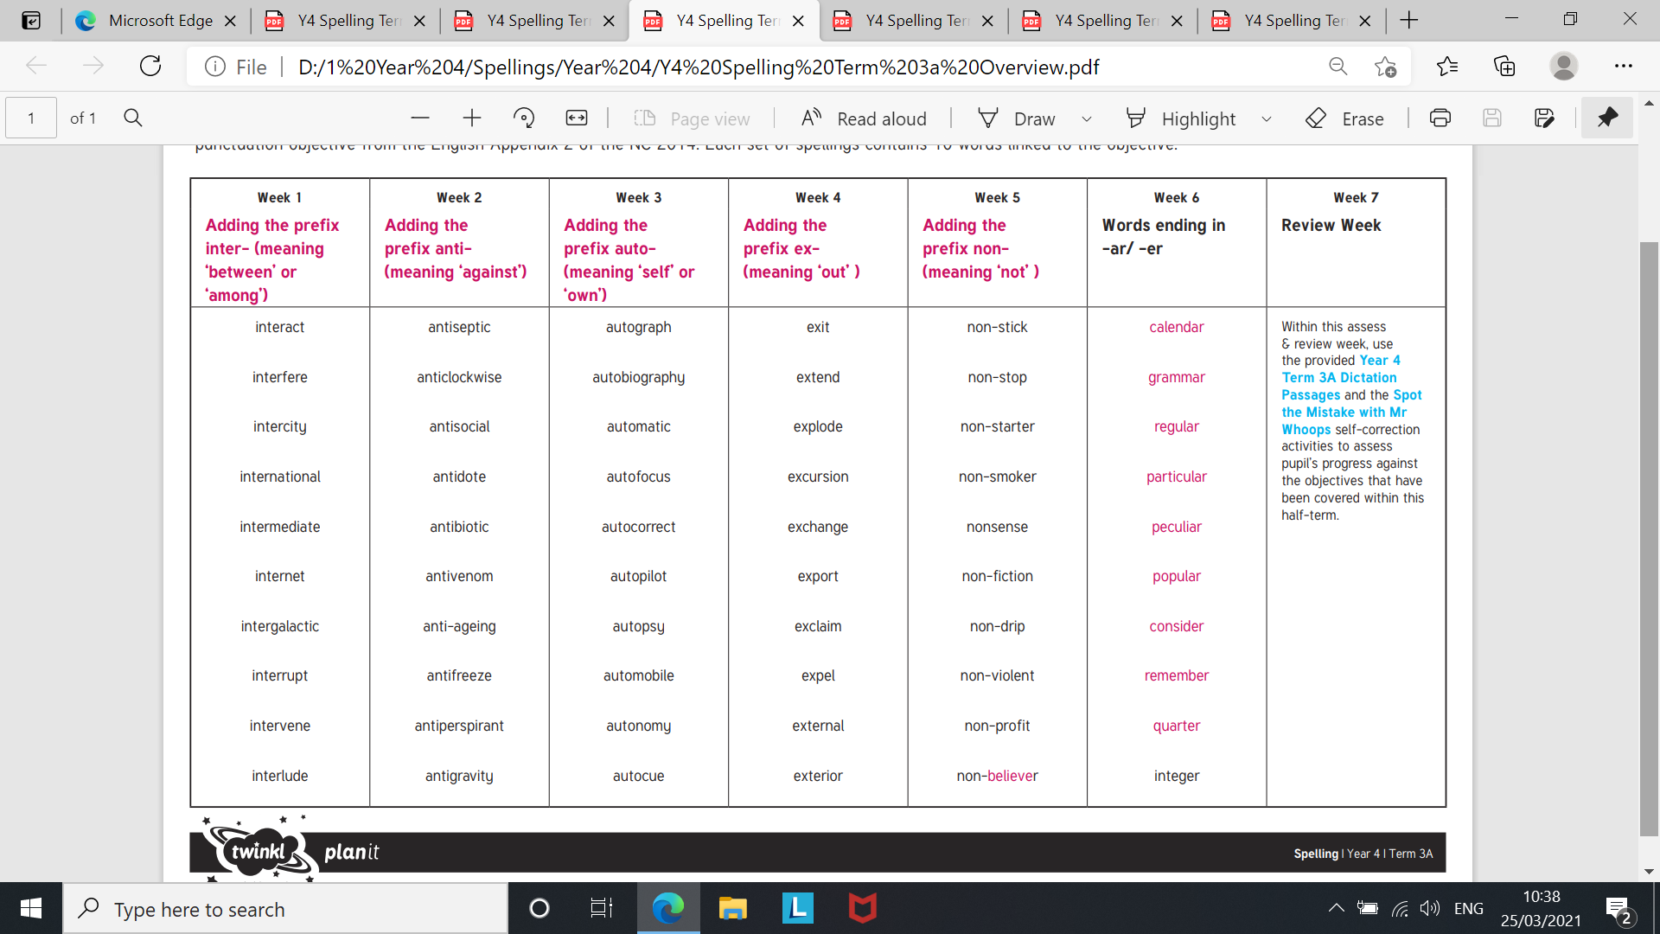
These are the spellings for each week up to the Easter holidays
