
RE: Desert to Garden
Recall the words & actions of Jesus at the Last Supper and make simple links with his words and actions in the miracle of Feeding the 5000. Describe how Jesus showed his love at the Last Supper and how he shares this love when people celebrate their first Eucharist (First Holy Communion).
Make links between the story of the Last Supper & the Mass, giving reasons for these links.
Recognise that the Church teaches that the Eucharist is the meeting point where God gives himself to communicants as food; they receive the Body of Christ & become ever more united in his Body the Church
Describe prayers, religious signs, and actions of the Mass, focusing on the Liturgy of the Eucharist and begin to give reasons for some of the actions and symbols used and beliefs.
English: Big Blue Whale by Nicola Davies & The Morning I Met a Whale by Michael Morpurgo:
- Participate in discussions, presentations, performances, role play, improvisations and debates
- Write an informative article about whales persuading for the protection of the blue whale
- Include a fact file about other endangered sea creatures
Maths: place Value (understand place value in a 3-digit numbers, separating into H,T,U) Addition and Subtraction, (adding two 3 digit numbers using vertical addition, subtracting 3 digit numbers by counting up)) Time (reading time to a minute on a digital and analogue clock), Double and halve numbers up to 100, use the grid method to multiply 2 digit numbers

Science: Forces: Identify forces as pushes and pulls; describe friction as a force that slows objects down, compare how things move in different surfaces; gather and record data to find answers to questions.

St. St. Mary’s R.C. Primary School Learning Plan
Year 3 Spring 2
Topics:
History - Local history – Rainhill Trials & George Stephenson: What was the local area like in the past? How does its location in the UK affect how the area is used? How did the Industrial Revolution impact the local area.
D.T- Wearable Technology
Music- listen and appraise ‘’Dirty Old Town”, along with various other songs from popular culture and learn the lyrics. To learn cords on the ukulele and how to strum the strings to play an accompaniment in time to the song. 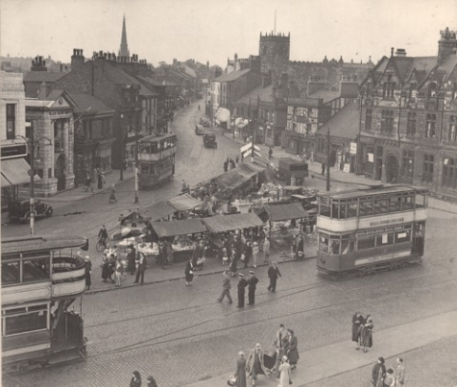 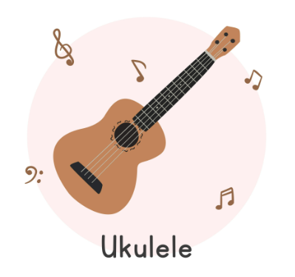 


Home Learning Opportunities:
- Research the history of your local area
- Practise all your spellings from the half term list each week
- Practise your times tables, try to increase your speed of recall and also learn the linked division facts.
- Practise & rehearse playing the pieces taught in ukulele lessons to master each chord and timings.

