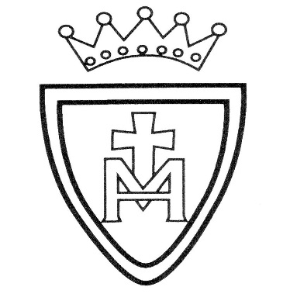
Geography: Polar Regions
Children will use maps and globes to locate the North and South Pole. They will find out what the climate is like in these areas. They will learn about features of these places such as animals and inhabitants living there.
D.T: The children will learn about structures. They will make and join materials to make a windmill.

Music: Children will complete the unit ‘round and round.’ Listen and appraise; learn about rhythm. Use untuned percussion instruments to play along in time.
Home Learning Opportunities

- Look at maps and locate countries.
- Watch nature programmes about Polar Regions such as BBC’s Natural World or cbeebies ‘Andy’s Adventures.’
- When out and about look at different structures such as bridges and talk about them.
RE: Desert to Garden
The focus of this branch is to learn a little about the season of Lent as a time to prepare for Easter. To know the story of the last week of Jesus’ life, his death, and resurrection. Children will experience Lent traditions as part of the school’s prayer life and through the charitable activities in Lent as part of a school’s Catholic life

English: Fiction reading and writing based on ‘adventure’ stories; children will develop comprehension skills by predicting what may happen next and using inference to understand what has happened so far. They will learn and recite poems. They will begin to write short narratives and they will develop the ability to read their work to check that it makes sense and is punctuated correctly.

Maths: Children will embed understanding of 2-digit numbers and place value; consolidate recall of number facts and apply these when solving word problems; carry out addition and subtraction using unit patterns and other strategies.

Science: As part of the unit on ‘animals and living things’ children will learn six main animal groups and they will begin to learn about their features. They will name and identify a range of common animals from each group. They will learn about different ways to classify, sort and group animals.

P.E: Gymnastics and futsal

St. Mary’s R.C. Primary School Learning Plan
Year 1 Spring 2 