

St. Lawrence Church of England
Primary School

HANDWRITING POLICY
SEPTEMBER 2026

Approved by: David Oludotun Fasanya (Chair of Governors)
Last reviewed on: September 2026
Next review on: September 2027

CONTENTS

1. Introduction and Rationale

2. Aims and Objectives

3. The Handwriting Approach at St Lawrence

4. Handwriting in the Curriculum

5. Early Physical Development

6. Development of Handwriting in the EYFS

7. Agreed Language

8. Ready to Write Expectations

9. Teaching and Learning

10. Organisation of Teaching

11. Exercise Books and Line Progression

12. Use of Pens

13. Provision for Left-Handed Pupils

14. Provision for Pupils with SEND

15. Intervention and Support

16. Assessment and Progression

17. Partnership with Parents

18. Appendices

1. Introduction and Rationale
Handwriting is a fundamental component of literacy and underpins pupils' success as writers. We recognise that fluent, legible and automatic handwriting enables pupils to focus on composing, vocabulary and the communication of ideas, rather than the physical act of writing. At St Lawrence, handwriting is taught explicitly, cumulatively and engagingly from Reception to Year 6, following a clear progression of skills. Through consistent teaching, modelling and practice, we aim to ensure that all pupils develop the fluency, confidence and independence needed to become successful writers.

2. Aims and Objectives
Our aims are to:
- Develop fluent, automatic and legible handwriting.
- Establish correct letter formation from the earliest stages.
- Provide pupils with the physical foundations necessary for successful handwriting.
- Promote pride in presentation across the curriculum.
- Ensure a consistent approach to handwriting throughout the school.
- Support all pupils in meeting age-related expectations.
- Enable pupils to write efficiently so that they can focus on composition and the communication of ideas.

3. The Handwriting Approach at St. Lawrence
At St Lawrence, handwriting is taught through a structured progression that ensures skills are built cumulatively from Reception to Year 6. Learning is carefully sequenced and revisited regularly so that pupils develop increasing accuracy, fluency and stamina.
Teachers provide explicit instruction, effective modelling and opportunities for purposeful practice. Handwriting expectations are reinforced across the curriculum to ensure consistency and application.

4. Handwriting in the Curriculum
Handwriting is taught as a discrete skill and is practised across all curriculum areas. Expectations for presentation, letter formation and handwriting quality apply consistently in all subjects.
All staff model the agreed handwriting style and reinforce expectations during everyday teaching.

5. Early Physical Development
We recognise that successful handwriting begins with strong physical development. Throughout the EYFS and Key Stage 1, pupils are provided with opportunities to develop:
- Gross motor skills
- Fine motor skills
- Core strength and stability
- Hand and finger strength
- Coordination and spatial awareness
These foundational skills support pupils in developing efficient and comfortable handwriting habits.

6. Development of Handwriting in the EYFS
Children begin by developing mark-making skills through a range of engaging and purposeful activities. Handwriting instruction focuses on:
- Developing pencil control
- Correct pencil grip
- Establishing hand dominance
- Learning correct letter formation
- Building confidence and stamina
Children are provided with regular opportunities to practise and apply these skills as they become ready for more formal handwriting tasks.

7. Agreed Language
To ensure consistency across the school, staff and pupils use shared handwriting terminology. This includes:
- Upper case letters
- Lower case letters
- Ascenders
- Descenders
- Short letters
- Letter bodies
- Horizontal and diagonal joins
Consistent use of this language supports pupils in understanding handwriting expectations and enables teachers to give clear, precise feedback.
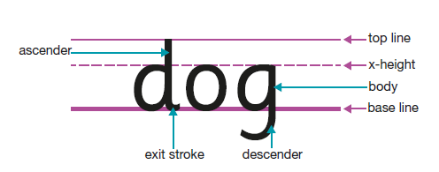

8. Ready to Write Expectations
Before handwriting activities, teachers ensure pupils are ready to write by reinforcing expectations for:
- Sitting position
- Foot placement
- Paper position
- Pencil grip
- Appropriate posture
These routines help pupils develop efficient and comfortable writing habits. All staff and children in KS1 and lower KS2 as needed use this check before writing:
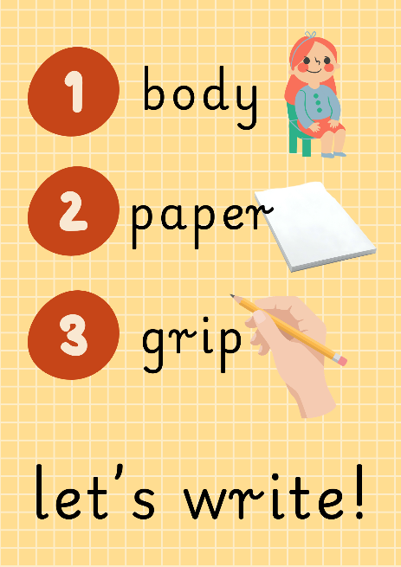

9. Teaching and Learning
Handwriting is taught explicitly through modelling, guided practice and independent application.
Teachers:
- Model correct letter formation.
- Provide clear explanations and demonstrations.
- Give immediate feedback.
- Address misconceptions quickly.
- Provide regular opportunities for rehearsal and practice.
Learning is designed to be engaging and purposeful while ensuring sufficient repetition to develop automaticity.

10. Organisation of Teaching
Handwriting is taught regularly throughout the school. Teaching is adapted to meet the developmental stage and needs of pupils.
Where appropriate, pupils receive additional support to secure key skills before moving on to new learning.

11. Exercise Books and Line Progression
At St Lawrence, we generally follow a progressive approach to the use of paper and line guides, moving from blank paper to standard exercise book lines as pupils develop confidence and fluency in handwriting. However, we recognise that children develop at different rates and, where appropriate, adaptations will be made to ensure that each pupil is provided with the level of support that best meets their individual needs.
The progression typically follows:
- Blank paper for early mark-making and letter formation.
- A single baseline for letters to sit upon.
- Feint lines with sufficient space for ascenders and capital letters.
- Double lines to support understanding of letter size and alignment.
- Standard exercise book lines as fluency develops.

12. Use of Pens
Children are encouraged to use a range of writing tools and, as their handwriting becomes increasingly fluent and well-presented, to write in pen. At St Lawrence, pupils in Year 4 may begin using a pen when they consistently meet year group expectations for handwriting, including accurate letter formation, sizing, spacing and presentation.

13. Provision for Left-Handed Pupils
Left-handed pupils are supported to develop an efficient writing position and grip. Staff provide appropriate guidance on paper position, pencil grip and posture to ensure comfort and promote fluent handwriting.

14. Provision for Pupils with SEND
We recognise that some pupils may require additional support to develop handwriting skills. Adaptations may include:
- Alternative resources
- Additional modelling and guided practice
- Modified line spacing
- Fine motor interventions
- Access to assistive technology where appropriate
Provision is tailored to individual needs.

15. Intervention and Support
Pupils who require additional support receive timely intervention to address identified areas of difficulty. Intervention focuses on securing foundational skills and developing confidence, accuracy and fluency.
Progress is monitored regularly and support is adapted in response to need. See Appendix for more information.

16. Assessment and Progression
Teachers assess handwriting through ongoing observation of pupils' work across the curriculum. Assessment focuses on:
- Letter formation
- Size and orientation
- Spacing
- Consistency
- Fluency
- Presentation
Assessment information is used to inform future teaching and intervention.

18. Appendices

Appendix A

EYFS

Taught daily x 5 - 10 minutes with provision for the development of fine and gross motor skills in the areas

Teaching sequence: Revisit and review, Teach. Practise will be either adult led or in the areas of provision

Prior to and working alongside the development of letter formation, children in the EYFS will have access to both fine and gross motor skill activities, that are both child initiated and adult supported. To support the development of fine motor skills, and to assess the children’s pre-writing skills, teachers and support staff may choose to use:

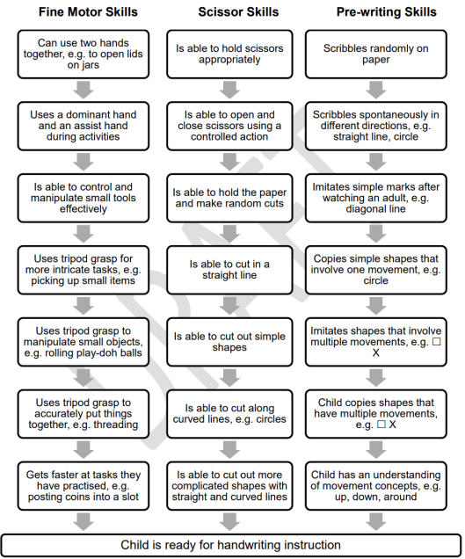

Pencil control - directionality

Teachers consider the concept of ‘directionality’ when promoting positive handwriting habitats. This means the ability of the child to control the change in direction of the pencil on the page. They will plan in opportunities for this. Some of these are listed below.

Pencil grip development

Children in reception will be provided with a range of mark making and writing opportunities that are both adult supported and child initiated. The children will be encouraged to explore a variety of pencil grips through mark making opportunities using a variety of different media. The children will be supported to achieving an appropriate pencil grip for their level of development, leading to improved and accurate letter formation. Throughout the year, teachers and support staff will assess the children through observation and they will identify children who may need intervention for fine motor support. Children will always be encouraged to use a tripod grid when they are deemed developmentally ready. Below you will find a progression grid for pencil grip development.

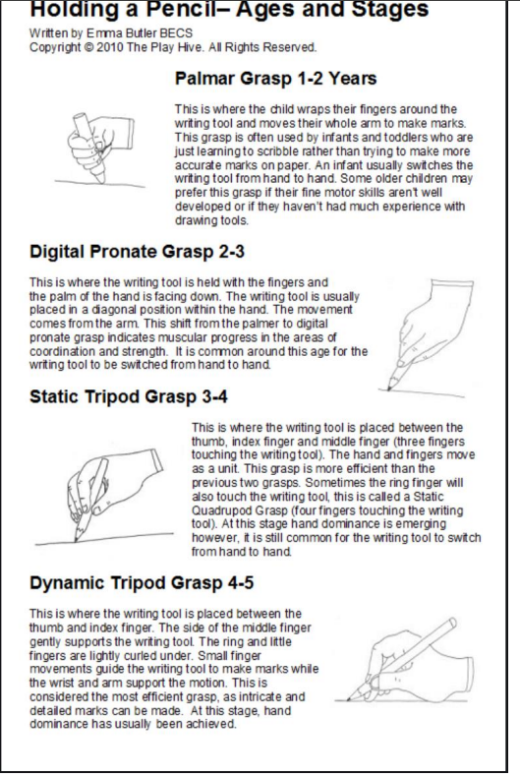

Mark making skills - handwriting patterns

Children in reception will be encouraged to access both child initiated and adult directed mark making activities that are cross-curricular. The children will have access to multi-sensory activities, including dough disco and outdoor writing opportunities, to also develop a positive attitude towards mark making and the development of early handwriting skills. Children may also be encouraged to work on an upright surface for shoulder and core strength. As part of this provision, children will be encouraged to make the following patterns to support the development of letter formation skills.

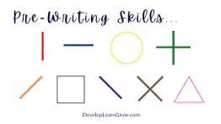

Mark-making is skill that needs to be taught. We follow EEF guidance that states the most effective approaches for physical development in mark making are through the teacher:
- preparing
- modelling
- narrating
- demonstrating
- using memory prompts
- commenting
- repeating for over-learning

Continuous Provision
Opportunities to develop the foundations for handwriting are embedded throughout the continuous provision. Resources and experiences are carefully planned and layered to match and extend children’s developing skills, ensuring progression across the year. Children are provided with frequent opportunities to strengthen fine and gross motor control, develop pencil grip, build hand strength and engage in purposeful mark-making through a range of indoor and outdoor activities. These experiences support the development of the physical skills and confidence needed for successful handwriting.

Autumn 1 | Physical Development  Gross motor activities  Hand and arm strengthening activities  These may include:  - Body shapes  - Dancing  - Shoulder strengthening through large scale air writing  - Travelling in different ways  - Balancing  - Crawling and commando crawling  - Climbing  - Colour on tummies on floor  - Drawing and writing on tummies on floor  - Dough disco  - Lego / K’nex  - Cutting and tearing  - Threading  - Zips and buttons  - Nuts and bolts  - Finger painting  - Stamping using stamps  - Bridget Riley (lines)
Autumn 2 | As above plus:  Gross motor activities  Hand and arm strengthening activities plus  Fine motor activities which may include:  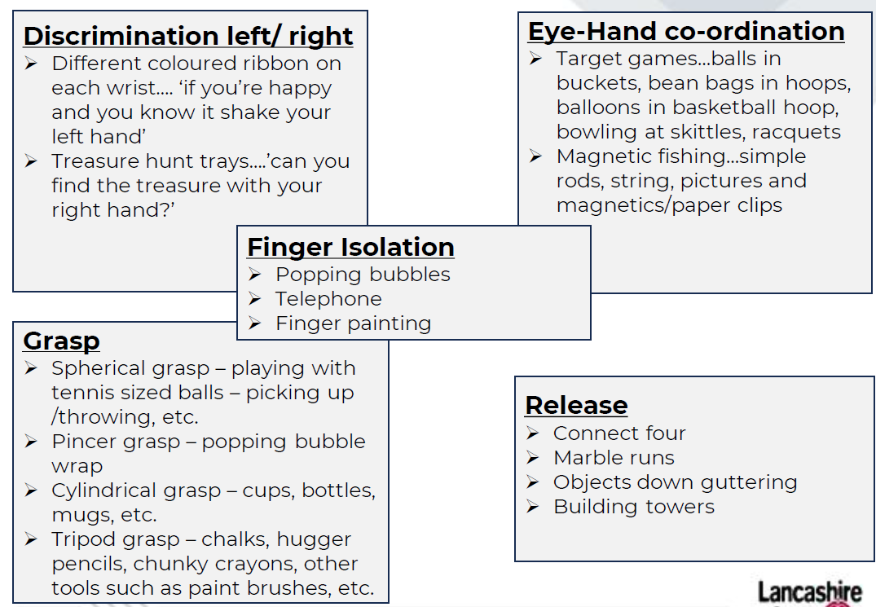  Plus directionality activities  These may include:  - Direct me: obstacle course  - Follow me: lights and ribbons - phonics  - Junk modelling: ‘put the tube behind the pot’  - Preposition action figures  - Art  Plus Pre-writing shape activities  These may include:  - Artwork inspired by Kandinsky (circles - triangles),  - Tracing lines and shapes (some use of Write Well scheme here)  - Tracing pictures  - Making shapes in surfaces such as sand, glitter, foam etc.
Spring 1 | Above activities will continue for as long as children require. Children will start to learn formal handwriting when they are developmentally ready (see appendix).  ‘Long Ladder Letters’  I, j, l, t, u, y  Children will learn to form these letters correctly using Red Rose patter.  - Activities may include:  - Gross motor skills to make the pre-cursor shape  - Multi-sensory / gross motor to write the letter using Red Rose patter  - Writing letter in large format, e.g. chalk, pens, paint.  - Whiteboards (especially teacher whiteboard)  - In books
Spring 2 | ‘Right Armed Robot Letters’  b, h, k, m, n, p, r
Summer 1 | Curly Caterpillar Letters’  c, a, d, e, g, q, o
Summer 2 | ‘Zig-zag letters’  v, w, x, z

EYFS Progression - expectations
Autumn | Spring | Summer
Demonstrate pre-phonemic writing:  -patterns  - pictures  - random scribbling  - scribble writing  - symbols that represent letters  - random letters or numerals  - letter strings (continuous string of letters, symbols or numerals)  - letter groups (groups of letters, symbols or numerals including spaces)-environmental print.  Use some recognisable letters and symbols.  Use handwriting patter/phrase to support formation, if appropriate. | Form letters from their name correctly.  Form some capital letters correctly, including the initial letter of their name.  Form some lower-case letters correctly; starting and finishing in the right place, going the right way round, correctly orientated.  Make marks, drawings and symbols with increasing control. | Begin to write on the lines with some control of letter size.  Hold paper in position, and use preferred hand for writing, developing a comfortable pencil grip.  Form lower-case letters with developing consistency.  Begin to form clear ascenders ('tall letters') and descenders ('tails') to write recognisable letters.  Write left to right and top to bottom.  Hold writing tools and implements with a developing grip, using an appropriate amount of pressure.

Year 1

Taught daily x 20 minutes

Teaching sequence: Revisit and review, Teach, Practise, Apply (end of week)

Monday: Gross motor skills to make the pre-cursor shape
Tuesday: Multi-sensory gross motor to write letter using Red Rose patter
Wednesday: Writing letter in large format, e.g. chalk, pens, paint.
Thursday: Whiteboards and correct misconceptions
Friday: In books, using handwriting lines

Red Rose Patter for formation phrases

Supported by Write Well Book 5 – Letter size and position

Key vocabulary: ascenders, descenders, anti-clockwise, line

Autumn 1 | ‘Curly Caterpillar Letters’  c, a, d, e, g, q, o plus s and f  Digits: 0, 6, 8 and 9
Autumn 2 | ‘Bridging Letters’  s, f  ‘Long Ladder Letters’  I, j, l, t, u, y  Digits: 1 and 4
Spring 1 | ‘Right Armed Robot Letters’  b, h, k, m, n, p, r  Digits: 2, 3 and 5
Spring 2 | ‘Zig-zag letters’  v, w, x, z  Digits: 7
Summer 1 | Capital letters  Letter size and position
Summer 2 | Spacing within words  Spacing between words

Year 2

Taught daily x 10 minutes

Teaching sequence: Revisit and review, Teach, Practise, Apply (end of week)

Monday: Gross motor skills to create the letter shape / join in large or multi-sensory format using Red Rose patter
Tuesday: Practising letters / joins on laminated handwriting sentence strips
Wednesday: In book, using handwriting lines – Try it
Thursday: In books, using handwriting lines – Practise it
Friday: In books, using handwriting lines – Apply it

Red Rose Patter for formation phrases

Supported by Write Well Book 6 – First Joining and Write Well Book 7 – More Joining

Key vocabulary: diagonal join, horizontal join, break letters, ascenders, descenders

Autumn 1 | - Revising Letter Shapes  This phase will continue until at least 80% of children are securely forming appropriately sized letters correctly, with clear ascenders and descenders and placing them on the line.  Any of the 20% children who are not ready to move on will receive systematic intervention at this point.  - Joining Patterns  - The diagonal join to r, n, m  - The diagonal join to i and u  - Revisiting the diagonal join to r, n, m, i, u  - The diagonal join to l, h, k
Autumn 2 | - Joining three letters  - The diagonal join to a, c, o  - Practising the join to a, c, o  - Joining words with diagonal joins
Spring 1 | - The horizontal join to r, n, m  - The horizontal join to i and u  - The horizontal join to l, h, k  - The horizontal join to a, c, o  - Joining words
Spring 2 | - The diagonal join to v and w  - The diagonal join to p and y  - The diagonal join to b and t  - The diagonal join to d and g  - The diagonal join to e
Summer 1 | - Joining words with diagonal joins  - The horizontal join to v and w  - The horizontal join to p and y  - The horizontal join to b and t  - The horizontal join to d and g
Summer 2 | - The horizontal join to e  - Joining words  - Starting with break letters  - Break letters within words  - Punctuation focus

Year 3

Taught x2 weekly
20 minutes

Teaching sequence: Revisit and review, Teach, Practise, Apply (end of week)

Lesson 1: Try it 1 and 2
Lesson 2: Practice and apply it

Red Rose Patter for formation phrases

Supported by Write Well Book 8 – Confident Joining

Key vocabulary: diagonal join, horizontal join, break letters, ascenders, descenders, straight letters, letter strings, double letters, prefix, suffix, compound words, direct speech

Autumn 1 | - Joining words  - Joining from r to straight letters  - Joining from r to round letters
Autumn 2 | - Joining to s  - Joining to f
Spring 1 | - Joining from f to straight letters  - Joining from f to round letters  - Joining difficult double letters
Spring 2 | - Joining letter strings with r  - The break letters g, q, y, j, p, b, s
Summer 1 | - The break letters x and z  - Joining compound words
Summer 2 | - Joining words with prefixes  - Joining words with suffixes  - Joining in direct speech

Year 4
Children are encouraged to use a range of writing tools and, as their handwriting becomes increasingly fluent and well-presented, to write in pen. At St Lawrence, pupils in Year 4 may begin using a pen when they consistently meet year group expectations for handwriting, including accurate letter formation, sizing, spacing and presentation.

Taught x2 weekly
20 minutes

Teaching sequence: Revisit and review, Teach, Practise, Apply (end of week)

Lesson 1: Try it 1 and 2
Lesson 2: Practice and apply it

Red Rose Patter for formation phrases

Supported by Write Well Book 9 – Fluency

Key vocabulary: consistent, position, spacing, parallel, downstrokes, ascenders, descenders, fluent, prefix, suffix

Autumn 1 | - Fluent handwriting  - Fluent joining  - Clear letter shapes
Autumn 2 | - Consistent letter size  - Consistent position
Spring 1 | - Checking spacing within words  - Parallel downstrokes  - Parallel ascenders
Spring 2 | - Parallel descenders  - Pen lifts after break letters
Summer 1 | - Fluent joining in longer words  - Joining words with prefixes
Summer 2 | - Joining words with suffixes  - Word and line spacing  - Writing fluently

Year 5

Taught x2 weekly
20 minutes

Teaching sequence: Revisit and review, Teach, Practise, Apply (end of week)

Lesson 1: Try it 1 and 2
Lesson 2: Practice and apply it

Red Rose Patter for formation phrases

Supported by Write Well Book 10 – Speed

Key vocabulary: legible, slant, speed, purpose, abbreviations, notes
Autumn 1 | - Joining for speed  - Fast and legible handwriting  - Check your writing speed
Autumn 2 | - Tools and tips for speed  - Eradicating problems with writing at speed
Spring 1 | - Practising for speed  - Looping for speed  - Speedy joining from b and p
Spring 2 | - Speedy joining from s  - Shortcut joins for speed
Summer 1 | - Slanting for speed  - Different speeds for different purposes
Summer 2 | - Taking notes  - Using abbreviations  - Check your writing speed

Year 6

Taught x2 weekly
20 minutes

Teaching sequence: Revisit and review, Teach, Practise, Apply (end of week)

Lesson 1: Try it 1 and 2
Lesson 2: Practice and apply it

Red Rose Patter for formation phrases

Supported by Write Well Book 11 – Style

Key vocabulary: personal style, looping, printing, slanting, decorative, calligraphy, proofreading, punctuation, black capitals

Autumn 1 | - Your own personal style  - Looping for style  - Joining break letters b, p, s
Autumn 2 | - Joining break letters q, z, x  - Rounded v and w  - Slanting for style
Spring 1 | - Printing  - Block capitals  - Choosing writing tools
Spring 2 | - Decorative lettering  - Calligraphy  - Choosing your standard of handwriting
Summer 1 | - Your best handwriting  - Proofreading and punctuation
Summer 2 | - Presentation and layout

Appendix B
Letter Formation Guidance
All teachers and children use these agreed formation phrases.
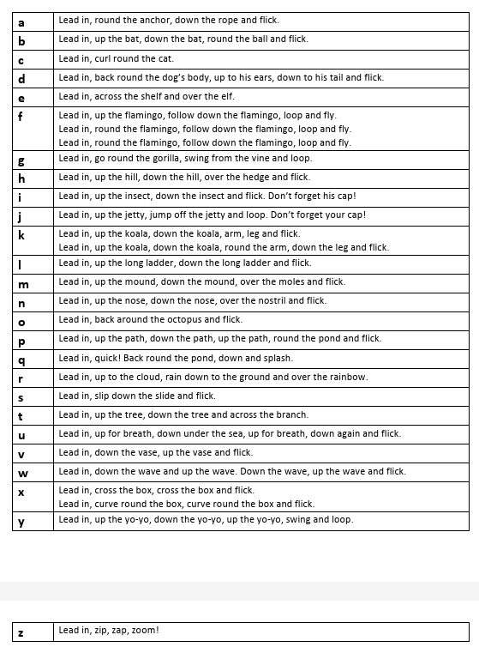

Appendix C
Intervention Programmes and Resources
Early Intervention
Children who do not reach age-appropriate handwriting milestones require early, well-targeted intervention so gaps do not widen and working memory is not overloaded as writing demands increase. Both The Writing Framework (2025) and Ofsted’s Strong Foundations in the First Years of School emphasise that early identification and responsive action are critical, particularly where weaknesses in core strength, fine motor control, pencil grip, or letter formation are evident.

Effective early intervention begins with strengthening the gross and fine motor foundations essential for handwriting—developing core stability, shoulder strength, bilateral coordination and finger dexterity through structured activities such as climbing, crawling, dough disco, threading and tool use.

Alongside motor development, children need explicit, supervised teaching to correct and embed accurate letter formation, ensuring they do not practise incorrect movements. Programmes such as Print Like a Pro, recommended in your staff documents, provide a systematic and highly visual approach that supports children in forming letters with correct directionality, starting points and sequencing.

