Curriculum Sequencing
EYFS Curriculum
At St Lawrence, we have designed an ambitious EYFS English curriculum that supports children in building knowledge, language and literacy skills progressively across the year. While our curriculum is carefully planned and sequenced to ensure progression towards the Early Learning Goals, we also recognise the importance of responding to children's individual needs, interests and stages of development. Therefore, opportunities are provided to follow children's interests in order to deepen engagement, motivation and learning. As a result, some texts—particularly supporting or linked texts—may change throughout the year to reflect the interests and needs of the children. Whilst children's interests help to shape and enrich learning experiences, they complement rather than replace our planned curriculum. Please see the EYFS website link for more information.

 | Autumn 1 | Autumn 2 | Spring 1 | Spring 2 | Summer 1 | Summer 2
Focus Texts | We’re Going on a Bear Hunt by Michael Rosen  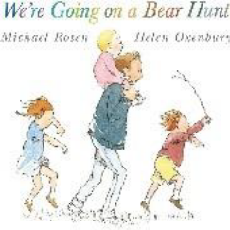  The Gruffalo by Julia Donaldson  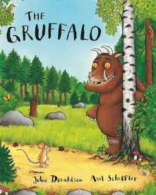 | The Enormous Turnip  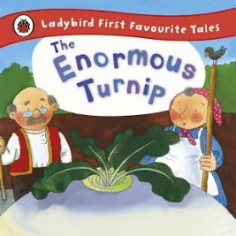  Stick Man by Julia Donaldson  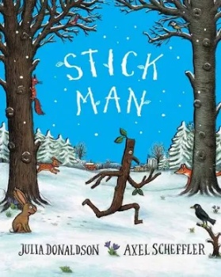 | The Three Little Pigs  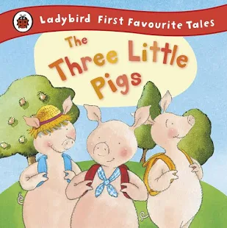  The Gingerbread Man  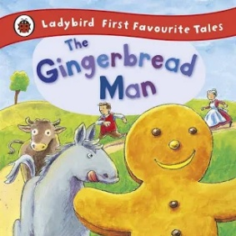 | What the Ladybird Heard by Julia Donaldson  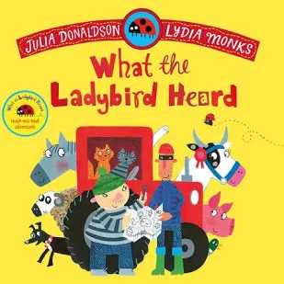  The Snail and the Whale by Julia Donaldson  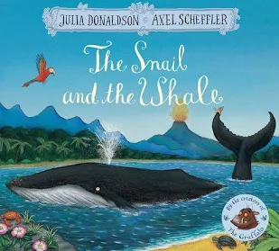 | Jack and the Beanstalk by Carly Gledhill  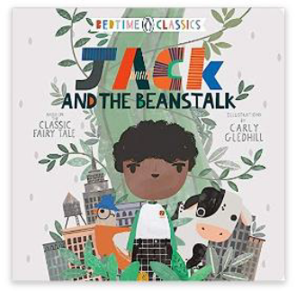  The Very Hungry Caterpillar by Eric Carle  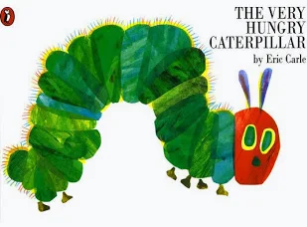 | The Three Billy Goat’s Gruff  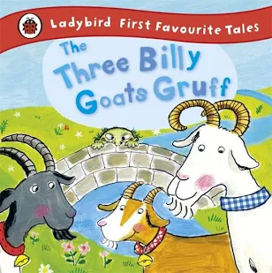  The Journey Home from Grandpa's – Jemima Lumley  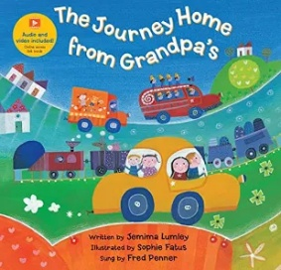
Link Texts | Fiction:  Rosies Hat  Rosie’s Walk  Owl babies  The squirrels who squabbled  The Lost Words  Non-fiction:  Why Do Leaves Fall from Trees  Tree (Seasons Come, Seasons Go)  Poetry/ Rhyme:  The Seasons | Fiction:  The Queens Handbag  The Queen’s Knickers  Paddington at the Palace  The Queens Lift off  The King’s Hat  Non-fiction:  Everything castles  King Charles  (Little People, Big Dreams)  Poetry/ Rhyme:  Humpty Dumpty | Fiction:  Eric Carle’s Book of Amazing Animals  Fabulous Frankie  Arlo the Lion Who Couldn’t Sleep  Harry and the Bucketful of Dinosaurs  The Hugasaurus  Non-fiction:  Mary Anning (Little Book, Big Dreams)  The Big Book of Beasts  First Facts Dinosaurs  Poetry/ Rhyme:  Down in the Jungle | Fiction:  Astro girl  Toys in Space  Beegu  Look Up  How to Catch a Star  Non-fiction:  Mae Jemison (Little People, Big Dreams)  Poetry/ Rhyme:  5 little men in a flying saucer | Fiction:  The Growing Story  The Bad Seed  Oliver’s Vegetables  Jasper’s Beanstalk  Grandpa’s Garden  Non-fiction:  Mama Miti  The Big Book of Blooms  Poetry/ Rhyme:  Incy Wincy Spider  Mary Had a Little Lamb | Fiction:  Mr Gumpy’s Motor Car  No Nancy No  Blown Away  The Journey Home  Non-fiction:  Ameila Earhart (Little People, Big Dreams)  Big Picture Atlas  Poetry/ Rhyme:  The Wheels on the Bus
Talk for Writing Opportunities | Repetition, actions, retelling, story maps, descriptive language, settings | Repetitive structure, characters, sequencing, problem/solution, changing settings | Traditional tales, repeated phrases, character voices, story structure, innovation | Setting, journeys, rhyme, descriptive vocabulary, maps and story innovation | Traditional tale, prediction, story structure, transformation, sequencing | Purpose: To create a class book called ‘The Naughty Bus Strikes Again!’
Year 1 Curriculum Map
 | Autumn 1 | Autumn 2 | Spring 1 | Spring 2 | Summer 1 | Summer 2
Focus Texts | The Train Ride by June Crebbin  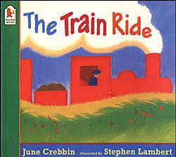  The Great Pet Sale by Mick Inkpen  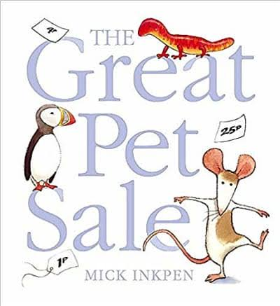 | Lost and Found by Oliver Jeffers  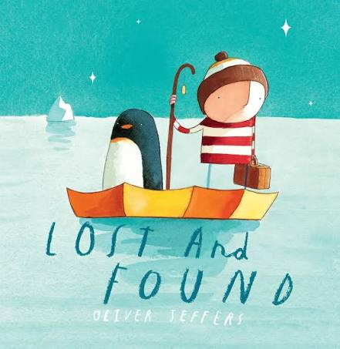  The Snowman by Raymond Briggs  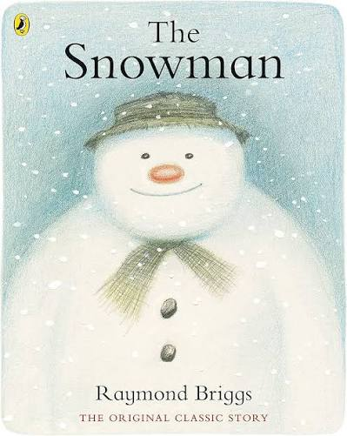 | Supertato by Sue Hendra  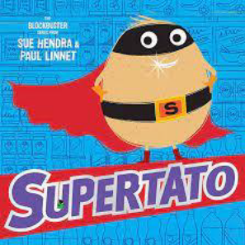 | Little people, Big dreams: Beatrix Potter by Maria Sanchez Vegars  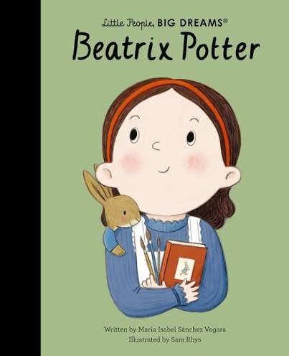 | Peter Rabbit by Beatrix Potter  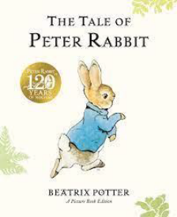 | How to Train a Train by Jason Carter  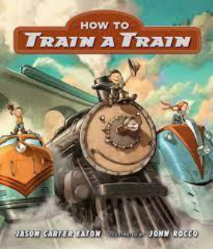
Link Texts | Fiction:  The Great Pet Sale by Mick Inkpen  The Train Ride by June Crebbin  Charlie Cook’s Favourite Book by Julia Donaldson  That’s Not My … books | Fiction:  How to catch a star by Oliver Jeffers  Handa’s Surprise  The Nativity Story  The Snail and the Whale by Julia Donaldson | Fiction:  -Supertato: Veggies Assemble. By Sue Hendra.  -Supertato: Night of the Living Veg.  -Supertato: Evil Pea Rules!  Non-Fiction:  Gruffalo Crumble and other recipes.  BBC Good Food Kids recipes. | Non-fiction:  Biographies of Beatrix Potter and Debbi Gliori | Fiction:  -The Tale of the Raddish Robber- BBC iplayer.  -Beatrix Potter stories.  Debi Gliori stories:  -The Tobermory Cat  -No Matter What.  -Bookworm. | Fiction:  Thomas the Tank Engine annuals.  Thomas the Tank Engine and Friends.  Non-fiction:  Steam Trains for Children- Gecko's  Real Vehicles (Youtube)  Trains for Children with Blippi- Steam Train Tour (Youtube)  National Geographic Kids Readers: Trains - Level 1.  See Inside Trains by Emily Bone and Colin King
Outcomes | Sentence structure:  Writing simple sentences including capital letter, finger spaces and full stops.  Information text:  Purpose: Information poster based on an animal using capital letters, finger spaces and full stops.  Poetry:  Purpose: To write an innovated poem based on Hickory Dickory Dock using punctuation to demarcate simple sentences | Sentence structure:  Writing simple sentences including capital letter, finger spaces and full stops.  Poems on a theme: Write own poem on the theme of winter | Narrative:  Purpose: Innovated story based on the plot pattern using adjectives to describe and the ’ed’ suffix.  Instructions:  Purpose: Write a set of instructions on how to trap the evil pea using the adverbs. | Information text:  Purpose: Write a fact file about Beatrix Potter using the conjunctions: and/but. | Narrative:  Purpose: Write their own version of the Radish Robber using capital letters for names and adjectives to describe.  Poetry: Write own poem based on the classics | Information text:  Purpose: Write an information guide on steam trains using the suffixes ‘er' and ‘est’.  Persuasive:  Purpose: Write a persuasive piece of writing using adjectives and suffixes to describe. Personal pronoun ‘I’.  Narrative:  Purpose: To write a story based on ‘Thomas Goes Crash!’ using the skills previously taught this year.
Year 2 Curriculum Map
 | Autumn 1 | Autumn 2 | Spring1 | Spring 2 | Summer 1 | Summer 2
Focus texts | The Way Home for Wolf  The Way Home for Wolf by Rachel Bright  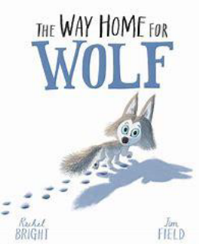  National Geographic Kids: Wolves  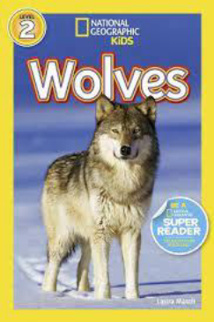 | Twisted Fairy Tales  The Great Fairy Tale disaster by David Conway, illustrated by Melanie Williamson  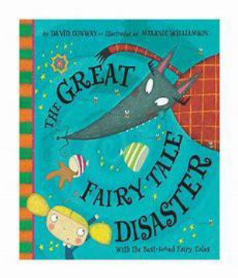 | 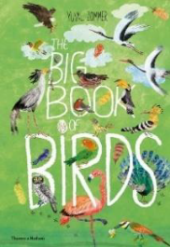  The Big Book of Birds by Thomas Hudson  Nature Guide: Birds  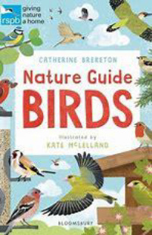 | Amazing Birds!  Various leaflets for local wildlife attractions   Amazing Birds! The Owl who was Afraid of the Dark by Jill Tomlinson  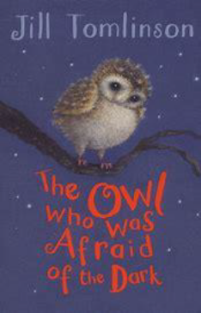 | Classic Fiction:  Wind in the Willows by Kenneth Grahame  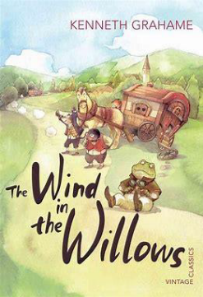  Classic Poetry: Duck’s Ditty by Kenneth Grahame  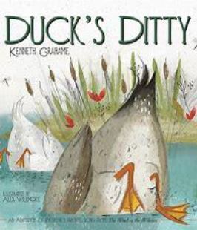 | Last Push Pack Aladdin  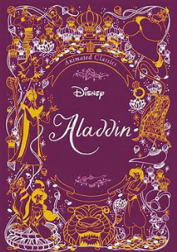
Link texts | Fiction  The Last Wolf  Wolves  Little Red Riding Hood  The Three Little Pigs  The Boy Who Cried Wolf  Peter and the Wolf  The Wolves Who Came for Dinner  Wolf in the Snow  Non Fiction  National Geographic Kids: Roar!  100 Fun Facts about African Animals  A World Full of Animal Stories  National Geographic Kids Puzzle Book  Poetry  Rumble in the Jungle by Giles Andreae (poetry) | Fiction  Cinderella  The Gingerbread Man  Snow White  The Jolly Postman  The True Story of the Three Little Pigs  Snow White in New York  Seriously, Cinderella is so annoying  Honestly, Red Riding Hood is so Rotten  Jack and the Baked Beanstalk.  The three little wolves and the big bad pig  Poetry  Revolting Rhymes | Non Fiction  National Geographic: Owls  National Trust Out and about: Bird spotter  Poetry  Poem: Day and Night by David Windle | Non Fiction  Various leaflets for local attractions. | Fiction  Brer Rabbit Joel Chandler Harris  The reluctant dragon  Poetry The Owl and the Pussycat  The Ugly Duckling | Fiction  Aladdin movie (2019)  Aladdin Movie (1992)
Outcomes | Narrative  Purpose: to write an innovated story including punctuation for simple and compound sentences using and, but, so and or (co-ordination).  Information text  Purpose:  An information page on a chosen animal using the correct punctuation and a variety of sentences (statements, questions, exclamations etc) | Traditional tale with a twist  Purpose: to write an innovated twisted fairly tale including adjectives, noun phrases and subordination for time (when, before and after) | Stories with a theme  Purpose: To write a new chapter of the ‘Owl who was Afraid of the Dark’ including sentence demarcation, subordination for reason using because  Non-chronological- reports  Purpose: to write a non-chronological report using: Subordination for reason (because), sentence demarcation, conjunctions to extend ideas and to use subheadings to present information | Persuasion  Purpose: to write a persuasive leaflet for their own wildlife attraction including present tense verbs, commas in a list . subordination for time and subordination- when before and after (revision) | Classic Narratives  Purpose: to write their own animal adventure story/chapter based on a model, which includes:  Subordination for time and reason.  The suffix –ly to turn adjectives into adverbs.  Features of animal adventure stories.  Classic poems  Purpose: Children will be able to recite a classic poem by heart.  Children will be able to write their own verse of poetry based on a classic poem, including:  The effective use of adjectives.  The effective use of verbs. | Non-fiction (a selection of different genres)  Purpose: to write a variety of text types with application of taught grammar skills including subordination, co-ordination, past and present tense, commas in a list, commands, statements and exclamations and noun phrases
Year 3 Curriculum Map
 | Autumn 1 | Autumn 2 | Spring 1 | Spring 2 | Summer 1 | Summer 2
Focus Texts | A Bear Called Paddington  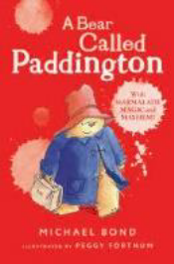  A Bear Called Paddington by Michael Bond  Look Inside London by Jonathan Melmoth (Usborne)  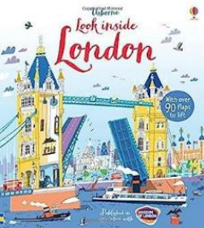 | The Green Children  The Green Children by Kevin Crossley Holland  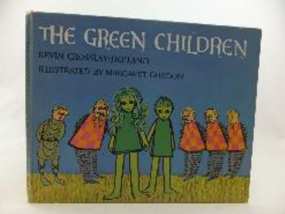  The Night Gardener by Terry Fan  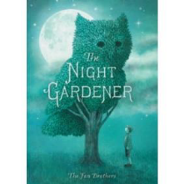 | Iron Man  The Iron Man by Ted Hughes  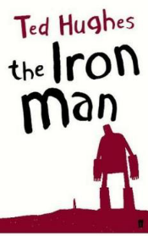  Diary of a Wimpey Kid By Jeff Kinney  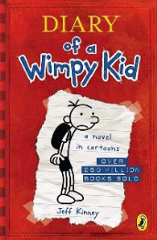 | Romans (non-fiction)  Romans on the Rampage by Jeremy Strong  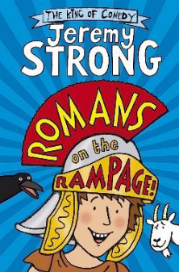 | Romans (Narrative)  Queen Boudica’s Revenge! By Stephen Kenyon | The Spider and the Fly  Spider and the Fly by Stephen Kenyon  Spider and the Fly poem Mary Howitt  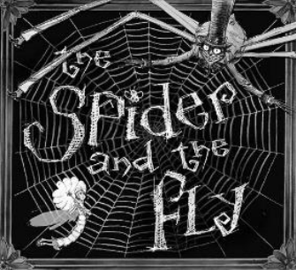
Link Texts | Fiction  Best-Loved Paddington Stories by Michael Bond  The Complete Adventures of Paddington by Michael Bond  Paddington film (PG) 2014  Paddington 2 film (PG) 2017  Paddington 2: Story of the Movie by Anna Wilson  Non-fiction  Kids’ Travel Guide London (Flying Kids)  I-spy London: What Can You Spot? (Collins Michelin i-SPY Guides)  50 Things to Spot in London (Usborne Spotter’s Cards) | Fiction  The Greenling  The Green Ship  Grandpa Green  Non-fiction  Range of instructions  Plantopedia  Gardening projects for kids | Fiction  The Iron Woman by Ted Hughes.  My Secret Scrapbook Diary - Little Red Riding Hood - Fairy Tale Diaries by Kees Moerbeek.  The Diary of Dennis the Menace by Stephen Butler.  Diary of a Wimpy Kid by Jeff Kinney.  Non-fiction  Recounts page from the BBC Bitesize website  Range of diary extracts.  Diary models written by the teacher at an appropriate for the class. | Fiction  Rotten Romans  So you think you’ve got it bad? (A kid’s life in Ancient Rome)  Land of the Gods  Revolt Against Romans  A Roman Story by Leila Rasheed  Non-fiction  What Did the Romans Do for Us? | Fiction  Queen of Darkness  My Family and Other Romans  The Captive Celt  Boudica’s Army- I Was There  Non-fiction  What Did the Romans Do for Us? | Fiction  Charlotte's Web  The Spider and the Fly  Non-fiction  Spiders (National Geographic)  All Things Spiders for Kids  Poetry  The Spider and the Fly
Outcomes | Narrative  Purpose: To write an innovated adventure story using subordination for time, commas to separate clauses, noun phrases and inverted commas to punctuate speech  Persuasive leaflets  Purpose: To create a leaflet based on London landmarks using compound words, complex sentences, the determiners a/an, commas, different forms of sentences and noun phrases | Folk tale  Purpose:  To write an innovated story based on the same plot using subordinating conjunctions, commas to separate clauses, inverted commas  Instructions  Purpose: To create a set of instructions for the topiary using determiners a/an and adverbs for time | Novel as a theme  Purpose: Story based on a plot structure from the focus text using effective use of adverbs, conjunctions to create complex sentences and paragraphs.  Recount  Purpose: To create a diary entry in role of  a character using determiners and text type features. | Information text  Purpose: Create a leaflet about the Roman’s using headings and subheadings, use subordinating conjunctions to create complex sentences demarcated with a comma. | Story as a theme  Purpose: To write an innovated story based on the same plot using prepositions, adverbs, inverted commas, expanded noun phrases. | Classic poetry  Purpose: To perform the poem using intonation, volume, tone and action.  Narrative  Purpose: To innovate the story using expanded noun phrases, prepositions, adverbs, inverted commas, subordinated conjunctions and paragraphs
Year 4 Curriculum Map
 | Autumn 1 | Autumn 2 | Spring 1 | Spring 2 | Summer 1 | Summer 2
Focus Texts | The Firework Maker’s Daughter by Phillip Pullman  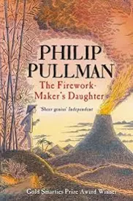 | 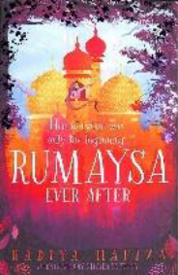  Rumaysa by Radiya Hafiza | Last Bear by Hannah Gold 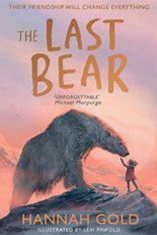 | Various persuasive texts (see link texts)  Poem based on BGT Aneeshwar Kunchala audition | Gulliver's Travels by Miss Marie Crook  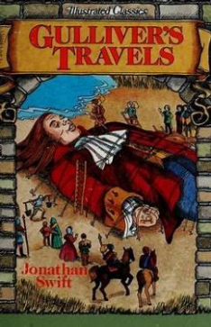 | Macavity by T.S Eliot  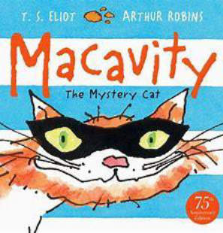
Link Texts | Fiction  I was a Rat by Phillip Pullman  Non Fiction  Fireworks: Eureka! The Biography of an Idea | Fiction  Matilda  Alice in Wonderland  101 Dalmatians  Aladdin  Peter Pan  An Owl called Star  Non Fiction  Range of websites linked to Owls | Fiction  Hunter’s icy adventures  The girl who went on strike to save the planet  Non Fiction  Eco Kids  What is climate change?  Fund out Climate Change  A climate in chaos  BGT- climate change audition  Young people’s trust for environment/ climate change  Frozen planet | Fiction  Eco Kids  What is climate change?  Fund out Climate Change  A climate in chaos  BGT- climate change audition  Young people’s trust for environment/ climate change  Frozen planet  Poetry  Haiku Poems (see sightline website on climate change Haikus)  The rang tan advert  Greenpeace advert | Fiction  Fig’s Giants  Gulliver’s Travels 1939 Film on YouTube  Gulliver’s Travels 1977 Film  Gulliver’s Travels 2010 Film  Dancing Bear  Clockwork  The Ice Palace  Non Fiction  Information texts on place chosen (linked to Geography or fictional place from novel)  Planet Earth by Katie Daynes.  Usborne First Encyclopaedia of Our World | Fiction  Shaun the Space Sheep  Various newspaper reports with interesting headline  Fiction  Max the detective cat  Six Dinner Sid  Evil Secret Society of Cats  Varjak Jaw  Toto the Ninja Cat  To be A Cat  Poetry  Atticus Claw breaks
Outcomes | Fantasy story  Purpose: Innovate an fantasy story which includes noun phrases, inverted commas and punctuation for speech, and fronted adverbials for when  Character description  Purpose: Use the focus text to write a character description for the characters which includes complex sentences with a range of conjunctions, commas to  separate clauses, fronted subornation and noun phrases. | Fairytale  Purpose: an innovated fairytale following plot patterns which includes noun phrases, precise nouns, fronted adverbials for when, inverted commas for direct speech  exp  Monologue  Purpose: Innovate the lyrics from the Frozen ’Let it Go’ based on Rumaysa to create a monologue which includes precise nouns, typical features of monologues and expanded noun phrases | Self Discovery story  Purpose: Innovate the setting of the Last Bear which includes adverbs for where, fronted adverbials and tier 3 vocabulary | Hybrid Text  Purpose: innovate a persuasive/ explanation text to inform and persuade others to look after our climate better which includes  Haiku Poem  Purpose: innovate their persuasive texts in the format of a Haiku poem to raise awareness of climate change which includes; expanded noun phrases, tier 3 vocabulary and rhyming techniques | Classic narrative  Purpose: innovate a classic narrative with a dilemma including fronted adverbials for ‘where’, standard English, verb inflections with appropriate pronouns e.g. first person and an opening paragraph which combines characters and setting.  Information poster  Purpose: create a non chronological report about a place linked to Geography unit or a fictional place from the novels covered which includes standard English verb agreement and appropriate text type features. | Newspaper report  Purpose: to create a newspaper report on Mr Mistoffelees or Mungojerrie and Rumpelteazer which includes noun phrase, commas in a list and text type features  Poetry  Purpose: which includes apostrophes for possession, apostrophes for contractions.
Year 5 Curriculum Map
 | Autumn 1 | Autumn 2 | Spring 1 | Spring 2 | Summer 1 | Summer 2
Focus Texts | The Lion, Witch and the Wardrobe by CS Lewis  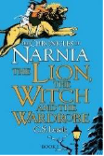 | 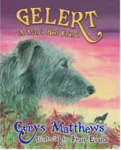Legend of Gelert by Cerys Matthews  Leaflets on our local area (including websites) | The Portal- Andrew Norriss  Time Spinner- Roy Apps  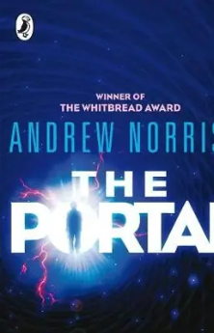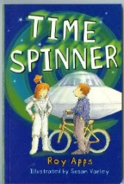 |  | 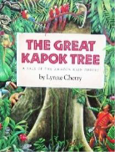The Great Kapok Tree by Lynne Cherry  The Deforestation Debate on the Scholastic website  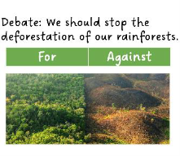 | The Jabberwocky by Lewis Carroll  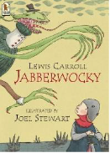
Link texts | Fiction  Evacuees of the Second World War  Anne Frank  Prince Caspian by C.S Lewis  The Chronicles of Narnia film  The Snow Queen by Hans Christian Andersen | Fiction  English: George and the Dragon  Scotland: The Fairy Flag of MacLeod  Ireland: Finn McCool and the Giant’s Causeway  Wales - The Story of Gelert  High King of Britain by Michael Morpurgo  Outlaw by Michael Morpurgo  Beowulf by Michael Morpurgo  Non Fiction  Junior Dragons’ Den BBC Children in Need - Youtube  Range of formal and informal persuasive texts | Fiction  Time Spinner by Roy Apps.  The Fun They Had by Isaac Asimo  The Portal by Andrew Norriss  Aquila by Andrew Norriss Aquila 2 by Andrew Norriss  Dr Xargle’s book of Earthlets by Jean Willis and Tony Ross  Poetry  Pie Corbett’s space poems  Haiku poems on the Word Wizard website  Limerick poems on the Kidzone website  Limericks read aloud on the Children’s Poetry Archive website  Blast Off! by Tom Bradman | Non Fiction  Explanation: Story of the Universe from the European Space Agency website  Non-chronological report: The Sun, Our Nearest Star from the European Space Agency website  Recount: Astronaut Recalls Spacewalk Drowning from the News 24 website  Instructions: Making a Gingerbread Spacecraft from the NASA website  Discussion: India’s First Space Rocket Blasts Off to Mars from the CBBC Newsround website  Persuasion: SMASH instant mashed potato advert YouTube clip  Playing through the  Nature Detectives (Woodland Trust) website  Recycling from the Energy Quest website | Fiction  Journey to the River Sea by Eva Ibbotson  Hymn to the Rainforest - short film on YouTube  The Wings of the Butterfly; A Tale of the Amazon Rainforest  The Tree of Life on the Story Museum website  The Vanishing Rainforest by Richard Platt.  The Shaman’s Apprentice by Lynne Cherry and Mark Plotkin.  Non Fiction  Threats to the Rainforest from Businesses and Farming from the BBC Bitesize website  The Blue Planet by David Attenborough  Amazon Wildlife on the WWF Global website | Fiction  George and the dragon  Hercules  The Minotaur  Medusa  Poetry  Poems to live your life by  Jabberwocky and other poems
Outcomes | Adventure story  Purpose: Innovated outcome of an adventure story which includes fronted adverbials for when and where, ing opening clauses, inverted commas and simile starters  Non Chronological Report  Purpose: Innovated outcome of a non chronological report including brackets to indicate parenthesis, commas to indicate parenthesis, expanded noun phrases. | Legend story  Purpose: innovated outcome of a legend story which includes -ed' openers, blending action and dialogue  Persuasion  Purpose: Innovated persuasive Film/TV broadcast about a place of interest within the British Isles which includes; modal verbs, relative clauses with relative pronouns | Sci Fi story  Purpose: Innovated sci-fi suspense story which includes; specific nouns and expanded noun phrases, blended action and description, commas to demarcate and for clarity.  Poems on a structure  Purpose: innovated poem which includes; expanded noun phrases. metaphors, similes and personification | Hybrid information text  Purpose: Innovated hybrid text on Space which includes; appropriate use of adverbials for time and place, devices to build cohesion within a paragraph, adverbials for place, features of the chosen text types and an awareness of purpose an audience. | Multi Cultural Story  Purpose: Innovated story from a different culture which includes; suffixes –ate, -ise, -ify to convert nouns and adjectives into verbs, -ed openers, -ing openers ad blended action and dialogue  Debate  Purpose: class debate on the topic of climate change (can be more specific) which includes; modal verbs. identifying the audience and purpose, select the appropriate language and  structures, use devices to build cohesion, using appropriate intonation and volume. | Narrative based on poem  Purpose: Innovated poem which includes; portmanteau words, powerful verbs, features of this poem, relative clauses omitting relative pronoun, semi colons and dashes  Narrative based on poem  Purpose: Innovated narrative based on the poem which includes; relative clauses with a range of relative pronouns, commas to demarcate, specific nouns and  noun phrases and blending action, dialogue and description
Year 6 Curriculum Map
 | Autumn 1 | Autumn 2 | Spring 1 | Spring 2 | Summer 1 | Summer 2
Focus texts | Churchill's We Shall Fight  Remembrance Poetry  Winston Churchill Biography  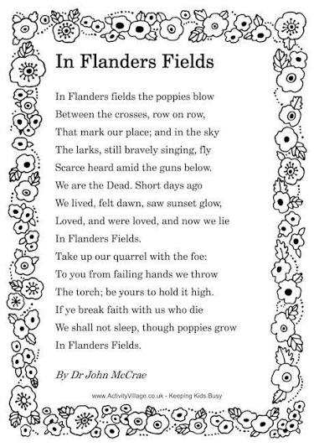 | Winston Churchill’s Biography  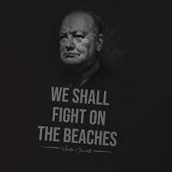 | Wizard of Oz  David Attenborough Wildlife Documentaries  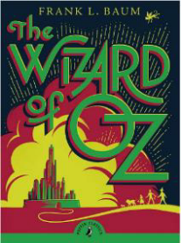 | Older Literature  Romeo and Juliet  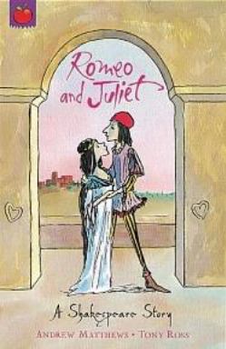 | Narrative  Sherlock Holmes  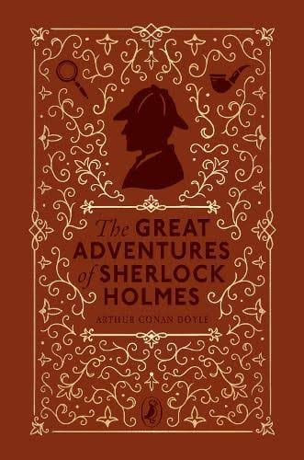 | Alma  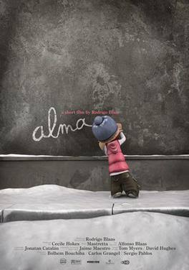
Link Texts | Non-Fiction  Greta Thunberg – persuasive speech  Winston Churchill – We Shall Fight on the Beaches  Franklin D. Roosevelt – Day of Infamy  Remembrance poetry and First/Second World War texts  Winston Churchill biographical texts and source material | Non-fiction  Torvil and Dean Biography  William Shakespeare Biography  Usain Bolt Biography  Steven Spielberg Biography  Neil Armstrong Biography | Fiction  Mary Poppins  Chitty Chitty Bang Bang  Little Women  The Railway Children  Black Beauty  Mary Poppins original film clips  Wizard of Oz film clips  Non-fiction  David Attenborough wildlife documentaries  Documentary narration and voiceovers  Mockumentary-style clips  Examples of wildlife and observational documentary scripts | Fiction  Romeo and Juliet by  Romeo and Juliet by K.J. Ohara  Romeo and Juliet by Marcia Williams  Clips from Romeo and Juliet film | Fiction  Sherlock Holmes short stories  The Speckled Band – Arthur Conan Doyle  Detective and mystery fiction extracts  Crime scenes, clues and suspect profiles  Film/TV detective fiction clips | Fiction  Alma – animated short film  Suspense and mystery extracts  Setting and atmosphere descriptions  Short films with unexpected endings  Visual storytelling and film techniques
Outcomes | Persuasive Speech  Purpose: Create a persuasive speech presenting themselves as a suitable School Ambassador, using persuasive techniques, rhetorical devices, cohesive argument, supporting evidence, vocabulary for impact and formality, and effective openings and conclusions.  Remembrance Poetry  Purpose: Create an original Remembrance poem using carefully selected vocabulary, imagery, figurative language, symbolism, repetition and structural choices to convey atmosphere, emotion and reflection.  Biography – beginning  Purpose: Research, plan and begin a biography of Winston Churchill, selecting and organising relevant information chronologically and using third person, past tense, formal vocabulary, relative clauses and cohesive devices. | Biography  Purpose: Create own biography based on Winston Churchill which includes manipulating sentences for effect, cohesive devices across paragraphs and within paragraphs, relative clauses. | Classic Fiction  Purpose: Innovated outcome of a classic fiction story which includes blending action, dialogue and description within sentences and paragraphs, use vocabulary to convey formality, synonyms and antonyms.  Documentary / Mockumentary Script  Purpose: Create and perform a documentary-style mockumentary about life in Year 6, using the conventions and language of wildlife documentaries. Writing to include formal and technical vocabulary, precise description, varied sentence structures, parenthesis, relative clauses, cohesive devices and deliberate shifts in formality for humorous effect. | Older Literature  Purpose: Using spoken and drama to explore literary language, plan and participate in a drama focused summary of Romeo and Juliet.  Writing to include synonyms, antonyms, explore levels of formality, blending action dialogue and description, active and passive voice and use of oxymorons. | Detective Fiction  Purpose: Create an original detective story which builds mystery and suspense through the controlled revelation of clues. Writing to include atmospheric description, characterisation, dialogue to advance action, shifts in pace, cohesive devices, varied sentence structures, precise vocabulary and punctuation for effect. | Suspense Narrative  Purpose: Create an original narrative inspired by Alma which builds suspense and creates an unsettling atmosphere. Writing to include controlled shifts in pace, precise vocabulary, show-not-tell description, manipulation of sentence length, effective dialogue, cohesive devices, punctuation for effect and the deliberate withholding and revealing of information.

