
Theme | Year 4: Electricity
School Values  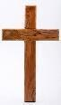 | Resilience: Testing and adapting circuits when investigations do not go as planned.  Articulation: Explaining scientific ideas using scientific vocabulary.
Global Citizenship  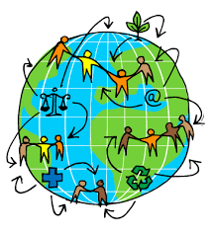 | Understanding how electricity is generated and used around the world and the importance of conserving energy.
Big Question   | How does electricity power our world?
Smaller Questions- key knowledge  (sequence- and assessment)   | - What is electricity?  - What are the parts of a circuit?  - What is a complete circuit?  - How do switches work?  - What are conductors and insulators?  - How can we reduce electricity use?
Spoken Language | Explainer presentations,  scientific discussions and investigation presentations.
Essential Enrichment   | Circuit building workshop, STEM activities and renewable energy investigations.
Outdoor Learning  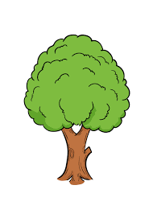 | Electricity around us: identifying electrical devices and power sources around school. | Significant people | Michael Faraday  Thomas Edison  Nikola Tesla  Lewis Latimer
Key Vocabulary   | Electricity, circuit, cell, battery, bulb, buzzer, switch, wire, conductor, insulator, energy, current.
Links to prior learning  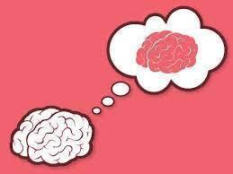 | Year 1 – Everyday Materials: Pupils identified and described materials, providing foundations for understanding conductors and insulators.  Year 2 – Uses of Materials: Pupils explored why materials are chosen for different purposes, helping them understand why specific materials are used in electrical components.  Year 3 – Forces and Magnets: Pupils developed enquiry skills and investigated material properties, preparing them for testing circuits and identifying conductors and insulators.  Working Scientifically: Pupils apply previous skills in predicting, observing, testing and recording results when investigating electrical circuits.
Cross-Curricular Links   | Maths, Computing, DT and Geography links. |  | Texts  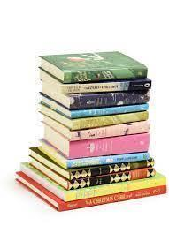 | Until I Met Dudley; See Inside How Things Work.

