

Theme | Year 2: Cooking and nutrition – A balanced diet
School Values   | Confidence, Resilience.
Global Citizenship  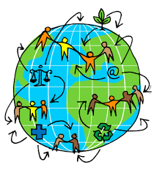 | Making thoughtful food choices and recognising that people eat different foods.
Big Question   | How can we design and make a tasty, balanced meal using different food groups?
Smaller Questions- key knowledge  (sequence- and assessment)   | - Can I identify and name the five food groups?  - Can I explain what a balanced diet means?  - Can I identify an appropriate piece of equipment to prepare food?  - Can I follow a design brief and choose ingredients from different food groups?  - Can I plan a recipe based on criteria?  - Can I make my food product and evaluate its taste, appearance and how well it meets the design brief?
Spoken Language | Name and discuss food groups; describe ingredients using taste and smell; explain design choices; evaluate a finished product, giving reasons and suggesting improvements.
Essential Enrichment   | Enrichment: Taste-testing session.
Outdoor Learning  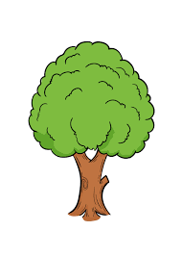 | Discuss where fruit and vegetables come from. | Significant people   | People who grow, prepare and cook food (e.g. farmers and chefs).
Key Vocabulary   | Cut, design, design brief, evaluate, fruit, grate, ingredient, smell, snip, spread, taste, vegetable
Links to prior learning  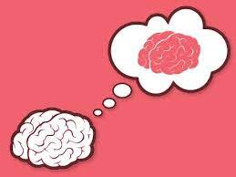 | Where does my food come from? (Y1)
Cross-Curricular Links  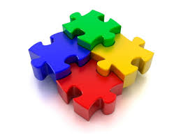 | Science: Animals' needs for survival |  | Texts  