
St. Lawrence Church of England Primary School
HANDWRITING
Introduction
Handwriting is a fundamental component of early literacy and a vital foundation for pupils’ future success in writing. As a school, we recognise that fluent, legible and automatic handwriting is not simply a presentational skill, but a core element of transcription that enables pupils to express their ideas clearly, confidently and independently. When handwriting becomes effortless, pupils are able to devote more cognitive resources to the craft of writing, including composing sentences, choosing vocabulary and organising ideas, without being hindered by the physical act of writing.
This policy sets out our whole-school approach to the explicit, cumulative, engaging and high-quality teaching of handwriting from Reception to Year Six. It draws on national guidance, including the Writing Framework (2025) and Strong Foundations in the First Years of School (2024), both of which emphasise the importance of securing strong foundational knowledge and skills early in a child’s education. These documents highlight that early attention to transcription skills, including letter formation, grip, posture, fluency and stamina, significantly improves later writing outcomes, reading development and overall academic achievement.
We recognise that the foundations for handwriting begin long before pupils pick up a pencil. Therefore, our approach places strong emphasis on early physical development, including fine and gross motor skills, core strength, coordination and spatial awareness. High-quality provision in the EYFS, combined with well-planned warm-up routines and repeated, varied and engaging opportunities for mark-making, ensures that children develop the motor control necessary for confident and efficient handwriting.
Across the school, handwriting is taught explicitly, cumulatively and engagingly, following a clear progression of skills informed by research into effective practice. Lessons are carefully sequenced so that new learning builds on previously secured knowledge and skills, while varied activities, purposeful practice and effective modelling help pupils remain motivated and fully engaged in developing handwriting fluency. All staff model our agreed handwriting style consistently and use shared routines for posture, pencil hold, paper position and letter formation. Handwriting instruction is supported by ongoing feedback, precise intervention and early identification of pupils who need additional practice or targeted support.
This policy reflects our commitment to ensuring that every pupil becomes a fluent, competent writer through explicit, cumulative and engaging handwriting instruction. By establishing strong foundations in transcription, we enable pupils to engage fully with the wider writing curriculum, develop pride in the presentation of their work, and build the confidence and independence needed to thrive as writers throughout their schooling.
To reflect this, the policy ensures that our approach to handwriting:

1. Prioritises Early Physical Development
We recognise that gross and fine motor development—including strength, co-ordination, balance, posture and spatial awareness—is essential for handwriting fluency and must be intentionally taught through well-planned provision in Reception and KS1. This aligns with Ofsted’s recommendation that early curricula focus strongly on foundational physical and early learning skills that “make the biggest difference by the end of KS1.”
It also mirrors guidance emphasising the EYFS role in strengthening core, arm and hand muscles through movement-rich experiences.

2. Ensures Explicit, Systematic Teaching of Letter Formation
Following both the Writing Framework and national recommendations, handwriting instruction begins early in Reception, initially supporting children to control movements before progressing to accurate letter formation taught in clear, manageable steps.
Strong Foundations reinforces the need for structured early teaching to secure key knowledge before children reach KS1, noting that foundational learning in Reception directly impacts literacy outcomes such as the Year 1 phonics check and later reading and writing attainment.

3. Builds the Conditions for Efficient Pencil Grip and Posture
Strong Foundations and linked guidance stress that children need well-sequenced opportunities to develop the physical skills required for a comfortable and efficient pencil grip. This policy ensures consistency in how staff teach grip, posture and paper position so children can write without discomfort and sustain stamina.

4. Protects Cognitive Load by Securing Transcription Early
The Writing Framework makes clear that if handwriting is not automatic, it overloads working memory and inhibits composition. This policy therefore embeds regular, short, focused handwriting sessions to build automaticity, enabling pupils to express ideas freely in writing across the curriculum.

5. Promotes High Expectations and Consistent Modelling
The policy requires all staff to model the agreed handwriting style across all subjects, supporting Ofsted’s finding that consistency and high expectations are critical features of schools where early foundations lead to secure literacy outcomes.

6. Ensures Early Identification and Responsive Intervention
In line with Strong Foundations, the policy establishes a proactive approach to monitoring early handwriting development and addressing difficulties swiftly, ensuring no child falls behind in acquiring foundational skills.

Overall Purpose
Through this unified, evidence-aligned approach, the handwriting document aims to:
- Secure automatic, fluent handwriting for every pupil
- Provide a strong early foundation in physical and transcriptional skills
- Ensure consistent, high-quality teaching across all classrooms
- Reduce barriers to writing so pupils can focus on communicating meaning
- Support early identification and intervention
- Cultivate confidence, pride and independence in pupils’ written work
By embedding principles from Ofsted’s Strong foundations in the first years of school, alongside the Writing Framework and our school’s progression model, this document ensures that handwriting is not treated as a superficial presentational skill, but as a core component of early literacy, essential for enabling every child to thrive as a writer.

Supporting Left-Handed Pupils
We recognise that left-handed pupils may require specific adaptations to support comfortable and effective handwriting. Staff ensure that pupils are taught how to position and angle their paper appropriately, maintain a comfortable pencil grip and avoid developing a hooked wrist. Consideration is given to seating arrangements, with left-handed pupils seated where possible to avoid bumping arms with right-handed peers. A range of equipment, including pencils with specially designed left-handed grip grooves, is available to support individual needs. Left-handedness is respected as a natural difference, and pupils are supported to develop a fluent and efficient handwriting style.

Ready to Write Routines
Our school chant:
Feet flat, back straight,
Paper in place, ready to create.
Nip, flip, grip,
Let's write!
Before handwriting sessions, children take part in a consistent Ready to Write routine. Staff explicitly model and reinforce correct posture, paper position and pencil grip. Children are encouraged to use the school’s Ready to Write Chant, helping them to develop habits that support comfortable, fluent and efficient handwriting.


Barton St Lawrence

Handwriting Progression Document

EYFS

Taught daily x 5 - 10 minutes with provision for the development of fine and gross motor skills in the areas

Teaching sequence: Revisit and review, Teach. Practise will be either adult led or in the areas of provision

Prior to and working alongside the development of letter formation, children in the EYFS will have access to both fine and gross motor skill activities, that are both child initiated and adult supported. To support the development of fine motor skills, and to assess the children’s pre-writing skills, teachers and support staff may choose to use:

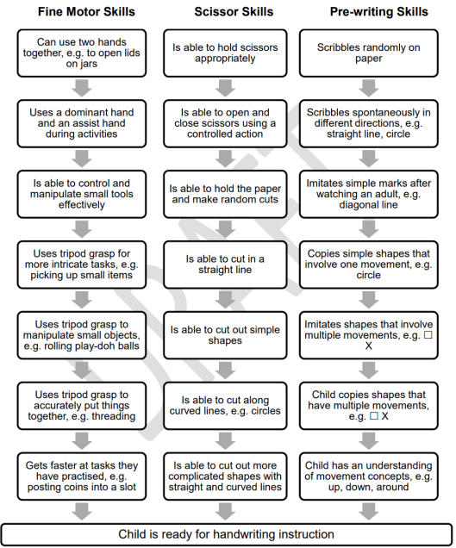

Pencil control - directionality

Teachers consider the concept of ‘directionality’ when promoting positive handwriting habitats. This means the ability of the child to control the change in direction of the pencil on the page. They will plan in opportunities for this. Some of these are listed below.

Pencil grip development

Children in reception will be provided with a range of mark making and writing opportunities that are both adult supported and child initiated. The children will be encouraged to explore a variety of pencil grips through mark making opportunities using a variety of different media. The children will be supported to achieving an appropriate pencil grip for their level of development, leading to improved and accurate letter formation. Throughout the year, teachers and support staff will assess the children through observation and they will identify children who may need intervention for fine motor support. Children will always be encouraged to use a tripod grid when they are deemed developmentally ready. Below you will find a progression grid for pencil grip development.

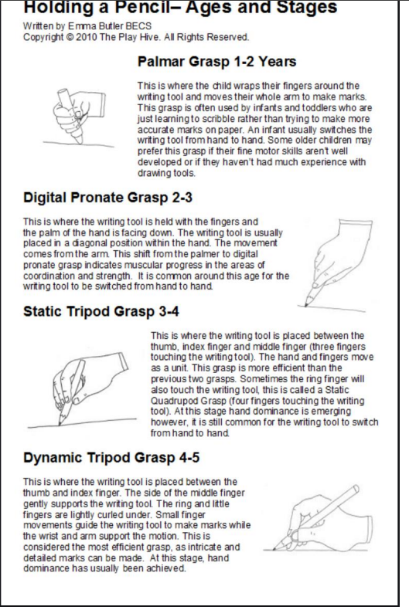

Mark making skills - handwriting patterns

Children in reception will be encouraged to access both child initiated and adult directed mark making activities that are cross-curricular. The children will have access to multi-sensory activities, including dough disco and outdoor writing opportunities, to also develop a positive attitude towards mark making and the development of early handwriting skills. Children may also be encouraged to work on an upright surface for shoulder and core strength. As part of this provision, children will be encouraged to make the following patterns to support the development of letter formation skills.

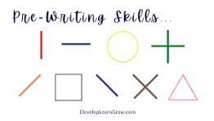

Mark-making is skill that needs to be taught. We follow EEF guidance that states the most effective approaches for physical development in mark making are through the teacher:
- preparing
- modelling
- narrating
- demonstrating
- using memory prompts
- commenting
- repeating for over-learning

Continuous Provision
Opportunities to develop the foundations for handwriting are embedded throughout the continuous provision. Resources and experiences are carefully planned and layered to match and extend children’s developing skills, ensuring progression across the year. Children are provided with frequent opportunities to strengthen fine and gross motor control, develop pencil grip, build hand strength and engage in purposeful mark-making through a range of indoor and outdoor activities. These experiences support the development of the physical skills and confidence needed for successful handwriting.
Autumn 1 | Physical Development  Gross motor activities  Hand and arm strengthening activities  These may include:  - Body shapes  - Dancing  - Shoulder strengthening through large scale air writing  - Travelling in different ways  - Balancing  - Crawling and commando crawling  - Climbing  - Colour on tummies on floor  - Drawing and writing on tummies on floor  - Dough disco  - Lego / K’nex  - Cutting and tearing  - Threading  - Zips and buttons  - Nuts and bolts  - Finger painting  - Stamping using stamps  - Bridget Riley (lines)
Autumn 2 | As above plus  Gross motor activities  Hand and arm strengthening activities  plus fine motor activities which may include:  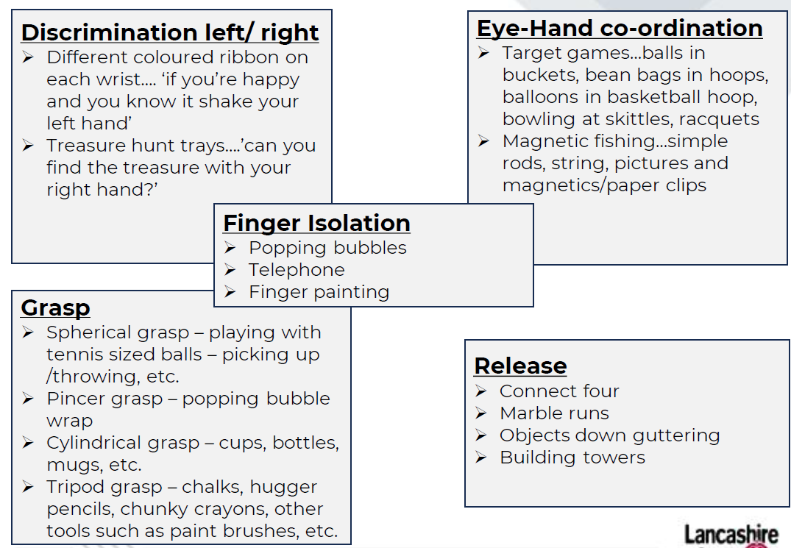  Plus directionality activities  These may include:  - Direct me: obstacle course  - Follow me: lights and ribbons - phonics  - Junk modelling: ‘put the tube behind the pot’  - Preposition action figures  - Art  Plus Pre-writing shape activities  These may include:  - Artwork inspired by Kandinsky (circles - triangles),  - Tracing lines and shapes (some use of Write Well scheme here)  - Tracing pictures  - Making shapes in surfaces such as sand, glitter, foam etc.
Spring 1 | Above activities will continue for as long as children require. Children will start to learn formal handwriting when they are developmentally ready (see appendix).  ‘Curly Caterpillar Letters’  c, a, d, e, g, q, o  Children will learn to form these letters correctly using Red Rose patter.  Activities may include:  Gross motor skills to make the pre-cursor shape  Multi-sensory / gross motor to write the letter using Red Rose patter  Writing letter in large format, e.g. chalk, pens, paint.  Whiteboards (especially teacher whiteboard)  In books
Spring 2 | ‘Long Ladder Letters’  I, j, l, t, u, y
Summer 1 | ‘Right Armed Robot Letters’  b, h, k, m, n, p, r
Summer 2 | ‘Zig-zag letters’  v, w, x, z

EYFS Progression - expectations
Autumn | Spring | Summer
Demonstrate pre-phonemic writing:  -patterns  - pictures  - random scribbling  - scribble writing  - symbols that represent letters  - random letters or numerals  - letter strings (continuous string of letters, symbols or numerals)  - letter groups (groups of letters, symbols or numerals including spaces)-environmental print.  Use some recognisable letters and symbols.  Use handwriting patter/phrase to support formation, if appropriate. | Form letters from their name correctly.  Form some capital letters correctly, including the initial letter of their name.  Form some lower-case letters correctly; starting and finishing in the right place, going the right way round, correctly orientated.  Make marks, drawings and symbols with increasing control. | Begin to write on the lines with some control of letter size.  Hold paper in position, and use preferred hand for writing, developing a comfortable pencil grip.  Form lower-case letters with developing consistency.  Begin to form clear ascenders ('tall letters') and descenders ('tails') to write recognisable letters.  Write left to right and top to bottom.  Hold writing tools and implements with a developing grip, using an appropriate amount of pressure.

Year 1

Taught daily x 20 minutes

Teaching sequence: Revisit and review, Teach, Practise, Apply (end of week)

Monday: Gross motor skills to make the pre-cursor shape
Tuesday: Multi-sensory gross motor to write letter using Red Rose patter
Wednesday: Writing letter in large format, e.g. chalk, pens, paint.
Thursday: Whiteboards and correct misconceptions
Friday: In books, using handwriting lines

Red Rose Patter for formation phrases

Supported by Write Well Book 5 – Letter size and position

Key vocabulary: ascenders, descenders, anti-clockwise, line
Autumn 1 | ‘Curly Caterpillar Letters’  c, a, d, e, g, q, o plus s and f  Digits: 0, 6, 8 and 9
Autumn 2 | ‘Bridging Letters’  s, f  ‘Long Ladder Letters’  I, j, l, t, u, y  Digits: 1, 4 and 7
Spring 1 | ‘Right Armed Robot Letters’  b, h, k, m, n, p, r  Digits: 2, 3 and 5
Spring 2 | ‘Zig-zag letters’  v, w, x, z
Summer 1 | Capital letters  Letter size and position
Summer 2 | Spacing within words  Spacing between words

Year 2

Taught daily x 10 minutes

Teaching sequence: Revisit and review, Teach, Practise, Apply (end of week)

Monday: Gross motor skills to create the letter shape / join in large or multi-sensory format using Red Rose patter
Tuesday: Practising letters / joins on laminated handwriting sentence strips
Wednesday: In book, using handwriting lines – Try it
Thursday: In books, using handwriting lines – Practise it
Friday: In books, using handwriting lines – Apply it

Red Rose Patter for formation phrases

Supported by Write Well Book 6 – First Joining and Write Well Book 7 – More Joining

Key vocabulary: diagonal join, horizontal join, break letters, ascenders, descnders
Autumn 1 | - Revising Letter Shapes  This phase will continue until at least 80% of children are securely forming appropriately sized letters correctly, with clear ascenders and descenders and placing them on the line.  Any of the 20% children who are not ready to move on will receive systematic intervention at this point.  - Joining Patterns  - The diagonal join to r, n, m  - The diagonal join to i and u  - Revisiting the diagonal join to r, n, m, i, u  - The diagonal join to l, h, k
Autumn 2 | - Joining three letters  - The diagonal join to a, c, o  - Practising the join to a, c, o  - Joining words with diagonal joins
Spring 1 | - The horizontal join to r, n, m  - The horizontal join to i and u  - The horizontal join to l, h, k  - The horizontal join to a, c, o  - Joining words
Spring 2 | - The diagonal join to v and w  - The diagonal join to p and y  - The diagonal join to b and t  - The diagonal join to d and g  - The diagonal join to e
Summer 1 | - Joining words with diagonal joins  - The horizontal join to v and w  - The horizontal join to p and y  - The horizontal join to b and t  - The horizontal join to d and g
Summer 2 | - The horizontal join to e  - Joining words  - Starting with break letters  - Break letters within words  - Punctuation focus

Year 3

Taught x2 weekly
20 minutes

Teaching sequence: Revisit and review, Teach, Practise, Apply (end of week)

Lesson 1: Try it 1 and 2
Lesson 2: Practice and apply it

Red Rose Patter for formation phrases

Supported by Write Well Book 8 – Confident Joining

Key vocabulary: diagonal join, horizontal join, break letters, ascenders, descenders, straight letters, letter strings, double letters, prefix, suffix, compound words, direct speech
Autumn 1 | - Joining words  - Joining from r to straight letters  - Joining from r to round letters
Autumn 2 | - Joining to s  - Joining to f
Spring 1 | - Joining from f to straight letters  - Joining from f to round letters  - Joining difficult double letters
Spring 2 | - Joining letter strings with r  - The break letters g, q, y, j, p, b, s
Summer 1 | - The break letters x and z  - Joining compound words
Summer 2 | - Joining words with prefixes  - Joining words with suffixes  - Joining in direct speech

Year 4

Taught x2 weekly
20 minutes

Teaching sequence: Revisit and review, Teach, Practise, Apply (end of week)

Lesson 1: Try it 1 and 2
Lesson 2: Practice and apply it

Red Rose Patter for formation phrases

Supported by Write Well Book 9 – Fluency

Key vocabulary: consistent, position, spacing, parallel, downstrokes, ascenders, descenders, fluent, prefix, suffix
Autumn 1 | - Fluent handwriting  - Fluent joining  - Clear letter shapes
Autumn 2 | - Consistent letter size  - Consistent position
Spring 1 | - Checking spacing within words  - Parallel downstrokes  - Parallel ascenders
Spring 2 | - Parallel descenders  - Pen lifts after break letters
Summer 1 | - Fluent joining in longer words  - Joining words with prefixes
Summer 2 | - Joining words with suffixes  - Word and line spacing  - Writing fluently

Year 5

Taught x2 weekly
20 minutes

Teaching sequence: Revisit and review, Teach, Practise, Apply (end of week)

Lesson 1: Try it 1 and 2
Lesson 2: Practice and apply it

Red Rose Patter for formation phrases

Supported by Write Well Book 10 – Speed

Key vocabulary: legible, slant, speed, purpose, abbreviations, notes
Autumn 1 | - Joining for speed  - Fast and legible handwriting  - Check your writing speed
Autumn 2 | - Tools and tips for speed  - Eradicating problems with writing at speed
Spring 1 | - Practising for speed  - Looping for speed  - Speedy joining from b and p
Spring 2 | - Speedy joining from s  - Shortcut joins for speed
Summer 1 | - Slanting for speed  - Different speeds for different purposes
Summer 2 | - Taking notes  - Using abbreviations  - Check your writing speed

Year 6

Taught x2 weekly
20 minutes

Teaching sequence: Revisit and review, Teach, Practise, Apply (end of week)

Lesson 1: Try it 1 and 2
Lesson 2: Practice and apply it

Red Rose Patter for formation phrases

Supported by Write Well Book 11 – Style

Key vocabulary: personal style, looping, printing, slanting, decorative, calligraphy, proofreading, punctuation, black capitals
Autumn 1 | - Your own personal style  - Looping for style  - Joining break letters b, p, s
Autumn 2 | - Joining break letters q, z, x  - Rounded v and w  - Slanting for style
Spring 1 | - Printing  - Block capitals  - Choosing writing tools
Spring 2 | - Decorative lettering  - Calligraphy  - Choosing your standard of handwriting
Summer 1 | - Your best handwriting  - Proofreading and punctuation
Summer 2 | - Presentation and layout

Early Intervention
Children who do not reach age-appropriate handwriting milestones require early, well-targeted intervention so gaps do not widen and working memory is not overloaded as writing demands increase. Both The Writing Framework (2025) and Ofsted’s Strong Foundations in the First Years of School emphasise that early identification and responsive action are critical, particularly where weaknesses in core strength, fine motor control, pencil grip, or letter formation are evident.

Effective early intervention begins with strengthening the gross and fine motor foundations essential for handwriting—developing core stability, shoulder strength, bilateral coordination and finger dexterity through structured activities such as climbing, crawling, dough disco, threading and tool use.

Alongside motor development, children need explicit, supervised teaching to correct and embed accurate letter formation, ensuring they do not practise incorrect movements. Programmes such as Print Like a Pro, recommended in your staff documents, provide a systematic and highly visual approach that supports children in forming letters with correct directionality, starting points and sequencing.

Appendix:
Children in the EYFS are developmentally ready to begin formal handwriting instruction when they have secured the foundational skills needed for success. This includes being able to maintain an appropriate sitting posture, hold and control a pencil effectively, and understand that marks and symbols carry meaning. Children should also have sufficiently developed communication and language skills to understand and follow handwriting instruction, alongside a secure understanding of positional and directional language, which supports correct letter formation and orientation. These foundations are carefully developed and assessed through our EYFS provision before more formal handwriting teaching is introduced.

We also measure readiness to write using this:

