Theme | Year 3: Art - sculpture
School Values  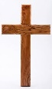 | Individuality
Global Citizenship   | How can an artist encourage others to look after their environment and treat it with respect?
Big Question   | How can we make a clay bas relief with patterns and texture?
Smaller Questions- key knowledge  (sequence- and assessment)   | - How can we record from the local environment from observation?  - How can we roll clay to an even thickness and create surface texture?  - How can we join pieces of clay together to form a bas relief?  - How can we add details of pattern and texture?  - How can we add colour to a clay bas relief?  - What are the skills that you have developed? What was successful and what would you like to develop further?
Spoken Language | Provide oral explanations, extending with additional details  - Evaluate their own and others’ work, describing and explaining why they chose certain tools or objects
Essential Enrichment   | Drawing outside. Displaying the clay bas relief in school as a Barton relief.
Outdoor Learning  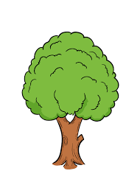 | Drawing outside in the local environment | Significant people | The Ancient Greeks – The Elgin Marbles  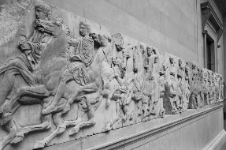
Key Vocabulary   | Bas relief, cross-hatching, slip, texture, detail, observation, viewfinder
Links to prior learning   | Year 2  3-D Clay  Manipulate malleable materials in a variety of ways including rolling, kneading  Manipulate malleable materials for a purpose, e.g. to make a sculpture.  Change the surface of a malleable material.  Use slip and cross-hatching to join two pieces of clay  Understand the safety and basic care of materials and tools.
Cross-Curricular Links   | History – Unit 1, Year 3. Local History of Preston, Geography – Unit 1, Year 3. Barton and Preston |  | Texts  