English:  To write a narrative based on a model text (Paddington) with innovated plot structure  - Complex sentences (when, before, after, while, until)  - Comma use to separate clauses  - Inverted commas  - Noun phrases  - Justify responses using point and evidence  - Sequence and discuss main ideas |  | Maths:  Week 1: Represent and partition numbers to 100 then 1000  Week 2: Flexible partitioning to 1000, numberlines and finding 1, 10, 100 more and less  Week 3: Estimate and order numbers to 1000, count in 50s  Week 4: Number bonds, adding and subtracting 1s, 10s, 100s  Week 5: Adding and subtracting with exchanges  Week 6: Column addition and subtraction  Week 7: Complements to 100 and estimating answers
Geography:  Our Locality  To investigate the local area using maps, aerial photographs and satellite imagery  To identify and describe human and physical features of the locality  To use fieldwork to create a sketch map and add to a digital map of the local area | 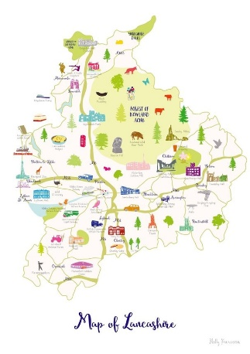  All Around Me  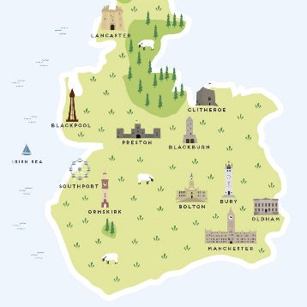  Year 3  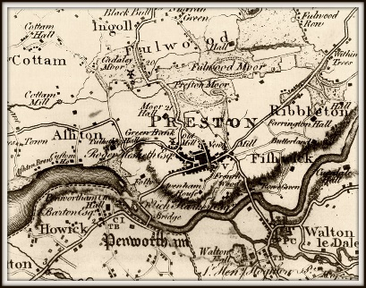 |  | History:  Local History  The historical significance of Preston and its importance in terms of the industrial revolution and cotton industry
Art:
Clay – bas relief
Making a bas relief of local buildings, focusing on surface pattern, detail and texture
Computing: | RE:  Harvest: To explore the meaning of the Harvest Festival and to learn from the way Jewish people celebrate Sukkot | PE:  Handball and Hockey | PSHE:  How can I manage my emotions?  What does it mean to be British?
Computing: |  | Science:  Light and Shadows  Exploring how light travels  Investigating how shadows are formed | French:  Le Phonetique  Fruits and Vegetables

