English  This half term we will focus on our use of sentence structure (capital letters, finger spaces and full stops). We will be focusing on writing simple sentences and ensuring our writing can be read by other people. We will have a strong focus on using our phonic knowledge to write words and sentences. We will also learn how to make plurals by adding ‘s’ to the end of a noun. | Maths  In maths this half term we will focus on place value within 10 and addition & subtraction. We will begin by sorting, counting and representing objects in different ways, before moving on to recognising numbers as words. We will be building on the number work from Reception, making sure that we count carefully (forwards and backwards within 10). We will use this knowledge to look at fewer/more/same, compare numbers and order numbers and objects. |  | 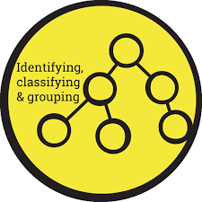  Science  Our science unit this half term focuses on animals and their common features. Children will learn to identify and name different common animals such as amphibians, reptiles, birds, mammals and fish.  We will also learn about carnivores, herbivores and omnivores. Finally, we will learn about a range of different lifecycles.
PE  PE will be taught by Mrs Rogerson. Amongst other skills, the children will be learning to control and roll a ball with accuracy, catch a ball and throw underarm. | 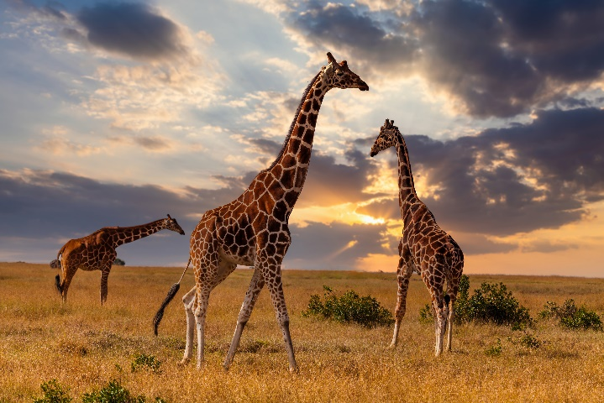  All Creatures Great and Small  Year 1  Autumn 1 |  | Music  This half term we will be learning how to find a beat within a piece of music. We will learn about pulse, beat and tempo. We will also explore the social aspects of music and how it helps to enrich society.
Computing  For the first half term we will focus on online safety. We will learn:  To log in safely and the importance of passwords.  To understand the concept of ownership over creative work.  To learn to use Purple Mash safely to complete computing work and our own home learning activities. |  |  | RE  This half term we will be learning about the Christian festival of Harvest and how this is celebrated around the world. The children explore the notion of charity and giving to those who have less than us.  We will also learn about the Jewish celebration of Sukkot and compare this to Christian harvest. We will also be covering the topic of Creation and looking at the Bible to read the story of Creation.
Geography  This half term we will be looking at different weather patterns and the way the weather changes through the seasons in our country. We will compare the weather through the seasons as we move through the school year. Therefore, this topic will be revisited several times throughout year 1. | Art and Design  In Art and Design this half term we will be working towards a clay sculpture. We will begin by sketching using a range of different media and exploring tone by using dark and light shapes and shading using pencil. We will then move on to paintings of the animals and explore mixing primary shades and tones of paint. Finally, we will produce a clay model of our chosen animal using sculpting tools safely and effectively. |  | PSHE  In our first unit of PSHE we will focus on our community within school and fostering a sense of belonging. We will look at what it means to be unique and why it is good to be ourselves. We will talk about what it means to be a good friend and how to form friendships. We will look at kind and unkind behaviours and how our actions can affect other people.
Key Experiences:  Sculpting a clay animal  Meeting a variety of real-life animals and finding out how to look after them.  Making a non-fiction booklet about an animal of our choice. |  | Key Vocabulary:  Herbivore, carnivore, omnivore, season, Autumn, Summer, Spring, Winter, compare, describe, observe, plural, tone, shade, sculpture, primary colour, secondary colour, Harvest, Sukkot, Judaism, reptile, mammal, amphibian, beat, pulse, tempo, rhythm.

