English:  To write a persuasive speech  To write a biography  To write remembrance poetry  Relative clauses using who, which, where, when, whose  Modal verbs and adverbs to indicate degrees of possibility/certainty  Passive voice  Cohesive devices, including adverbials and repetition  Parenthesis using brackets, dashes and commas  Colons, semicolons and dashes to mark boundaries between independent clauses |  | Maths:  Week 1: Understanding numbers to 10,000,000  Week 2: Comparing, ordering and rounding numbers  Week 3: Factors and Multiples  Week 4: Prime, square and cube numbers  Week 5: Multiplication  Week 6: Division  Week 7: Multi-step problems and orders of operations
Science:  Electricity  To investigate how changing the number and voltage of cells affects components in a circuit  To compare and explain how changes to a circuit affect bulbs, buzzers and motors  To use recognised electrical symbols to draw and interpret circuit diagrams | World War Two  Year 6  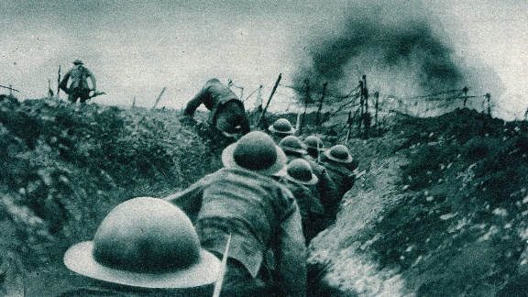 |  | History:  World War Two  The causes, key events and impact of World War Two, including the Battle of Britain, life on the Home Front and the legacy of the war.
Art:
To explore how artists use colour, tone, mark-making and mixed media to communicate mood and ideas.
Computing: Databases  To find information in databases by filtering and sorting.  To create graphs from data within a database.  To be able to find information in linked table databases.  To be able to find requested information using databases. | RE:  How do promises of commitment shape the lives of those who make them. | PE:  Hockey and Football | PSHE:  Communities and British values
French:
Greetings and Instructions

