English  During this unit, children will share and explore in detail the text ‘The Way Home for Wolf’ by Rachel Bright. We will cover 3 units this half term – A Wolf character poster, Information text based on a model, Innovated narrative based on a model. Through all these units, we will focus on our use of sentence structure (capital letters and full stops). We will look at the use of grammar and learn how to improve our writing by using joining words, punctuation (exclamation/ question marks and commas). We will research text features and try to use some of these in our own writing. | Maths  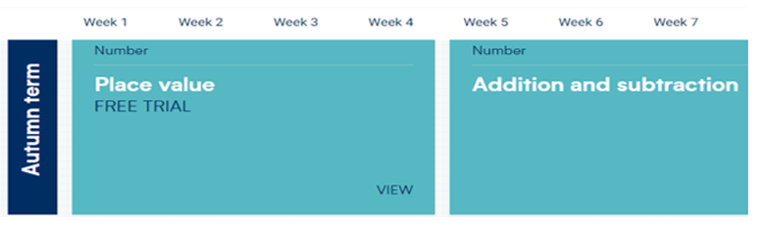  This term we will look at Place value to 100 (including counting in (10’s, 2’s, 5’s and 3’s) and addition and subtraction. We will be looking at different methods of adding and subtracting such as using 10’s and 1’s and adding/subtracting across a 10. | History  This half term we will be learning about the history of our local area. We will use and make simple comparisons to parts of stories and features of events. We will also recognise that our own lives are different from the lives of people in the past by describing some of the topics, events and people that we have studied.
PE  PE will be taught by Mrs O’Neil. Amongst other skills, the children will be learning the various skills of Rugby and Playground games in the 20th Century. | How we used to live  Year 2  Autumn 1 | Music  This half term we will be learning how to find a beat within a piece of music. We will learn about pulse, beat and tempo. We will also explore the social aspects of music and how it helps to enrich society. We are doing this using Kodaly rhythm online games.
Computing  For the first half term, we will focus on coding. We will learn:  Coding using 2Go. Writing simple instructions to move a screen turtle along routes.  - Considering direction and distance.  - Creating commands.  - Building an algorithm. | How we used to live  Year 2  Autumn 1 | RE  This half term, we will be learning about why the Bible is such a special book. This unit aims to widen the children’s understanding of the Bible, its contents and its importance to Christians. We will also begin to develop children’s understanding of holy books from various faiths and their significance in the lives of believers.
Geography  This half term, we will be looking at continents and oceans. We will do this by using a range of maps at different scales to help us learn how maps give us information about places in the world (where/what). We will use vocabulary such as bigger/smaller, near/far. | Art and Design  In Art and Design this half term, we will be working towards a repeated pattern print. We will start by recording and exploring ideas from first-hand observations and experimenting with a variety of media. We will then develop these and print with a range of hard and soft materials and make simple marks on rollers and printing palettes. | PSHE  In our first unit of PSHE we will focus on healthy and happy friendships. We will look at what it means to be a good friend and how to form friendships. We will look at kind and unkind behaviours and how our actions can affect other people. Finally, we will explore how, even if we are not friends, we can still get on and work together.

