PE and Sport Premium Impact Report 2025–2026
Maintaining Platinum School Games Mark

St Joseph the Worker is proud to have maintained its Platinum School Games Mark through its continued commitment to providing high-quality Physical Education, School Sport and Physical Activity (PESSPA) opportunities for all pupils.

Our vision is to ensure that every child develops confidence, competence, knowledge, and motivation to lead an active and healthy lifestyle. Through the effective use of PE and Sport Premium funding, we have continued to provide a broad, inclusive and engaging programme that supports physical, social and emotional development whilst promoting lifelong participation in physical activity.

- Physical Literacy
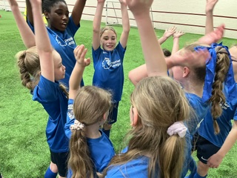
- Broad and Inclusive Sporting Opportunities
- Equality and Inclusion
- Supporting Numeracy Through PE
- Promoting 60 Active Minutes
- Impact of PE and Sport Premium Funding
- Community Engagement
- Overall Impact
- Next Steps for Development

Physical Literacy

This year, we have placed physical literacy at the heart of our provision. We have focused on developing pupils’ confidence, competence, motivation, and understanding of movement through a wide range of sporting and physical activities.

Through high-quality PE lessons, active playtimes, extracurricular clubs and enrichment opportunities, pupils have developed fundamental movement skills including balance, coordination, agility, throwing, catching and spatial awareness. Our approach has encouraged children to challenge themselves, develop resilience, and enjoy being active, helping them to understand the positive impact that physical activity has on both physical and mental wellbeing.

We aim to ensure that children view physical activity as a lifelong skill rather than simply participation in a sport or game. By developing physical literacy from an early age, pupils are better equipped to lead active and healthy lifestyles both now and in the future.

‘PE makes me feel good’ AH

Broad and Inclusive Sporting Opportunities

PE and Sport Premium funding has enabled us to offer a diverse range of sporting opportunities, ensuring all pupils can participate regardless of ability or previous experience.

Throughout the year, pupils have engaged in a wide variety of activities including:

- Dance for Rights
- Triathlon
- Outdoor and Adventurous Activities (OAA)
- Rugby
- Football
- Cricket
- Inter-school competitions and festivals
- Extracurricular sports clubs
- Swimming gala

These experiences have helped pupils develop teamwork, leadership, resilience, communication skills, and self-confidence while fostering a love of physical activity.
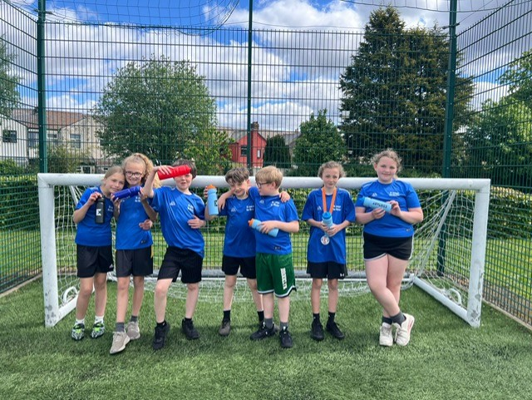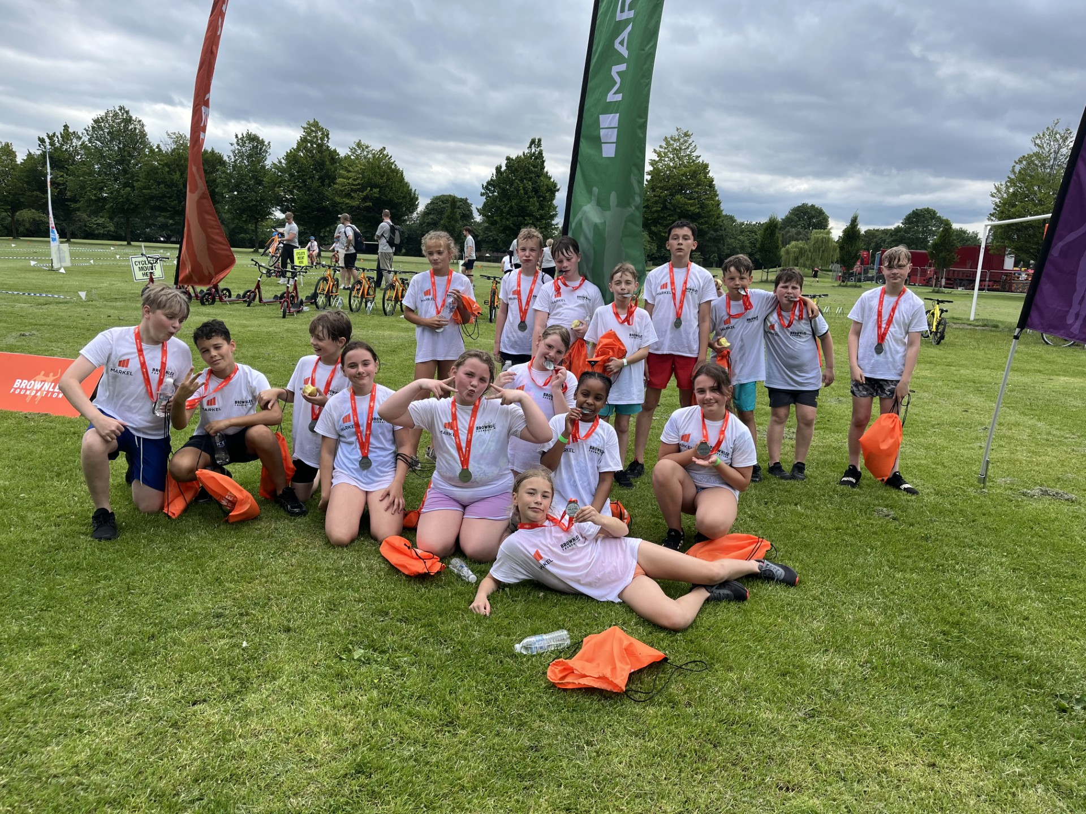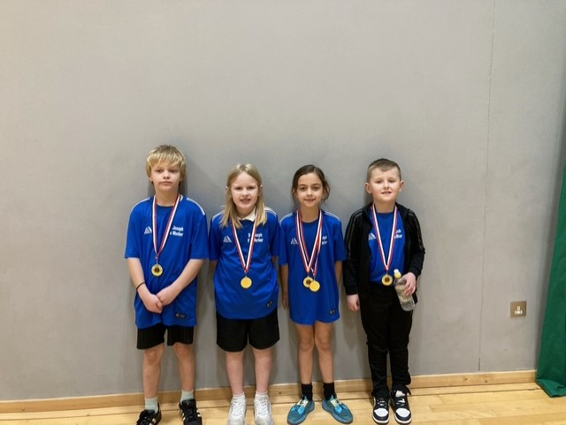

Equality and Inclusion

At St Joseph the Worker we are proud to provide equal opportunities for boys and girls across all areas of PE, school sport and physical activity. Throughout the year, pupils have had equal access to extracurricular clubs, competitions, festivals, leadership roles and enrichment opportunities.

We actively monitor participation and offer a diverse range of activities to ensure that all children, regardless of gender, ability or background, feel valued, included and confident in taking part. Our commitment to inclusion has resulted in strong engagement across the school, with pupils regularly participating in clubs, competitions and leadership opportunities such as playground leaders.

By creating an inclusive environment where every child can succeed, we continue to promote positive attitudes towards physical activity and support the development of confidence, resilience, and lifelong participation in sport.

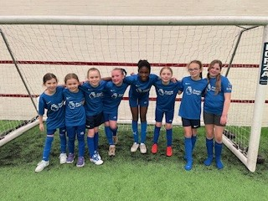
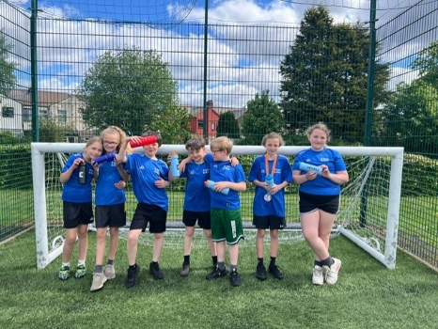

Supporting Numeracy Through PE

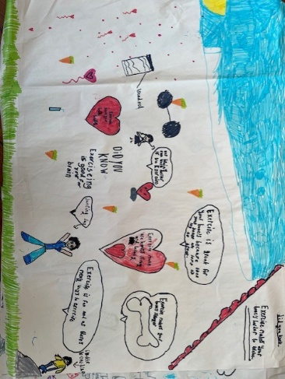
We have successfully incorporated numeracy into our PE curriculum, providing meaningful opportunities for pupils to apply mathematical skills in practical contexts.

Pupils have developed numeracy through:

- Timing races and challenges
- Measuring distances and performance
- Recording scores and results
- Collecting and interpreting data
- Problem-solving during team and OAA activities

This cross-curricular approach has strengthened pupils’ understanding of mathematics, while demonstrating the relevance of numeracy in everyday situations.

Promoting 60 Active Minutes

A key priority this year has been to ensure that pupils achieve the recommended 60 active minutes per day.

Through a whole-school approach, we have embedded physical activity throughout the school day by providing:

- Structured playground games
- Active learning opportunities across the curriculum
- Physical brain breaks between lessons
- Active playtimes and lunchtimes
- Extra-curricular sporting opportunities

These initiatives have increased daily activity levels, improved concentration and supported pupils’ physical and mental wellbeing. Active learning and movement breaks have enabled pupils to remain engaged in their learning whilst developing healthy habits and positive attitudes towards physical activity.

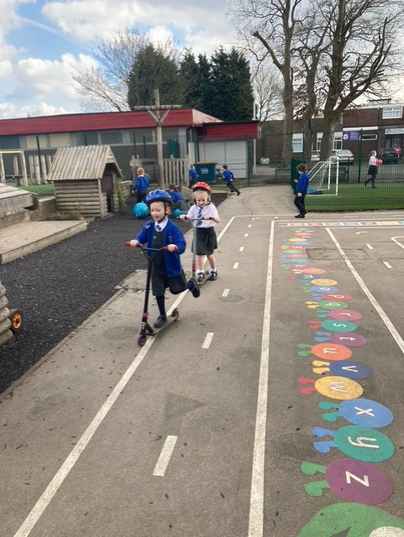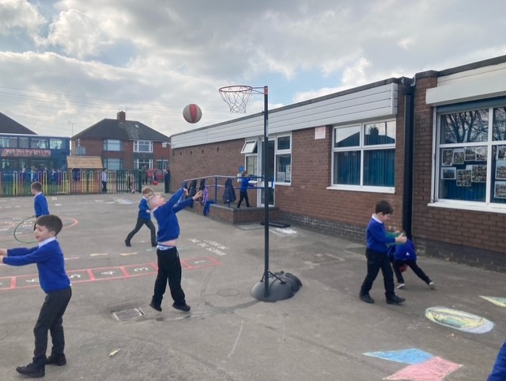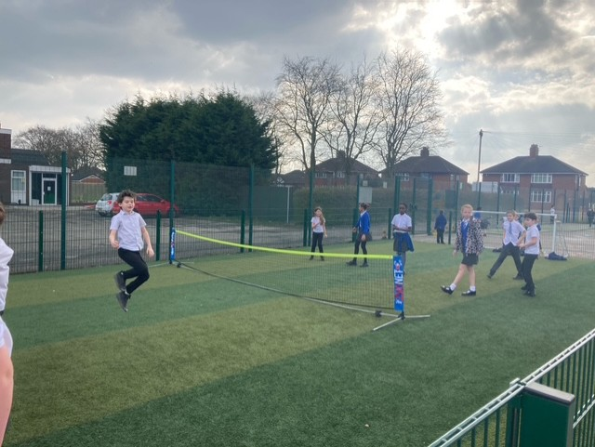

Our Playground Leaders have played a key role in supporting our commitment to achieving 60 active minutes each day. Trained pupils have organised and led a variety of inclusive playground games and activities during breaktimes and lunchtimes, encouraging participation from children across all year groups. This leadership opportunity has not only increased physical activity levels but has also helped to develop pupils’ confidence, communication, responsibility and leadership skills. The Playground Leader programme has contributed to a more active, inclusive and positive play environment, ensuring that all children have opportunities to be physically active throughout the school day.

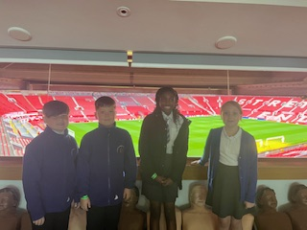
‘The playground Leaders taught me how to play and now I know how to do it’ - BH
‘I am good at tennis now because I practiced’- LN
‘Due to his responsibility for being a sports leader, his behaviour has improved in and out of the classroom. He has grown in resilience and adopted a nurturing role towards the children’ - Miss B

Impact of PE and Sport Premium Funding

The PE and Sport Premium funding has had a significant impact on the opportunities available to our pupils and has been instrumental in maintaining our Platinum School Games Mark status.

Funding has enabled us to utilise the school minibus to transport pupils to a wide range of competitions, festivals and sporting events throughout the year. This has ensured that children can access opportunities beyond the school environment, represent the school in competitive sport and experience a broad range of physical activities that may otherwise not have been possible.

The funding has also allowed us to purchase high-quality equipment and resources, enhancing the delivery of PE lessons, clubs and enrichment activities. Access to new equipment has increased participation, improved engagement and enabled us to broaden the range of activities available to pupils.

In addition, the funding has created opportunities for children to participate in new experiences such as a Triathlon, OAA, Rugby, Football and Cricket, helping them develop confidence, physical competence and a greater appreciation of healthy lifestyles.

Community Engagement and Transition

We have continued to strengthen links with local sports clubs, organisations, community events and our local high school, encouraging pupils to participate in physical activity beyond the school day and supporting a smooth transition into secondary education.

Through participation in competitions, festivals and enrichment activities, pupils have been introduced to a range of sports and community opportunities that support lifelong participation in physical activity. Where possible, pupils have attended local clubs and taster sessions, enabling them to experience sport in community settings and develop confidence in accessing opportunities outside of school.

Information about local sports clubs, community programmes and participation opportunities has been shared regularly with parents and carers, helping families to access activities that support healthy and active lifestyles. By signposting opportunities and maintaining strong partnerships with community providers, we have created clear pathways for pupils to continue their sporting journey beyond primary school.

We have also worked closely with our local high school to provide transition opportunities through sporting events, festivals and shared activities. These experiences help pupils become familiar with the secondary school environment, build confidence and encourage continued engagement in sport as they move into the next stage of their education.

These strong community links have enabled us to create clear pathways for pupils wishing to continue their sporting journey beyond school. By working closely with local providers and signposting opportunities to families, we have increased awareness of the wide range of activities available within the local area and encouraged greater participation in community sport.

Overall Impact

The impact of our PE and Sport Premium funding can be seen through:

- Successful maintenance of the Platinum School Games Mark.
- Increased participation in competitions, festivals and sporting events.
- Enhanced physical literacy across all year groups.
- Improved confidence, resilience, teamwork and leadership skills.
- Sustained commitment to achieving 60 active minutes each day.
- Increased engagement through active learning and physical brain breaks.
- Improved concentration, wellbeing and readiness to learn.
- Stronger links between physical activity, numeracy and curriculum learning.
- Access to high-quality equipment and resources.
- Greater opportunities for pupils using the school minibus.
- Increased participation in extracurricular clubs and community sport.
- Strong partnerships with local sports clubs and organisations.
- Improved transition experiences through sporting links with local high schools.
- Greater parental engagement through the sharing of community sporting opportunities.
- Development of lifelong healthy habits and positive attitudes towards physical activity.

Through strategic use of PE and Sport Premium funding, St Joseph the Worker has continued to provide an inclusive, engaging and high-quality sporting offer. Our commitment to physical literacy, daily activity, competitive sport and enrichment opportunities has enabled us to maintain our Platinum School Games Mark and ensure that all pupils have had the opportunity to thrive through physical activity and sport.

Next Steps for Development

As we continue to build upon our success, physical literacy will remain at the centre of our whole-school approach to Physical Education, School Sport and Physical Activity. We will continue to develop pupils’ confidence, competence, motivation and knowledge, ensuring that all children have the skills and desire to lead active and healthy lifestyles.

A key priority for the coming year is to strengthen our swimming provision. We are reviewing and adapting our swimming timetable to provide additional opportunities for pupils to access lessons and targeted catch-up sessions. These sessions will support children who have not yet met the expected swimming standards, ensuring that more pupils leave primary school able to swim confidently and safely.

By refining our swimming programme, we aim to increase the number of pupils who:

- Swim competently, confidently and proficiently over at least 25 metres.
- Use a range of strokes effectively.
- Demonstrate safe self-rescue skills in different water-based situations.
- Participate regularly in physical activity and school sport.
- Continue their involvement in sport as they transition to secondary education.

Alongside this, we will continue to promote 60 active minutes each day through active learning, physical brain breaks, playground activities and pupil leadership opportunities, ensuring that physical activity remains embedded throughout school life.

Through our commitment to physical literacy, inclusion, daily activity, competitive sport and community engagement, St Joseph the Worker will continue to provide an outstanding sporting offer and ensure that every child has had the opportunity to thrive, succeed and enjoy lifelong participation in physical activity and sport.

’AW would often get upset and refuse to participate in PE. After attending the nurture sessions with Mr Thompson and joining in at playtimes with the sports leaders, she now joins in all sport, PE and games with confidence.’ - Miss C

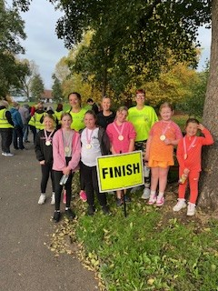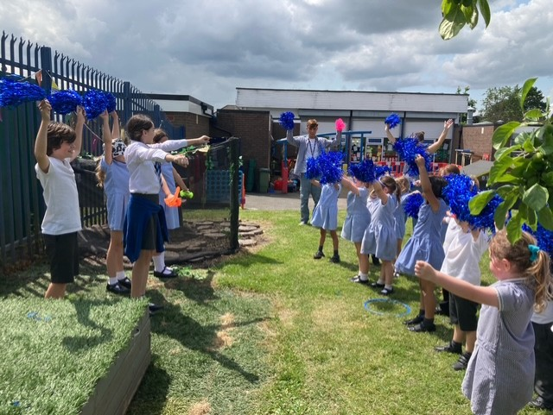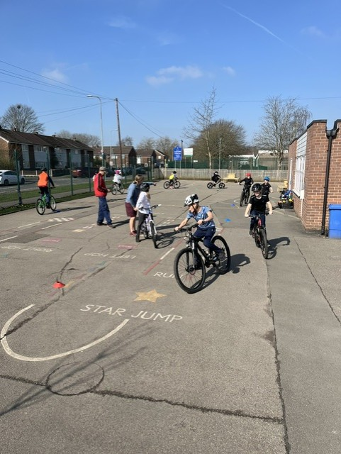
Park run Pom dance Bike ability

