Greenfield Academy
Behaviour Policy Appendix - Zones of Regulation
At Greenfield Academy, we have implemented the Zones of Regulation across the school as a strategy to assist our pupils in developing skills to maintain and improve their mental and social well-being. Adults and children alike, adopt the principles of the Zones on a daily basis and we incorporate these into lessons and daily life. The Zones of Regulation incorporates Social Thinking concepts and numerous visuals to teach pupils to identify their feelings/level of alertness, understand how their behaviour impacts those around them, and learn what tools they can use to manage their feelings and states. We encourage pupils to self regulate and use the Zones of Regulation to help manage their emotions. This approach helps pupils to develop an understanding of their own emotional state and provides them with strategies to regulate their behaviour. When pupils are able to recognise their emotions and self-regulate this is seen as a positive response to their behaviour.
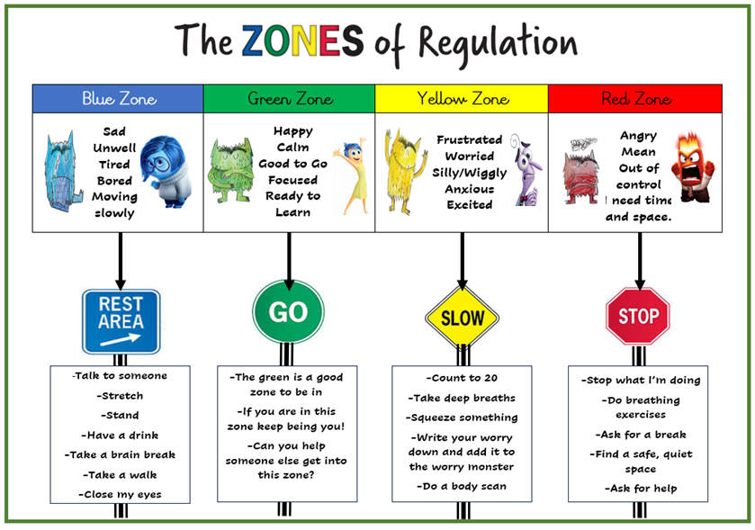

There are four zones:
Green Zone – is used to describe a calm state of alertness. A person may be described as happy, focused, content, or ready to learn when in the Green Zone. This is the zone where optimal learning occurs.
Blue Zone - is used to describe a low state of alertness. A person may have down feelings such as when one feels sad, tired, sick or bored.
Yellow Zone – is used to describe a heightened state of alertness and elevated emotions; however, a person has more control when they are in the Yellow Zone. A person may experience stress, frustration, anxiety, excitement, silliness, the wiggles, or nervousness when in the Yellow Zone.
Red Zone – is used to describe extremely heightened states of alertness and intense emotions. A person may be feeling or experiencing anger, rage, explosive behaviour, devastation, or terror when in the Red Zone.
The children learn to identify the emotions they are experiencing and the behaviour that may occur within each zone. They are taught how to regulate themselves using different strategies. When upset or angry children require time to calm down and manage their emotions before discussion around any unwanted behaviour takes place. Therefore, in every classroom, and on the playground, pupils have access to visuals and resources to share how they are feeling and a range of strategies to support them to manage their behaviour dependent on the zone they are in.
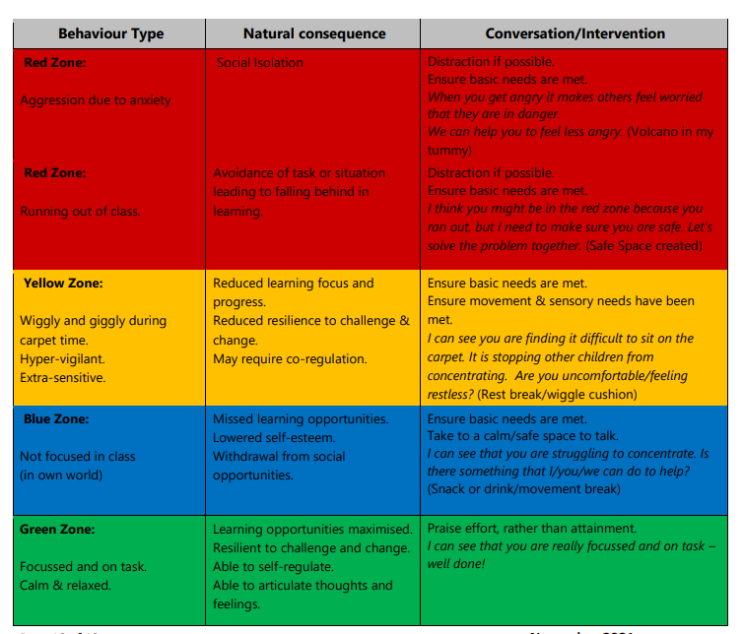

Expected and Unexpected Behaviour
Zones of Regulation teaches children how their behaviour affects the way other people think and act around them. We use the terms ‘expected’ and ‘unexpected’ behaviour. Pupils learn that expected behaviour enables people to have comfortable thoughts about them, and unexpected behaviour causes other people to have uncomfortable thoughts about them.
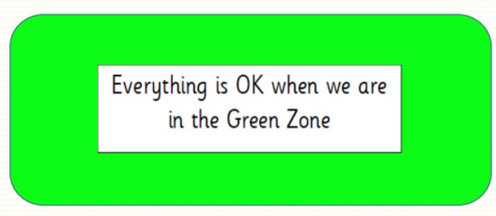

Size of the Problem
The Zones of Regulation ‘size of the problem’ teaches pupils to consider the size of their problem in contrast to the size of their reaction. It is an emotional regulation tool that can guide children to self regulate their emotions, in order to respond appropriately.
It helps children to know and understand the following:
- Problems come in different sizes
- Emotions and reactions come in different sizes
- Reactions come from emotions
- It’s expected that the size of the emotion and related reaction matches the size of the problem
By teaching pupils this, we help establish norms around defining and emotionally responding to a problem.
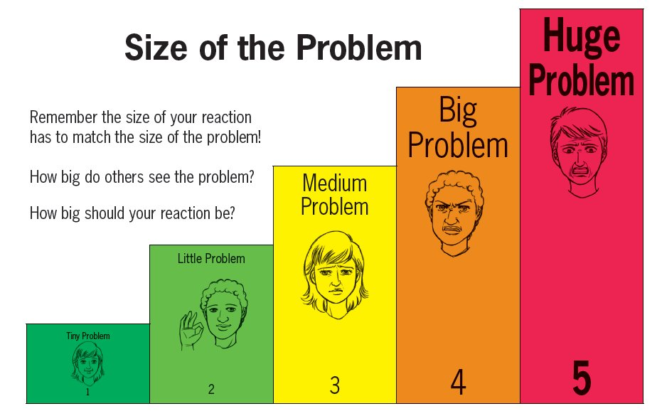
Inner Voice vs Inner Critic
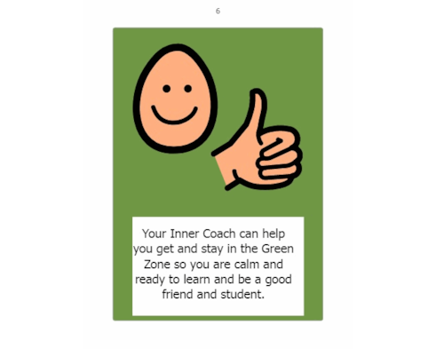
At Greenfield we teach pupils about positive self talk and the idea that everyone has an inner coach and an inner critic. Pupils learn that their Inner Coach uses positive self- talk to give courage and strength to get through stressful situations, even when they are hard or scary. Our Inner Critic uses a negative voice and angry self- talk when we make a mistake or something is hard. This makes us feel uncomfortable and does not solve problems. Pupils are taught that depending on “who” we listen to, it will impact our motivation, resilience, self-esteem, and skills to make connections with others.
