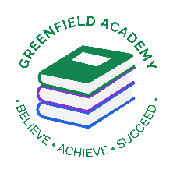
Greenfield Primary Academy
Year 3
Autumn Term 2 Learning Letter 2026
In Maths we are learning to …
In Maths, we will be exploring numbers up to 4 digits and addition and subtraction, and we will be:
- find 10 or 100 more or less than a given number
- Compare and order numbers up to 1000
- Recall and use multiplication facts for the 2, 4 and 8 multiplication tables
- Calculate mathematical statements for multiplication and division using what they know, including for two-digit numbers times one-digit numbers, using mental and progressing to formal written methods
- Recognise and use fractions as numbers
- Compare and order unit fractions,
- tell and write the time from an analogue clock
- add and subtract amounts of money to give change, using both £ and p in practical contexts

In English we are learning to …
Write in different ways: we will be looking at the features of emotion stories, setting descriptions, diary entry, persuasive letter in role and writing our own too.
Read more fluently: this term we will continue with whole class comprehension lessons in the same way as Year 2. Your child will have a reading book and will also have access to MyOn – our online reading program.
Understand Grammar: we will learn about:
Using coordination and subordination, inverted commas, apostrophes for possession, nouns and verbs, proper nouns and common nouns and prefixes.

In Art we are learning…To work with natural materials to complete a cave painting
To identify and explore secondary sources.​
To explore natural materials​
To collect and use natural materials for mark making.​
To create a painting using natural materials​
To reflect on my learning critically.

In RE we will explore the questions …
What does it mean to be a Hindu in Britain today?
This investigation enables pupils to learn about key aspects of Hindu belief and worship. What RE calls
‘Hinduism’ is the diverse way of life, spiritual practices and beliefs of the Indian people. We are focusing on
British Hindus, and there is great diversity in British Hindu tradition, as well as in ancient and modern Indian
Hindu traditions.

Our Learning Theme is …
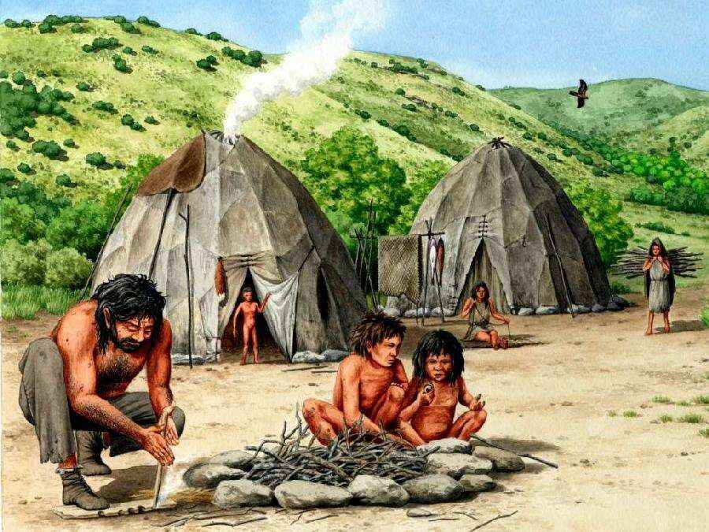

In History we are learning to …
Changes in Britain- The Stone, Bronze and Iron Age
- To know when the Stone Age was (ended in 3,300 B.C) and where it would be placed on a timeline of key events in British History.
- To know the achievements of prehistoric humans and the impact they have had.
- To describe what life was like for prehistoric humans.
- To know the differences between the stone, bronze and iron ages
- To know how Britain changed between the beginning of the stone age and the end of the iron age

In Science we are learning… Light and Shadow
Recognise that they need light in order to see things and that dark is the absence of light
- Notice that light is reflected from surfaces
- Recognise that light from the sun can be dangerous and that there are ways to protect eyes
- Recognise that shadows are formed when the light from a light source is blocked by an opaque object
- Find patterns in the way that the size of shadows change

In RHE/ PSHE we are learning to …
- To know the importance of exercise.
- To plan exercise into my daily and weekly routine.
- To understand the importance of hygiene
- To know ways of stopping germs from making me ill.
- To understand the role of food groups in a healthy diet.
- To plan and make a healthy meal.

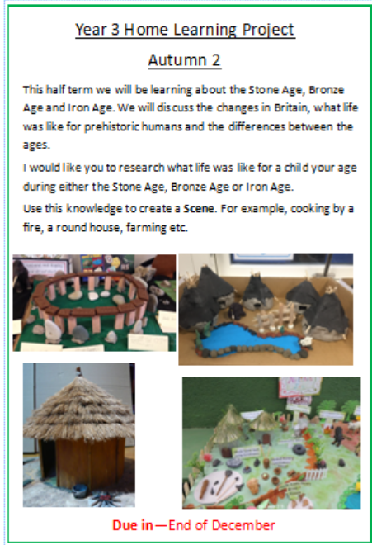
This half term we will be learning about the Stone Age, Bronze Age and Iron Age. We will discuss the changes in Britain, what life was like for prehistoric humans and the differences between the ages.
I would like you to research what life was like for a child your age during either the Stone Age, Bronze Age or Iron Age.
Use this knowledge to create a Scene. For example, cooking by a fire, a round house, farming etc.
Project due: End of December

READING
Please share your child’s reading book with them, as 10-15 minutes of reading every day at home can make a lot of difference to your child's reading ability.
Your child MUST bring their book bag into school every day so an adult can read with them on their reading day, and any extra days if there is an opportunity.
Children will have access to MyON or Bug Club to help develop their reading. This must we accessed at least 3 times a week for 10 minutes.
Each child will have a reading book, and an extra book from the class library.
MATHS TTRS and Sumdog
Children are to complete 30 minutes of TTRS Gig games every week. This will help them to learn their tables and become fluent.
Occasionally, their will be work set on Sumdog which will be related to the work completed in their maths lesson.
Swimming
The children will continue to go swimming weekly.

Year 3 Half Term Learning Project
Year 3 Weekly Home Learning Tasks

