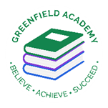
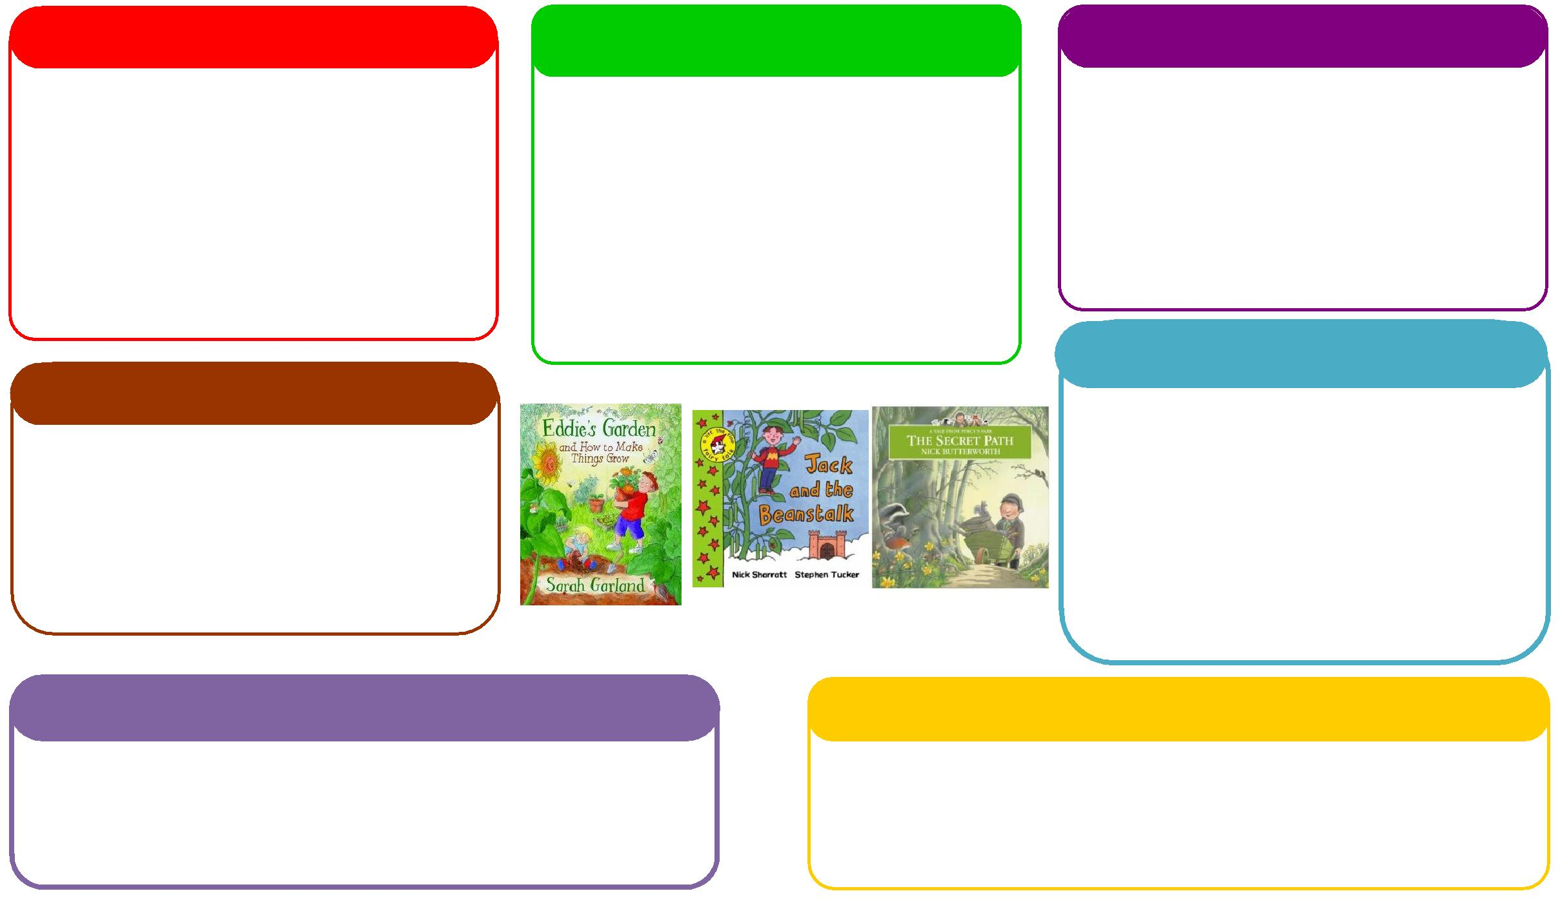
This half term we will be:
• Creating colourful firework pictures and rangoli-inspired patterns.
• Exploring paint, collage, textures and a variety of materials.
• Using small-world resources, role-play and Nativity props to act out stories.
• Making festive crafts and building models using different materials.

This half term we will be:

• Talking about celebrations, special days and our own experiences.
• Listening carefully to stories, songs, rhymes and to one another.
• Answering simple questions and talking about what might happen next.
• Building our vocabulary with words such as bright, loud, celebrate, festival, decorate and together.
• Retelling familiar stories and sharing our ideas with friends.
This half term we will be:

• Developing control when using pencils, paintbrushes, scissors and other tools.
• Strengthening our fine-motor skills through mark-making, collage and modelling.
• Moving our bodies in different ways, both indoors and outdoors.

This half term we will be:
• Recognising and talking about different feelings.
• Learning to take turns, listen to others and work together.
• Accessing familiar resources independently and seeking help from a trusted adult when needed.
• Trying new activities, sharing ideas and celebrating together.
This half term we will be:

• Finding out about Diwali, Bonfire Night, Remembrance and Christmas.
• Beginning to understand that people have different beliefs and celebrate different festivals.
• Talking about special events, family customs and celebrations we know.
• Exploring light and shadows using torches and natural light.
• Noticing seasonal changes and talking about the world around us.
This half term we will be:

• Exploring and making patterns with everyday objects, fabrics and loose parts.
• Comparing length and talking about position and shape.
• Recognising and exploring 2D shapes.
• Counting objects through practical games and activities.
• Comparing the weight of Christmas presents and other objects.
Expressive Arts and Design
Personal, Social and Emotional Development
Understanding the World
Physical
Mathematics
Communication and Language
English
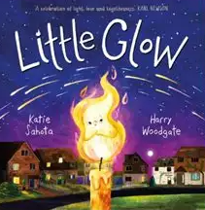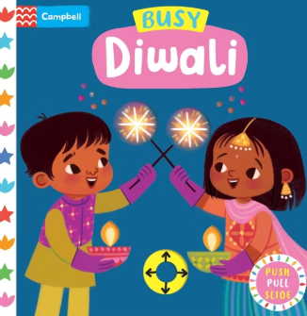
Learning Letter Autumn 2 Nursery & Reception
Let’s Celebrate!
This half term we will be:

• Talking about what is happening in stories and using pictures to help us understand.
• Learning new words from books and using them in play and conversation.
• Making marks, drawing pictures and experimenting with writing to share our ideas.
• Exploring books carefully, turning pages and enjoying stories, songs and rhymes.
EYFS Weekly Home Learning Tasks

READING
Please share your child’s reading book with them, as 10-15 minutes of reading every day at home can make a lot of difference to your child's reading ability.
Your child MUST bring their book bag into school every day so an adult can read with them on their reading day, and any extra days if there is an opportunity.
MATHS
Look for patterns and shapes at home or when you are out and about. Count objects together, compare which things are heavier or lighter, and talk about numbers you notice.

EYFS Half Term Learning Project

Choose a celebration that is special to your family. Create a picture, model or decoration inspired by it.
Be ready to tell us about your creation and share what you learned. We can’t wait to see it!

