
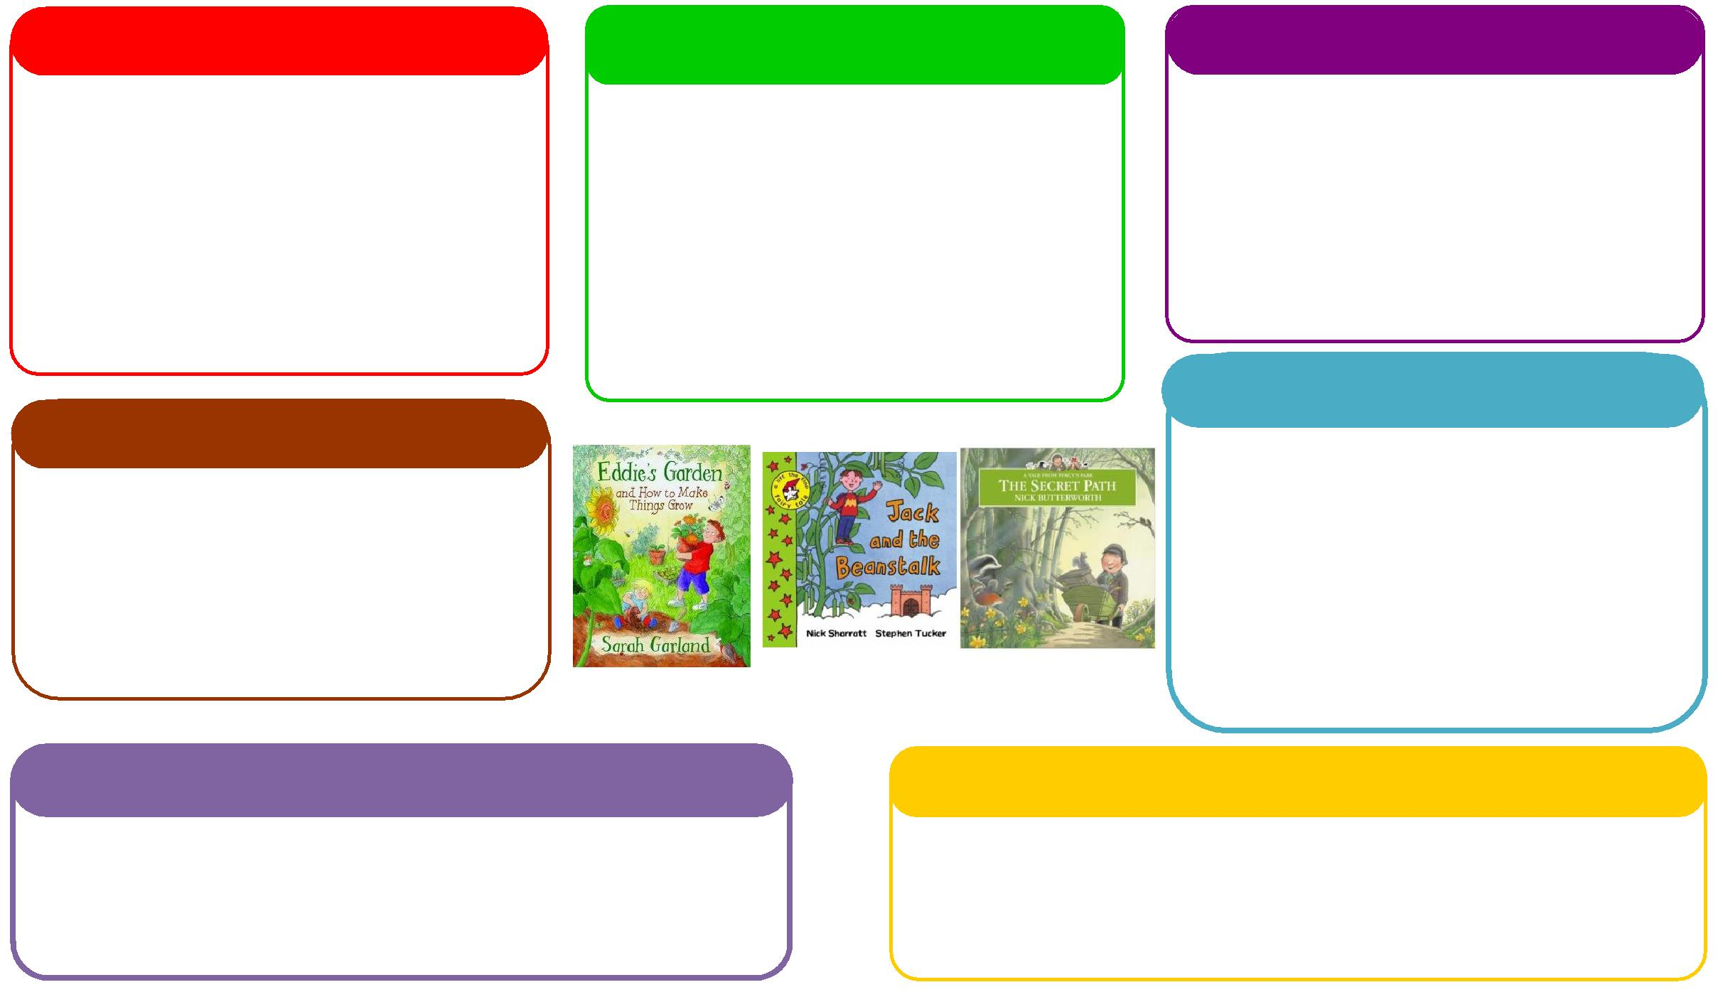
This half term we will be:

- Explore festive traditions and celebrations, talking about how families may celebrate in different ways.
- Encourage children to notice seasonal changes, such as colder weather, darker evenings and winter decorations.
- Explore the local environment through a festive learning walk, noticing lights, decorations, trees and other changes around

This half term we will be:
- Encourage children to share, take turns and play cooperatively during festive activities.
- Develop independence and confidence by encouraging children to make choices and help with simple festive tasks.
This half term we will be:
- Encourage children to count festive objects, such as lights, baubles, stars and presents.
- Explore colours, shapes and patterns through Christmas decorations and festive activities.
- Develop early understanding of size and quantity by comparing big/small, more/less and matching objects.

This half term we will be:
- Enjoy festive stories, songs and rhymes, encouraging children to listen, join in and repeat familiar words.
- Develop new vocabulary by talking about Christmas, decorations, colours, lights and festive characters.
- Encourage early mark-making through festive drawing, painting and creating simple Christmas cards or pictures.

This half term we will be:
- Develop gross motor skills through festive action songs, dancing and movement games.
- Practise balance and coordination by walking, stepping, jumping and moving
- Strengthen fine motor skills such as sticking, threading, posting and placing decorations
Physical
This half term we will be:
- Encourage children to talk about what they can see, such as lights, decorations, colours and festive objects.
- Develop listening and attention skills through festive stories, songs, rhymes and simple instructions.
- Introduce and encourage children to use new festive vocabulary, such as “sparkly”, “bright”, “tree”, “star” and “snow”.

Expressive Arts and Design
Personal, Social and Emotional Development
Understanding the World
Mathematics
Communication and Language
Literacy
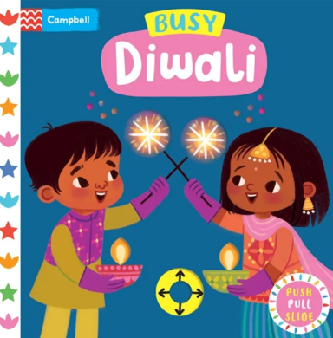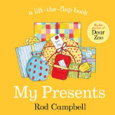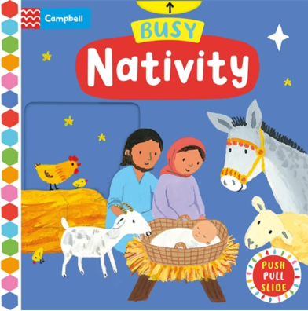
Learning Letter Autumn 2 Preschool
Special Times
This half term we will be:
- Encourage children to explore colours, textures and materials through festive painting, decorating and creative activities.
- Develop imagination and creativity through festive songs, dancing, role play and making Christmas decorations.

Preschool Weekly Home Learning Tasks
Communication and Language
Please talk together about festive things you see, encouraging your child to name colours, lights, decorations and objects.
Please share festive stories, songs and rhymes, giving your child opportunities to listen, join in and repeat words.
Please introduce new festive vocabulary, such as “sparkly”, “bright”, “twinkle”, “star” and “snow”, and use these words during everyday activities.
Physical Development
Please encourage festive movement and dancing through Christmas songs, action rhymes and simple movement games.
Please support fine motor skills through activities such as threading, sticking, decorating and making simple Christmas crafts.
Please enjoy active outdoor play and festive walks, encouraging children to walk, jump, climb and explore safely.
Personal, Social and Emotional Development
Please encourage children to share and take turns when playing with festive toys, decorations and activities.
Please talk about feelings and emotions using festive stories and everyday experiences, helping children name how they feel.
Please support independence and confidence by allowing children to make simple choices and help with safe festive tasks.

Preschool Half Term Learning Project

Festive Learning Walk 🎄✨
As part of our home learning, we would love for you and your child to go on a little festive learning walk together. Look out for different coloured lights, decorations, Christmas trees and other festive things you can spot along the way. Talk about the colours you see, count the lights or decorations, and encourage your child to describe what they can see. This is a lovely opportunity to develop their communication, observation and early maths skills while enjoying some festive fun together!

