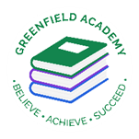
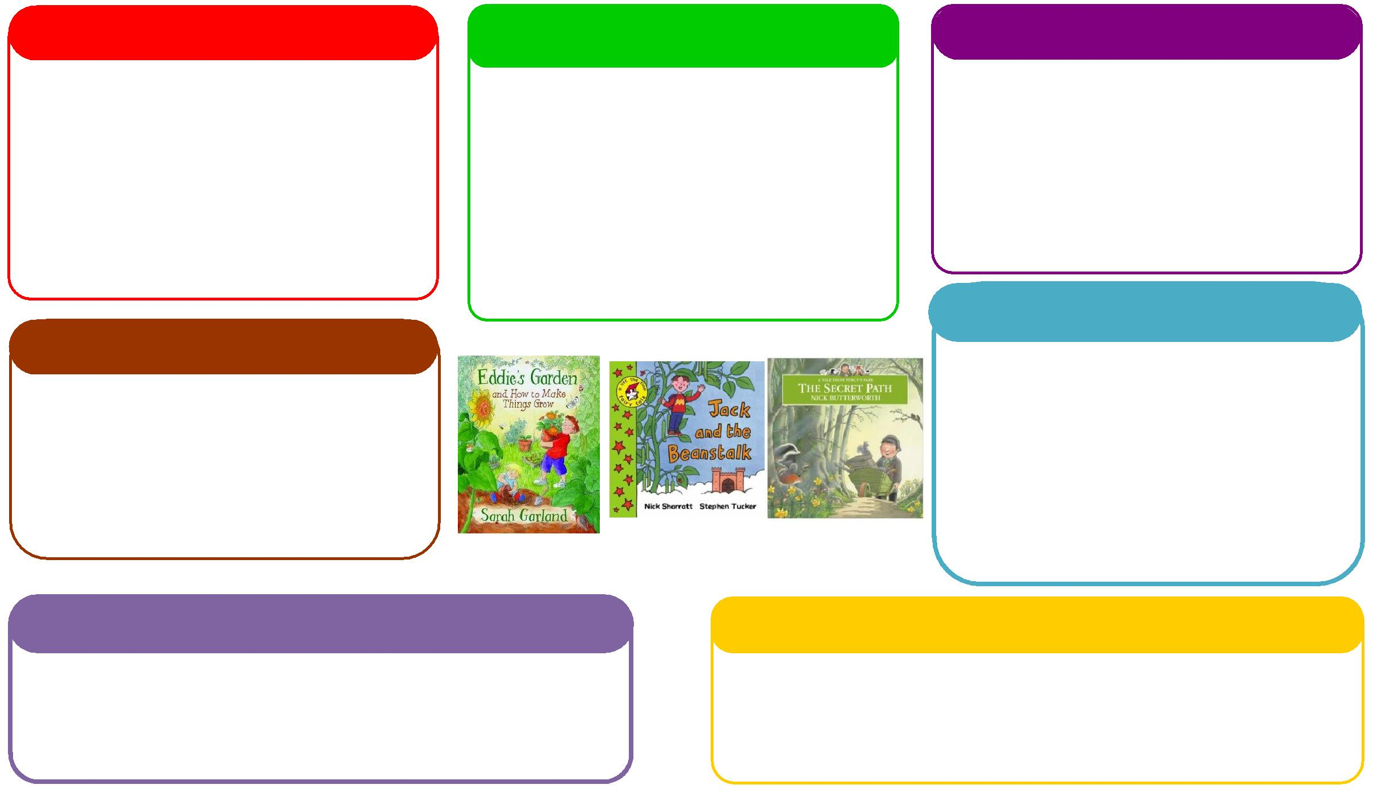
This half term we will be:

- Looking at baby photos of ourselves and talking about how we have changed,
- Talking about similarities and differences between people in the class,
- Talking about our families
- Beginnings to give meaning to pictures
- Starting to name different objects around the room
- Building on names of pupils and teachers

This half term we will be:

- Singing songs and rhymes,

- Labelling different parts of our body,

- Reading lots of books,
- Recognising our names a,
- Building on early stages of writing, drawing from left to right, up and down and to make circles
- Beginning to recognise letters and sounds

This half term we will be:

- Exploring our different senses,
- Looking at seasonal changes,
- Looking at family pictures to build on seeing that families look similar and different
- Exploring mirrors to build on facial recognition and to name those body parts
Expressive Arts and Design
Personal, Social and Emotional Development
Understanding the World
Physical
Mathematics
Communication and Language
English
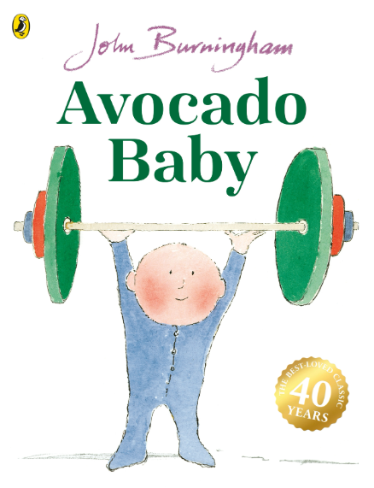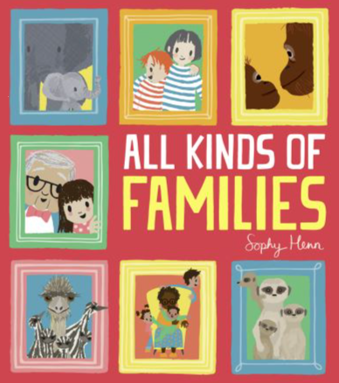
This half term we will be:
- Counting alongside their play within areas
- Modelling language
- Singing lots of number songs
- Exploring different resources in the room and garden to begin recognising basic shapes within their environment
Learning Letter Autumn 1 Preschool
This is Me
This half term we will be:
- Painting self-portraits – hand and finger painting,
- Making music with our bodies,

- Building on early stages of writing, drawing from left to right, up and down and to make circles

This half term we will be:
- Learning the rules and routines of the classroom,
- Working together to solve problems.
- Building on key bonds with teachers and other students
- Building on social interactions through back-and-forth activities

This half term we will be:
- Learning how to use the outdoor area safely,
- Learning how to manipulate resources using their hands
- Building on their special awareness within the environment

Preschool Weekly Home Learning Tasks
Communication and Language
Please build on singing on different nursery rhymes, promoting rhythm and rhyme.
Please read books with your child at home to build on language and modelling language for your child to copy.
Please talk about Preschool to support your child’s transition into a new place.
Physical Development
Please build on your child’s larger movements while you are out and about. Can you jump? Can you roll? Can you curl into a ball?
Please support your child’s smaller movements through their mark making. Can you draw up and down? Can you draw left to right? Can you draw in a circle?
Personal, Social and Emotional Development
Please can you support your child’s transition into Preschool by speaking lots about the room and teachers to support building a positive bond to the room
Please support your child through naming emotions to support their acknowledgement of their feelings
Please support your child to carry out turn taking activities, for example, rolling a ball to one another, taking turns stacking blocks

Preschool Half Term Learning Project

Go on an Autumn walk to collect lots of different natural resources to bring into class to show to others. We can add these into the mud kitchen for further exploration though their play

