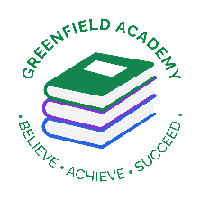
Greenfield Primary Academy
Year 3
Autumn Term 1 Learning Letter 2026
In Maths we are learning to …
- Count in multiples of 6,7,9, 25 and 1000
- Find 1000 more/less than a given number
- Use place value, know and derived facts to multiply and divide mentally, including: multiplying by 0 & 1;
- Recall multiplication and division fact for multiplication tables up to 12 x 12
- Use place value, know and derived facts to multiply and divide mentally, including: multiplying by 0 & 1; multiplying together 3 numbers,
- Count up and down in hundredths;
- Compare numbers with the same number of decimal places up to 2decimal places.
- Estimate, compare and calculate different measures,

In English we are learning to …
Write in different ways: we will be looking at the features of character descriptions, a persuasive letter and instructions, and will be writing our own too.
Read more fluently: this term we will continue with whole class comprehension lessons in the same way as Year 2. Your child will have a reading book and will also have access to MyOn – our online reading program.
Understand Grammar: we will learn about:
Noun, verbs, adjectives, Apostrophes (contraction), Prepositions,
Alphabetical order, write different types of sentences (statements, questions, commands) and find and use synonyms

In DT we are learning to …
- name and identify different UK-grown fruits and vegetables and explain why eating a variety of colours is healthy.​
- create a design for a rainbow salad pot using UK ingredients and describe what makes their salad healthy and colourful.​
- safely prepare and handle fruits and vegetables using appropriate tools and techniques.​
- Follow their plan to assemble a colourful, balanced salad pot with a dip, maintaining hygiene and safety throughout.​
- Use descriptive words to evaluate it, and suggest one way to improve their design.

Our Learning Theme is …
The UK


In RE we are learning …
What does it mean to be a Christian in Britain today?

- How do Christians show their beliefs in the home?
- What do Christians do to show their beliefs at Church?
- How and why do different Christians use music in worship?

In Science we are learning … Forces and Magnets
-compare how things move on different surfaces
-notice that some forces need contact between two objects, but magnetic forces can act at a distance
-observe how magnets attract or repel each other and attract some materials and not others
- compare and group together a variety of everyday materials based on whether they are attracted to a magnet, and identify some magnetic materials
-describe magnets as having two poles
-predict whether two magnets will attract or repel each other, depending on which poles are facing.

In Geography we are learning to …
- Identify that the United Kingdom is made up of England, Northern Ireland, Scotland and Wales.
- Identify the capital cities of these countries.
- Know that countries are split into counties and county towns
- Identify Human, Physical and Topographical Features
- Know that grid references are used to locate a particular square on a map and that they have 2 axes – x axes (horizontal) and y axes (vertical). We go along the x axes first and then up the y axes ‘along the corridor and up the stairs.
- Be able to record grid references by putting the number of the x axes square first followed by a comma and then the number of the y axes square.
- Identify the Compass Points (8 points)

In RHE/ PSHE we are learning to …
- Understand what rules and responsibilities are and explain the school rules.
- Understand what manners are and courtesy is.
- Talk about democracy and why it is important.
- Understand what respect is and how to treat others with respect.

Geography: The British Isles
Your Half Term Learning project is to research and plot a journey from one end of the UK to the other. You must begin your Journey at John o'Groats in Scotland and finish at Lands End in Cornwall.
You must make a map and plot at least 6 different cities and label them on your map.
You can get creative and make a PowerPoint presentation, and you can also make a short video diary of your work as you go! If you are feeling really creative, you could also make a model of the UK with your cities represented with a key feature.
Don’t forget to bring your work in to share with your class.

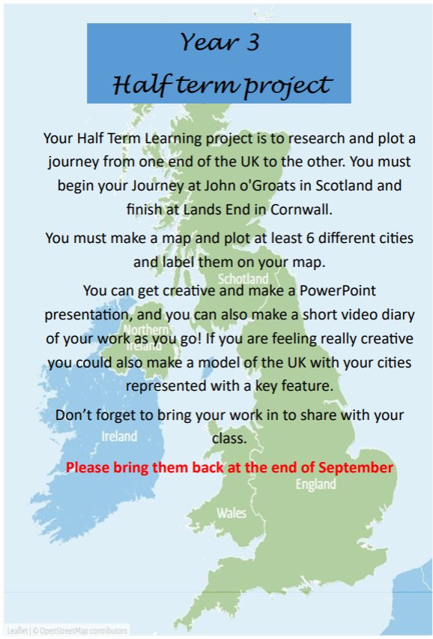
Year 3 Half Term Learning Project
Year 3 Weekly Home Learning Tasks
READING
Please share your child’s reading book with them, as 10-15 minutes of reading every day at home can make a lot of difference to your child's reading ability.
Your child MUST bring their book bag into school every day so an adult can read with them on their reading day, and any extra days if there is an opportunity.
Each child will have a reading book, and an extra book from the class library.
MATHS
Each child has received a copy of multiplications to 12. Please use this to work with your child so they become more confident with their times table knowledge.
Swimming
This year your child will attend weekly swimming sessions on Tuesdays You have received a booklet with all of the relevant information. If you have any questions either call school or come and see me at drop off and pick up.

