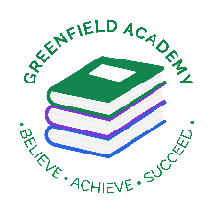
Greenfield Primary Academy
Year 4
Autumn Term 1 Learning Letter 2025
In Maths we are learning the following:
- Place value - 4-digit numbers, finding 1000 more and less than a given number.
- Addition – add 1,10,100 and 1000 to given numbers, adding 2 4-digit numbers using formal methods and regrouping.
- Subtraction – subtracting 1,10,100 and 1000 from a given number, subtracting 2 4-digit numbers with exchanging and using formal methods.
- Angles – full and half turns, acute, obtuse and right angles. Comparing angles.
- Shape – parallel and perpendicular lines, different triangles and quadrilaterals. Regular and irregular polygons.
- Time – reading analogue clocks, converting time between analogue and digital, reading 12 hour clock using AM and PM.

In English we are reading the text Perseus and the Gorgon Medusa and we will be…
- Writing setting descriptions
- Writing character descriptions
- Writing instructions on how to defeat a Gorgon.
Read more fluently: this term we will continue with whole class comprehension lessons in the same way as Year 3. Your child will have a reading book and will also have access to MyOn – our online reading program.
Understand Grammar: we will learn about:
Noun, verbs, adjectives, Apostrophes (contraction), Prepositions,
Alphabetical order, write different types of sentences (statements, questions, commands) and find and use synonyms.
Our Learning Theme is …
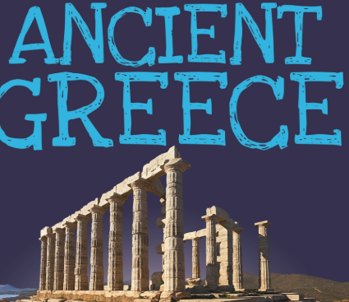

In Art we are learning to …
- Use different grades of pencil to shade
- To understand different techniques used by artists
- To understand tone and texture
- To make tertiary colours
- To use watercolours in the style of Monet
- Create different effects by using a variety of tools and techniques such as bleeds, washes, scratches and splashes

In RE we are learning to …
What does it mean to be a Hindu in Britain today?
- What it means to live in a Hindu community.
- How festivals are celebrated.
- Why Mahatma Gandhi is a hero
- What it is like to be a Hindu in Britian today.

In History we are learning about Ancient Greece. We will be focusing on…
- Placing Ancient Greece on a timeline.
- Exploring how living in Ancient Greece shaped lives. Democracy in Ancient Greece and the effect on people.
- The different roles of men and woman.
- The social hierarchy in Ancient Greece.
- Acropolis and its importance.

In Science we are learning that …
Materials exist in three ‘States of matter’ We will be focusing on…
- Key differences between solids, liquids and gases.
- How liquids have a fixed volume.
- Classifying materials into different states.
- Investigating gases.
- Identifying and classifying materials.
- The water cycle.

In RHE/ PSHE we are learning to …
- Understand what rules and responsibilities are and explain the school rules.
- Understand what manners are and courtesy is.
- Talk about democracy and why it is important.
- Understand what respect is and how to treat others with respect.
- Understand what an opinion is and give their opinions on different subjects.

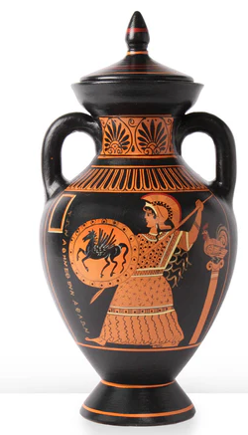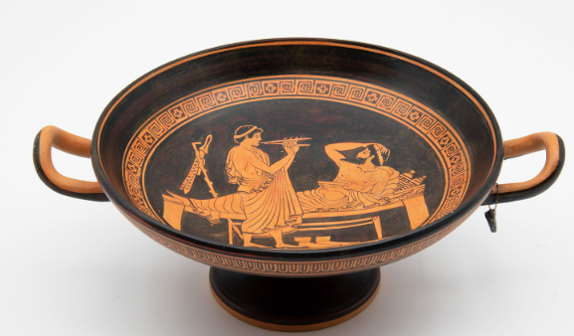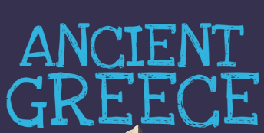
Geography: Ancient Greece
For your half term project, you are asked to research Ancient Greece and present your finding. You can create a poster with information and drawings or a PowerPoint.
If you wish, you can make an Ancient Greek artefact or model to be displayed in the class.
Be creative and I can’t wait to see what you come up with.

Due by: Friday 25th September

Year 4 Summer Learning Project
Year 4 Weekly Home Learning Tasks
READING
Please share your child’s reading book with them, as 10-15 minutes of reading every day at home can make a lot of difference to your child's reading ability.
Your child MUST bring their book bag into school every day so an adult can read with them on their reading day, and any extra days if there is an opportunity.
Each child will have a reading book, and an extra book from the class library.
Every child will have an online MyOn account where they can read books and answer questions. This is in addition to their daily reading book task.
MATHS
Every child has a TTRockstars, they can use these to practise their times tables facts online as it is important times tables are learnt for this year. 10 minutes every day will mean that they are ready for their times tables test in Summer and will make them much quicker at working things out in class.
They will also be receiving homework linked to maths and reading.

