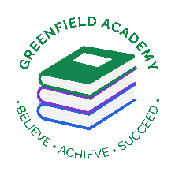
Greenfield Primary Academy
Year 5
Summer 2 Term Learning Letter 2026
In English we are studying, Hamlet and Oliver Twist. Our focus will be:
- Playscripts
- Persuasive letters
- Narrative
- Formal letter
In Math we are studying:
- Angles – acute, obtuse, reflex,
- Right angles, angles in a straight line
- Triangles
- Quadrilateral
- Statistics

In RE we are studying: Green religion? How and why should religious communities do more to care for the Earth?
- Does Earth belong to God?
- Muslims and environment.
- Christians and environment
- Hindus and environment
- Jewish and environment

In D.T we will learn how to make moving toys.
- Toys with cam mechanisms
- Different types of cams
- Design a toy with cam mechanism
- Make cam mechanism toys.

Our Learning Theme is
The Victorians
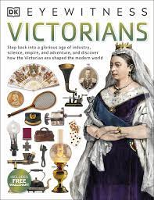

In Science we are studying Living things.
- Differences in life cycles
- Explore Jane Goodall and her work with Chimpanzees
- Create own animal and write a non-chronological report including life cycle.
In History we are studying The Victorians.
- Explore Bernardo
- How attitudes to children changed over time.
- Victorian time inventions
- Greatest impact from Victorian time.
- Impact of Victorian period on present day.

In PSHE out theme is Health and Well-being. We will be studying how we change and grow.
- What makes up health. . Know where to seek help for health
- Physical illness . Recognise change in bodies
- Effects of lack of sleep . Understand emotional changes

Half Term project
We would like children to spend time practicing their lines for the performance of Shakespeare’s Hamlet which will take place at the Middleton Arena on the 23rd June 2026.
Ticket information has been sent out- available to purchase on Parent Pay
A Maths pack has been given to al children to practice all four operations and Place value.
Year 5 Half Term Learning Project
In Year 5 there is a certain expectation when it comes to Home Learning. Please see this outlined below:
Individual Reading Books
All children must read a few pages each night at home and write a comment in their reading diary.
MyOn
Children are expected to complete MyOn reading everyday with books of their choice online.
TT Rockstars
Children will be set 25mins (5 mins daily) of TTRockstars to practise their times tables.
SumDog
Children will be set a task on SumDog where they have 50 questions to answer based on their learning in class that week.

Year 5 Weekly Home Learning Tasks

