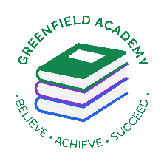
Greenfield Primary Academy
Year 3
Summer Term 2 Learning Letter 2026
In English we are learning to …
Write in different ways: this term we will focus on fantasy stories, explanations and mystery stories.
Read more fluently: this term we will continue with whole class comprehension lessons. Your child will have a reading book and will also have access to MyOn – our online reading program.
Understand Grammar: this term we will focus on tenses, paragraphs, word families based on common words, prefixes, clause, subordinate clause.

In Maths we are learning to …
In Maths, we will be exploring numbers up to 4 digits
- Rounding to the nearest 10, 100
- Times table facts and grid method
- Multiplying and divide by 10 and 100
- Finding unit fractions of amounts
- Finding non-unit fractions of amounts
- Measure and compare capacity
- Add and subtract capacity
- Tally charts
- Human bar charts
- Drawing bar charts
- Interpreting data and problem solving

In Art and Design, we are learning…Egyptian collar
(cutting and joining)
- How to use cross-stitch as a decorative feature or to join two pieces of fabric together.
- How to design, cut and shape their template for a collar.
- How to decorate their Egyptian collar using a variety of techniques.
- How to recognise different types and qualities of fabrics.

Our Learning Theme is …
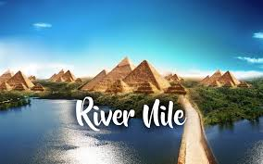

In RE, we will explore the questions … Why do people pray?
- Describe the practice of prayer in the religions studied.
- Make connections between what people believe about prayer and what they do when they pray.
- Describe ways in which prayer can comfort and challenge believers.
- Describe and comment on similarities and differences between how Christians, Muslims and Hindus pray.

In Geography, we are learning…The River Nile
- That the River Nile passes through Egypt and 10 African countries​.
- Why the River Nile was important in Ancient Egypt and still is in Egypt today​.
- Some of the changes that have happened to the River Nile over time including flooding​.
- The similarities and differences between the River Nile and the River Thames.

​

In Science we are learning…Skeletons, Muscles and Movement
- Know the main parts of a human skeleton
- Be able to compare the skeletal structure of different animals
- Know how muscles work

In RHE/ PSHE we are learning…Emotions
The children will:
- I can talk about loss and separation
- I respect and empathise with others
- I know some ways to manage and control strong feelings and emotions
- I know that I can get help if my family makes me feel unhappy or unsafe

Year 3 Weekly Home Learning Tasks

READING
Please share your child’s reading book with them, as 10-15 minutes of reading every day at home can make a lot of difference to your child's reading ability.
Your child MUST bring their book bag into school every day so an adult can read with them on their reading day, and any extra days if there is an opportunity.
Each child will have a reading book, and an extra book from the class library.
They all now have access to MyON – the schools online reading app to help develop and improve their reading
MATHS
Each child has received a copy of multiplications to 12. Please use this to work with your child so they become more confident with their times table knowledge.
Swimming/P.E
The children will continue to go swimming weekly on Tuesdays and P.E will be on Fridays

Year 3 Half Term Learning Project

