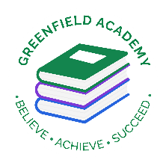
Greenfield Primary Academy
Year 5
Summer 1 Term Learning Letter 2026
In Math we are studying:
- Rounding numbers to the nearest 10, 100 and 1000
- Add and subtract numbers with more than 4 digits using a written method- including decimals
- To multiply integers and decimals
- To divide using short division
- To solve multiplication and division problems
- To convert between different units of time
- To know what percentages are and convert between percentages and fractions.

In English we are studying Spiderwick Chronicles
- Setting descriptions
- Character profiles
- Narratives
- Explanation texts

We will also be looking at Victorian poetry.

Our Learning Theme is …
The Victorians
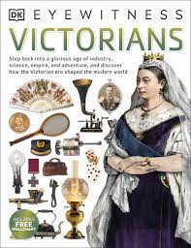

In RE we are studying: If God is everywhere, why go to a place of worship?
- Churches
- Synagogues
- Hindu Temples
- Create our own place of worship.

In Art we are looking at printing and patterns.
Focusing on work by William Morris.

In Science we are studying Living things.
- Life cycles of mammals, amphibians, insects and birds.
- Life process/reproduction of animals and plants.
- Describe changes in humans over time.

In History we are studying The Victorians.
- Victorians and British timeline
- Queen Victoria
- Victorian schooling.
- Children in Victorian times
- How the Victorian Era has impacted modern day Britain

In RHE/ PSHE we will be completing Apple Module 4 – Solving Problems and how to stay safe online.
- Effects of online bullying – mentally and effect on others.
- Know how to get help
- Benefits of rationing time online.

In Year 5 there is a certain expectation when it comes to Home Learning. Please see this outlined below:
I
ndividual Reading Books
All children must read a few pages each night at home and write a comment in their reading diary.
MyOn
Children are expected to complete MyOn reading everyday with books of their choice online and complete quizzes on AR
TT Rockstars
Children will be set 25mins (5 mins daily) of TTRockstars to practise their times tables.
SumDog
Children will be set a task on SumDog where they have 50 questions to answer based on their learning in class that week.
Shakespeare Lines
Children will be given a Shakespeare script to learn over the term for performance in June.

Your task is to research an invention from Victorian times and the person who invented it. Then create a fact file about it and its inventor. You can present the information in this fact file however you wish. Be as creative as possible!
You could include information such as:
- Who was it that invented the invention?
- What was their occupation, what was their family life like? What was their childhood like?
- What’s does the invention do? What does it look like?
- How did the inventor come up with their idea?
- What makes their invention so special?
- How does their invention effect modern life?

Year 5 Half Term Learning Project
Year 5 Weekly Home Learning Tasks

