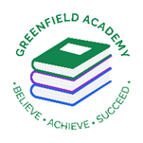
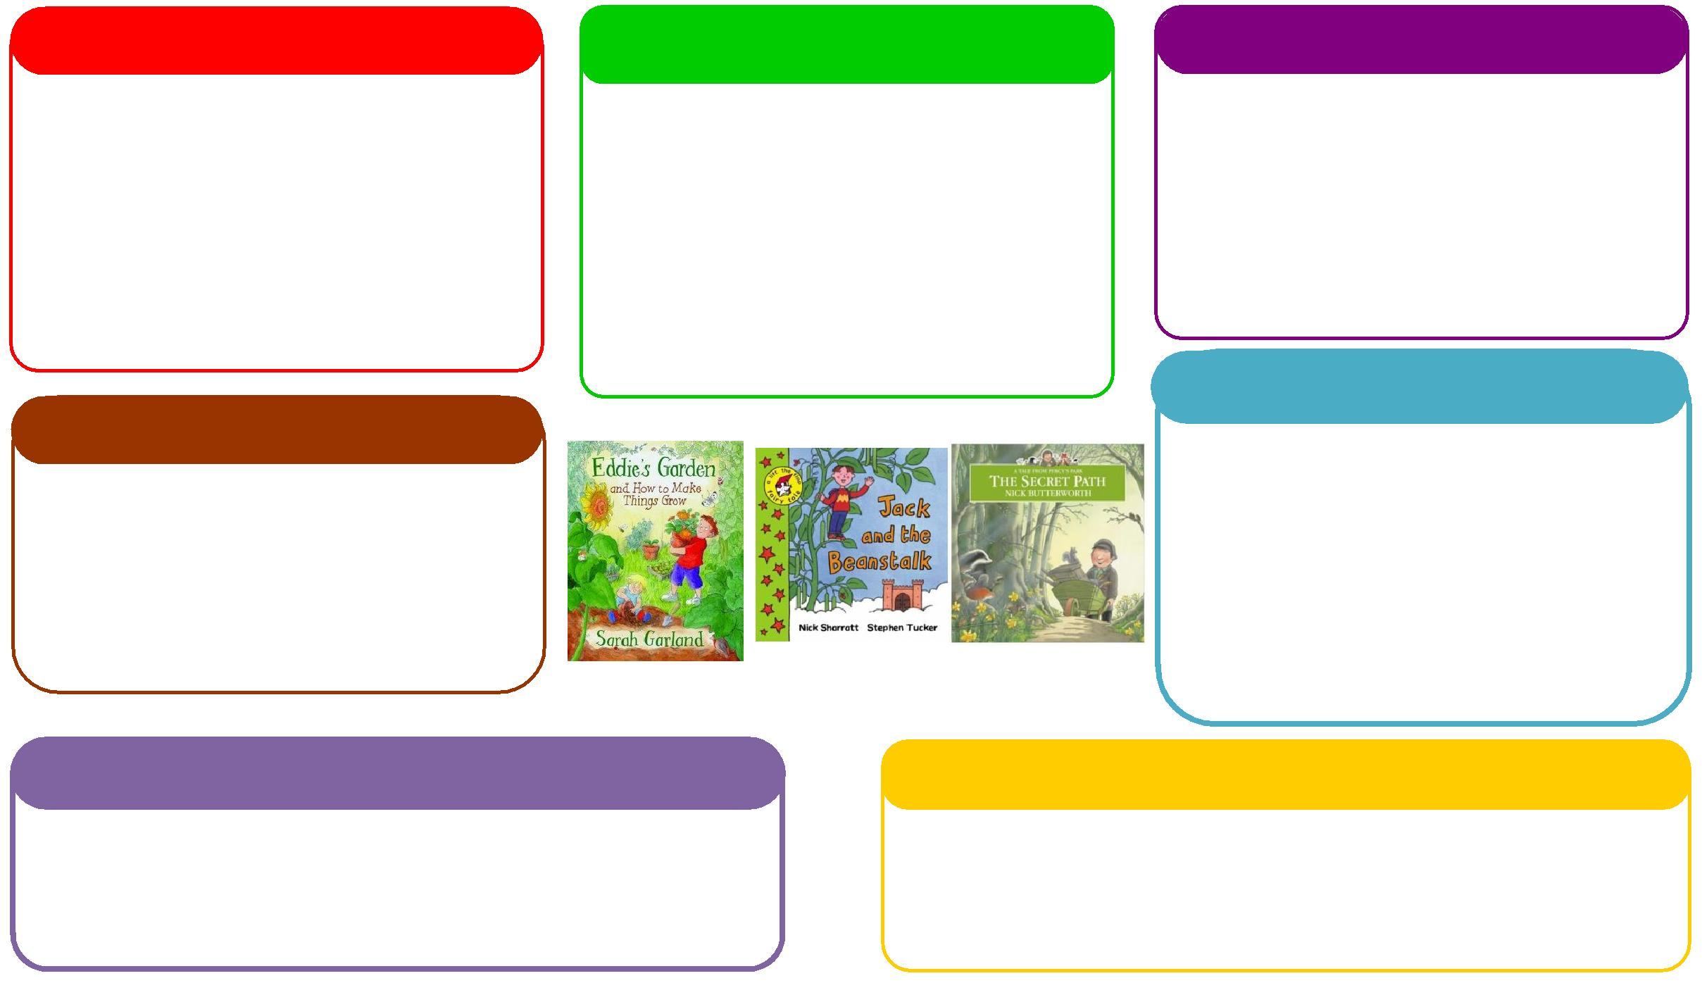
Learning Letter Summer 1 EYFS
Life Cycles
This half term we will be:
- Looking at the key features of the life cycle of a hen by hatching our own chicks,
- Growing our own plants and herbs,
- Looking at animal life cycles,
- Comparing different environments.

Expressive Arts and Design
Personal, Social and Emotional Development
Understanding the World
Physical
Mathematics
Communication and Language
English
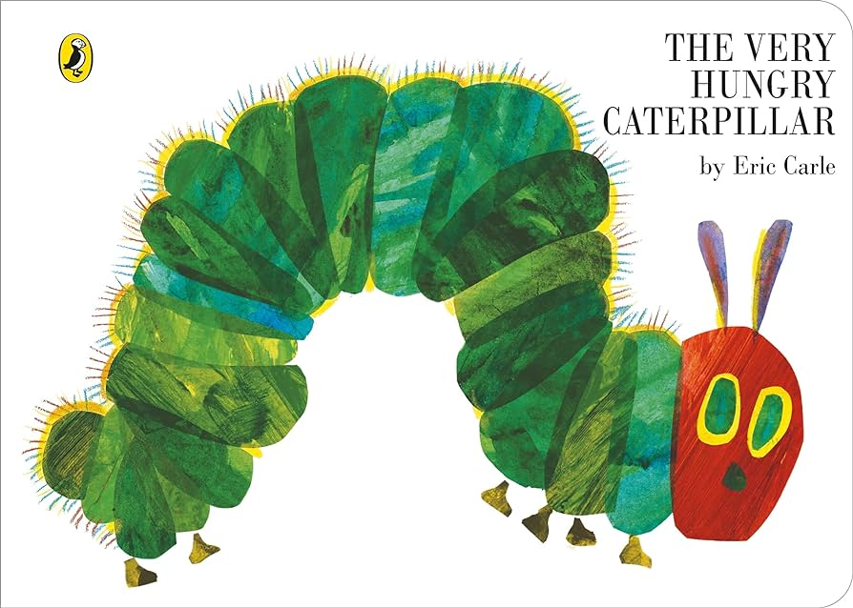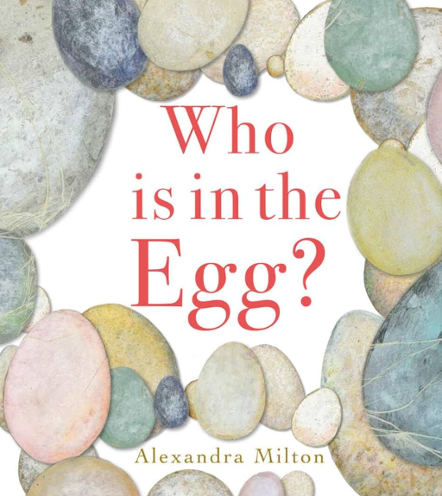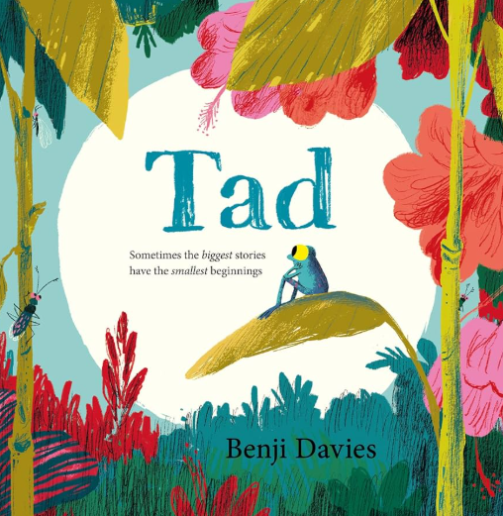
This half term we will be:
Reception:
- Spatial reasoning,
- Building numbers beyond 10,
- Doubling,
- Halving,
- Odd and even.
Nursery:
- 3D shape
- Counting beyond 10
- Sequencing
- More/less
- Matching numerals to amounts

This half term we will be:

- Discussing with our friends what we got up to in the holidays,
- Acting out different stories together,
- Using the language of explanation to explain lifecycles,
- Talking about seasonal changes.
This half term we will be:
- Introducing the artist, Andy Goldsworthy.
- Having dance lessons in the hall,
- Making pictures using natural resources. Focusing on cutting and layering techniques.

This half term we will be:
- Discussing how we can care for the chicks,
- Looking at the different characters in the story and how they are feeling,
- Using our Think Equal books during circle time.

This half term we will be:
- Retelling stories,
- Recording how our plants have grown,
- Writing in response to the chicks in classroom, including how they hatch from eggs,
- Creating life cycle
- Reading nonfiction books about life cycles.
This half term we will be:
- Exploring healthy and unhealthy foods linked to the text Oliver’s Vegetables,
- Making vegetable soup using simple utensils and equipment to mix, grate and squeeze safely,
- Using our skills from Little Bikers to practice riding our new balance bikes.

EYFS Half Term Learning Project

Can you plant a seed at home? What does the seed need to grow? What have you grown? Can you measure how tall it has grown?

