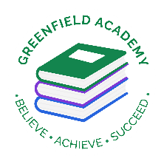
Greenfield Primary Academy
Year 3
Spring Term 2 Learning Letter 2026
In Maths we are learning to …
In Maths, we will be exploring numbers up to 4 digits and addition and subtraction, and we will be:
- Read, write and compare numbers
- Word problems
- Multiply by 10 and 100
- Missing factors
- Inverse operations
- Dividing by 10 and 100
- Missing factors
- Adding and subtracting fractions
- Equivalent fractions
- Making and reading the time digitally
- Roman numerals

In English we are learning to …
Write in different ways: Stories from another culture, informal letter and non-chronological report.
Read more fluently: this term we will continue with whole class comprehension lessons. Your child will have a reading book and will also have access to MyOn – our online reading program.
Understand Grammar: Suffixes, Past tense, Present perfect form of verbs, Homographs, Determiners

In Art and Design we are learning…Food
- Food Seasonal tart (Baking)
Understand how to prepare and cook a savoury dish safely and hygienically including, where appropriate, the use of a heat source.
Begin to understand how to use a range of techniques such as peeling, chopping, slicing, grating, mixing, spreading, kneading and baking

- Form and Sculpture (Paper technology)

-

In RE we will explore the questions … Why are festivals important to religious communities?
- Make connections between stories, symbols and beliefs with what happens in at least two festivals.
- Ask questions and give ideas about what matters most to believers in festivals.
- Identify similarities and differences in the way festivals are celebrated within and between religions.
- Explore and suggest ideas about what is worth celebrating and remembering in religious communities and in their own lives.
Our Learning Theme is …
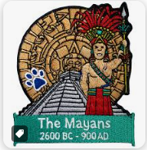

In History we are learning to … Mayan Civilisation
- To understand that the Mayan civilization started in 2000BC and ended in 250AD.
- Know about the impact that the Mayan civilisation had on the world.
- Know why they were considered an advanced civilisation in relation to that period of time in Europe

​

In Science we are learning…
-identify and describe the functions of different parts of flowering plants: roots, stem/trunk, leaves and flowers
- explore the requirements of plants for life and growth (air, light, water, nutrients from soil, and room to grow) and how they vary from plant to plant
-investigate the way in which water is transported within plants
-explore the part that flowers play in the life cycle of flowering plants, including pollination, seed formation and seed dispersal.

In RHE/ PSHE we are learning to …
Identify some of the dangers of being online
Understand the importance of keeping personal information safe
Describe how to behave appropriately online

READING
Please share your child’s reading book with them, as 10-15 minutes of reading every day at home can make a lot of difference to your child's reading ability.
Your child MUST bring their book bag into school every day so an adult can read with them on their reading day, and any extra days if there is an opportunity.
Each child will have a reading book, and an extra book from the class library.
MATHS
Each child has received a copy of multiplications to 12. Please use this to work with your child so they become more confident with their times table knowledge.
PURPLE MASH
Each week the children will be set several tasks on Purple Mash. They log on to their account and complete their tasks. When they log on, there is a bell at the top of the screen. When they click on this, it will show them all the tasks they need to complete for that week.
Tasks are allocated on a Friday and have to be completed by the following Tuesday. There is usually a grammar, writing, spelling, maths and a Topic task.
Swimming
The children will continue to go swimming weekly.

Year 3 Half Term Learning Project
Year 3 Weekly Home Learning Tasks

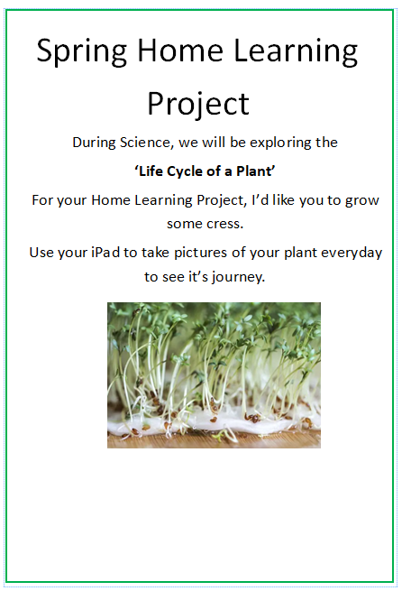
Due back on
Monday 23rd March
Keep the cress at home, maybe eat it.
Take pictures of it every day.

