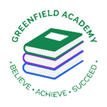
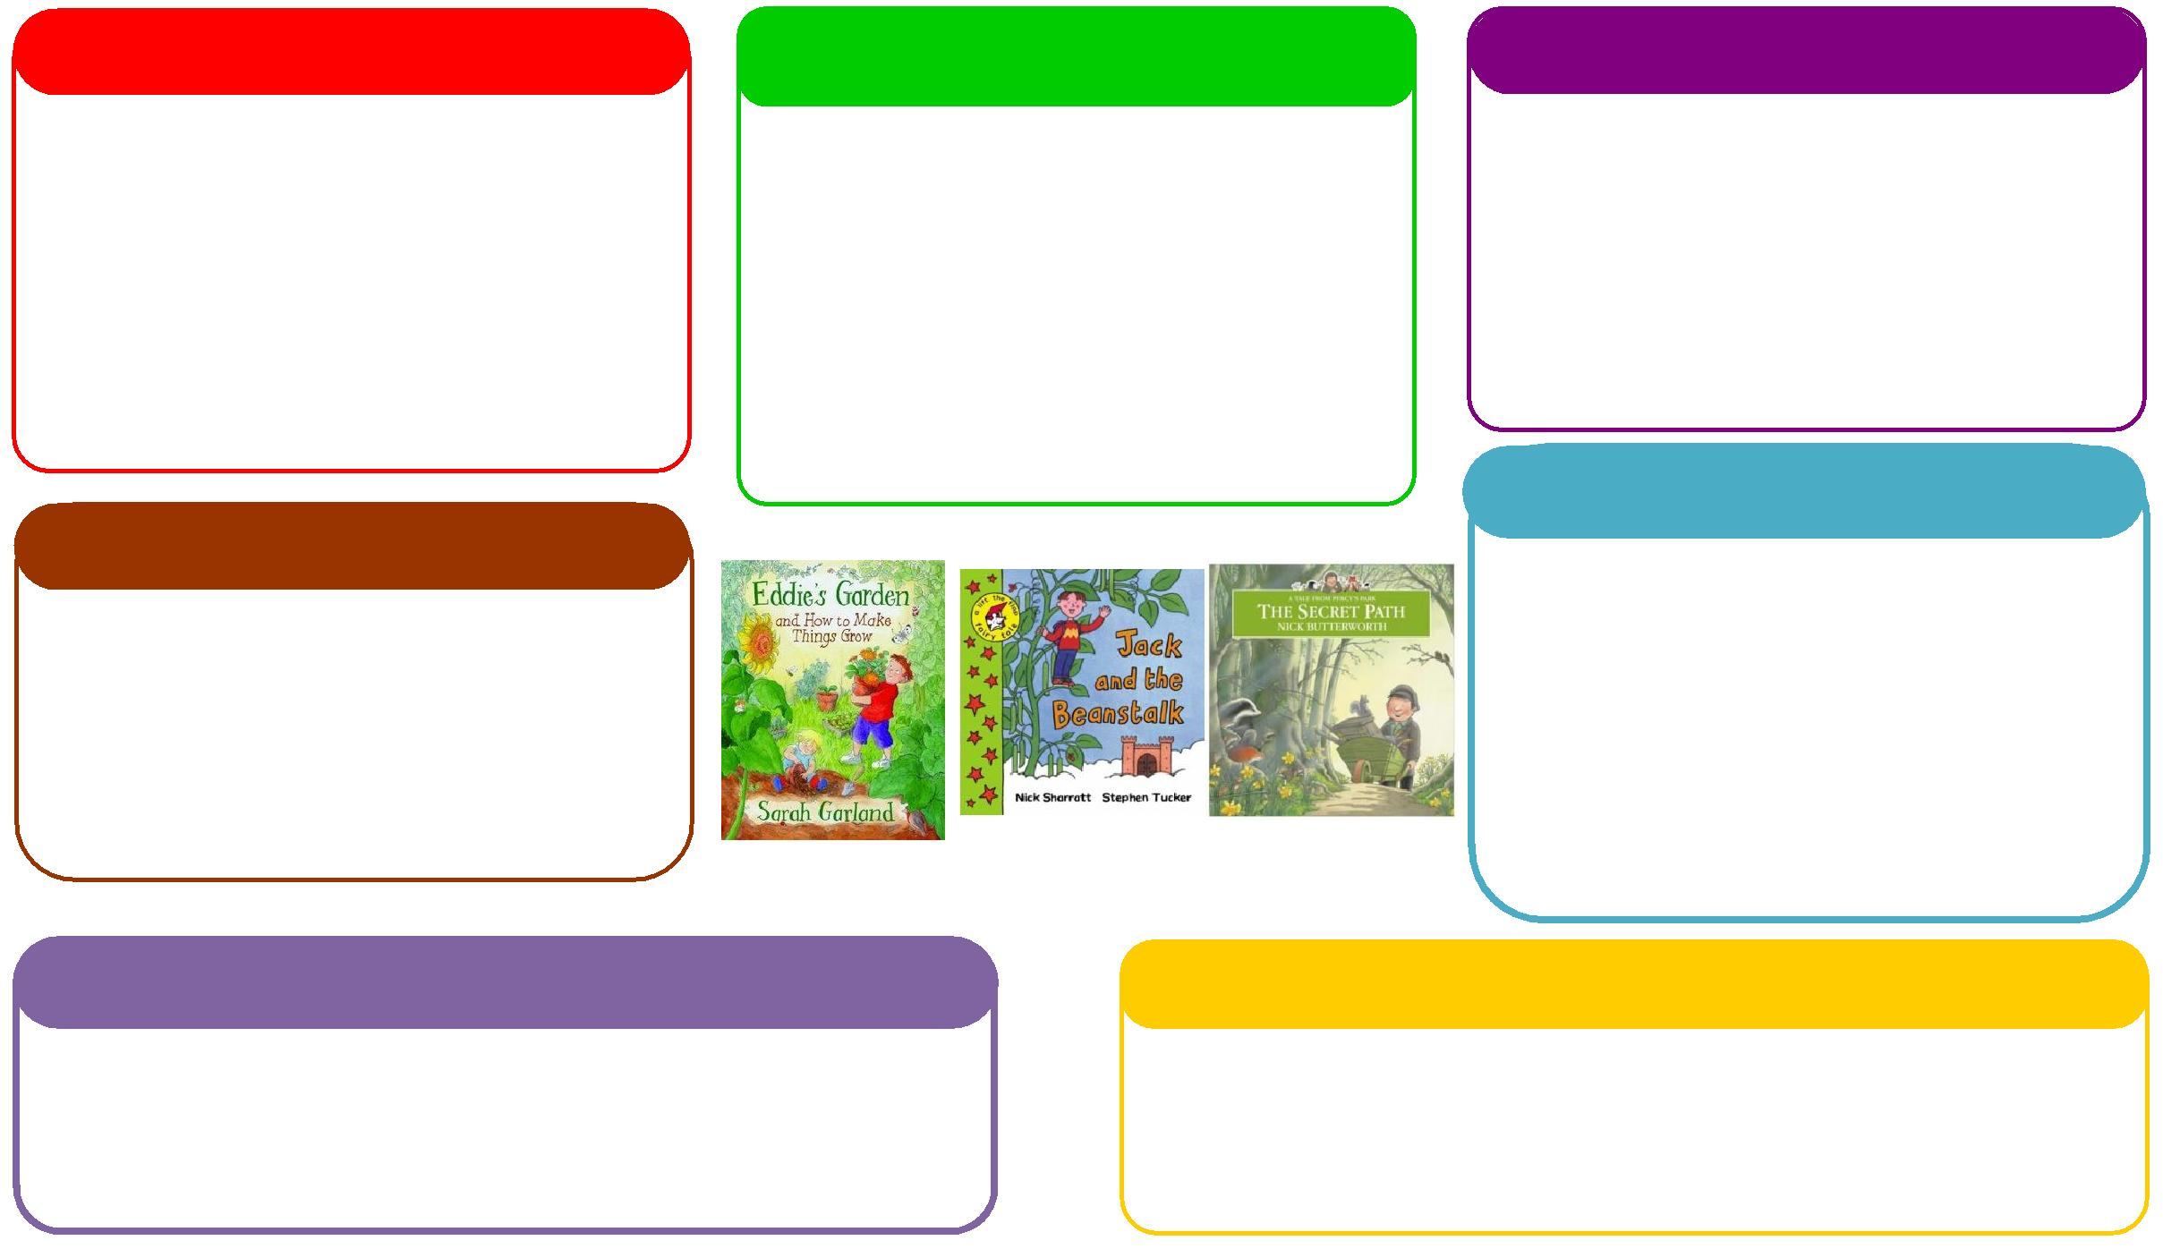
This half term we will be:

- Using our phonics knowledge to write words and simple sentences,
- Making marks with vehicles,
- Large scale mark making on big paper, creating roads, maps and journeys,
- Looking at travel brochures and nonfiction books about the wider world.
This half term we will be:
- Looking at globes, maps and nonfiction books/guides on places around the world,
- Exploring our outdoor area to look for signs of Spring,
- Learning about Easter and why it is special.

Expressive Arts and Design
Personal, Social and Emotional Development
Understanding the World
Physical
Mathematics
Communication and Language
English
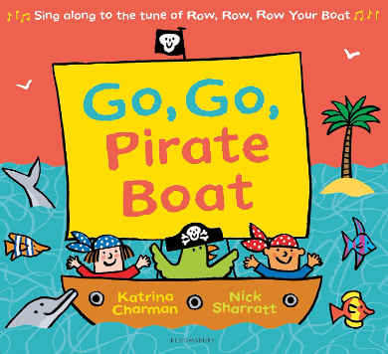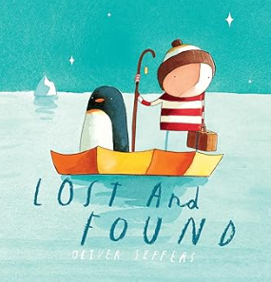
This half term we will be:

- Nursery:
- Repeating patterns, positional language, 2D shapes.
- Reception:
- Practical subtraction, missing number calculations, spatial reasoning
This half term we will be:

- Discussing with our friends what we got up to in the holidays,
- Talking about different types of transport,
- Talking about the wider world and our own experiences of going on a journey,
- Talking about signs of Spring.
Learning Letter Spring 2 EYFS
Journeys and Transport
This half term we will be:
- Role play going on a train ride,
- Creating roadways for cars and trucks to travel along,
- Creating junk modelling vehicles,
- Making Easter crafts.

This half term we will be:
- Discussing our half term holidays and what we got up to,
- Looking at the different characters in the story and how they are feeling,
- Thinking about how to live a healthy lifestyle.
This half term we will be:
- Weaving ribbon through old bike wheels,
- Taking part in PE lessons,
- Creating a dance linked to transport,
- Focusing on scissor skills,
- Focusing on using a tripod grasp.

EYFS Half Term Learning Project

How many types of Transport can you name? Choose one of these types of transport to creating out of junk modelling.

