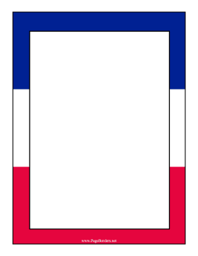
Our Spring 1 project about ...
France

Our topic this term is about France. We will be looking the physical and human geographical features of France.

Your challenge this half term is to create a model of a famous landmark in France.
Your model must also come with an information leaflet about the landmark you have made.
Below are some examples of what you could create.
The deadline for your models and information leaflet is Friday 6th February.
Have fun!
Miss Begum

