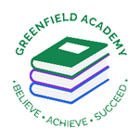
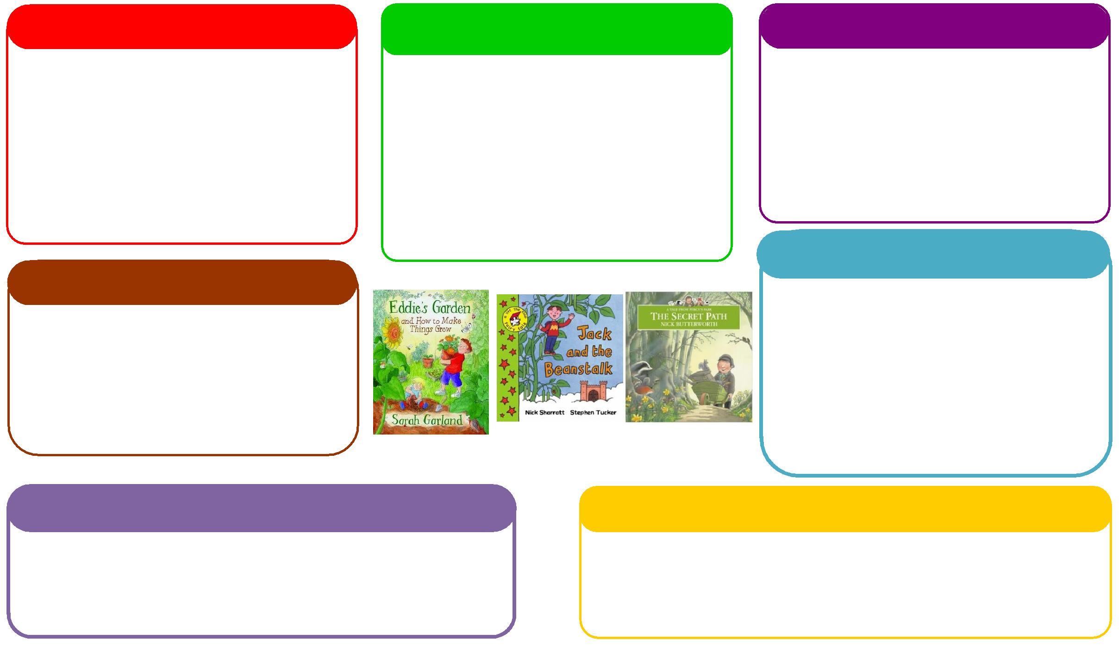
This half term we will be:

- Using our phonics knowledge to write words and simple sentences,
- Retelling stories,
- Typing on the keyboard in response to our Three Bear pictures on Purple Mash,
- Visiting our local library.
This half term we will be:
- Making porridge, gingerbread men and cakes linked to our chosen texts,
- Exploring our outdoor area to look for seasonal changes,
- Planting blubs in our outdoor area,
- Learning about Easter and why it is special.

Expressive Arts and Design
Personal, Social and Emotional Development
Understanding the World
Physical
Mathematics
Communication and Language
English
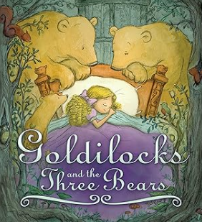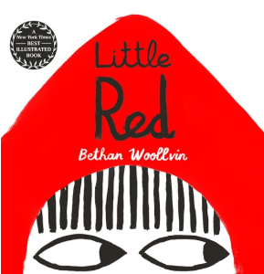
This half term we will be:

- Composition of numbers to 10,
- Number bonds to 5,
- Number bonds to 10,
- Practical addition,
- Starting to chant in tens and twos.

This half term we will be:

- Discussing with our friends what we got up to in the holidays,
- Acting out different stories together,
- Using traditional tales to inspire our own helicopter stories,
- Talking about seasonal changes
Learning Letter Spring 1 EYFS
Traditional Tales
This half term we will be:
- Sculpting characters from traditional tales,
- Having dance lessons in the hall,
- Making Easter crafts,
- Learning new songs and rhymes,

This half term we will be:
- Discussing our half term holidays and what we got up to,
- Looking at the different characters in the story and how they are feeling,
- Thinking about how to live a healthy lifestyle.
This half term we will be:
- Making magic wands with sticks outside for large arm moment,
- Taking part in PE lessons,
- Experimenting with different types of body movement: big and small; high and low, both inside and outside,
- Focusing on using a tripod grasp.

EYFS Half Term Learning Project

How many Traditional Tales can you read at home? Which is your favourite Traditional Tale? Why is this your favourite? Can you create some art work in response to this story?

