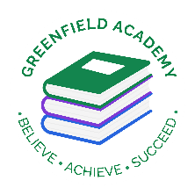
Greenfield Primary Academy
Year 4
Spring Term 1 Learning Letter 2026
In Maths we are learning to …

Recognise place value of larger numbers
Addition and subtraction using formal methods of column addition and subtraction
Recognise and use equivalent fractions
Measure and calculate the perimeter of a rectilinear figure (inc. squares) in centimetres and metres and calculate area of shapes
Describe positions on a 2D grid as coordinates in the first quadrant. And describe movement
Convert between different units of measure e.g. km to m, hour to minute
Memorise times tables. The children will be having a formal assessment of their times tables and will need to know both the multiplication and division facts for all tables up to 12. . Children need to use TTRockstars daily at home, and we will have an assessment in school each week.

In English we are learning to …
Write in different ways: We will be looking at stories with a theme, recounts and explanation texts. We will use the stories and our own research to gather vocabulary, ideas and inspiration. We will be writing letters and explanations as well as creating an e-book.

Read more fluently: We will continue with our comprehension lessons three days a week, building on the skills we have been learning. We will continue to read in class with your child and they will also use MyOn – our online reading program.

Understand Grammar: We will continue to gather new vocabulary and will be using nouns, verbs, adjectives and prepositions. We will be using conjunctions for time and cause (for example when, before, after, while, so, because) We will be using commas for fronted adverbials, prefixes, im, il, in, ir and writing sentences with more than one clause.

In RE we are learning…
What does it mean to be a Christian in Britain today?
We will:
Describe some examples of what Christians do to show their faith, and make connections with some Christian beliefs and teachings
Describe some ways in which Christian express their faith through hymns and modern worship songs
Suggest at least two reasons why being a
Christian is a good thing in Britain today, and give reasons why it might be difficult.
two reasons why it might be hard sometimes
(B2).
• Discuss links between the actions of Christians
in helping others and ways in which people of
other faiths and beliefs, including pupils

In Art we are learning how to:
- use different grades of pencil to shade
- show different tones and textures. ​
- Create repeating patterns in print
- Use different printing techniques
We will use ideas and sketches collected during our research of famous artists work to create a rainforest print.
Each child will need a large shirt as an overall
Our Learning Theme is …

Rainforests

In Science we are learning that …
- Evaporation and condensation are important aspects of the water cycle

- To know that some materials change state when they are heated and cooled and know that this is linked to temperature changes

- Know some common conductors and insulators of heat
In Geography we are learning to …
- describe and understand key aspects of:
  - physical geography, including: climate zones, biomes and vegetation belts, rivers, mountains, volcanoes and earthquakes
  - human geography, including: types of settlement and land use, economic activity including trade links, and the distribution of natural resources including energy, food, minerals and water

This will all be taught by studying the rainforest, and its importance for the health of the planet.

In RHE/ PSHE we are learning about …
- the different ways to pay for things and the choices people have about this
- to recognise that people have different attitudes towards saving and spending money; what influences people’s decisions; what makes something ‘good value for money’
- that people’s spending decisions can affect others and the environment (e.g. Fair trade, buying single-use plastics, or giving to charity)
- to recognise that people make spending decisions based on priorities, needs and wants
- different ways to keep track of money

- (L22) about risks associated with money (e.g. money can be won, lost or stolen) and ways of keeping money safe

- (L23) about the risks involved in gambling; different ways money can be won or lost through gambling-related activities and their impact on health, well-being and future aspirations

- (L24) to identify the ways that money can impact on people’s feelings and emotions

Any questions? Please ask us at the door when you collect your child.
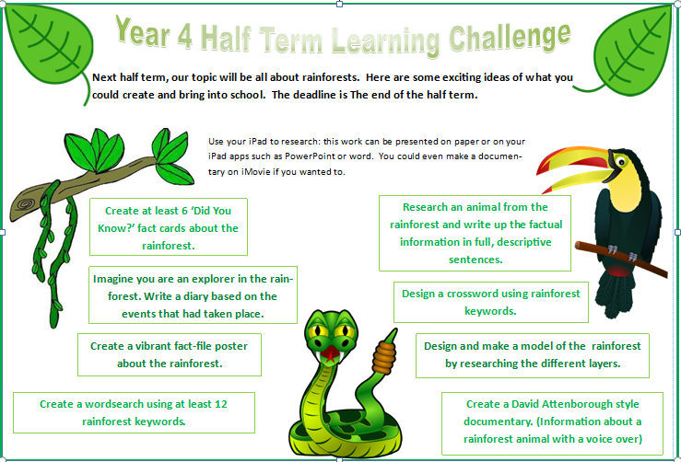
Rainforests
At the beginning of the topic we will be going to Chester Zoo and looking at their rainforest animals and the environments they live in.
Your child’s half-term project is to create a piece of work about the rainforest. They should research animals, plants, other organisms that live in the rainforest, and how it works as an eco-system.
Once they have done their research, they choose one of the options on the Half Term Learning Challenge – they have a copy on their iPad as well as a paper copy. There are written projects, as well as the opportunity to be creative and make a model of the rainforest.
Please bring projects into school by the 31st January 2025.

Year 4 Half Term Learning Project
Year 4 Weekly Home Learning Tasks
READING
Please share your child’s reading book with them, as 10-15 minutes of reading every day at home can make a lot of difference to your child's reading ability.
Your child MUST bring their book bag into school every day so an adult can read with them on their reading day, and any extra days if there is an opportunity.
Each child will have a reading book, and an extra book from the class library.
Every child will have an online MyOn account where they can read books and answer questions. This is in addition to their daily reading book task.
MATHS
Every child has a TTRockstars and Numbots account. They can use these to practise their number bonds and times tables facts online. 10 minutes every day will mean they will be ready for their times tables test in June, and will make them much quicker at working things out in class.
PURPLE MASH
Each week the children will be set several tasks on Purple Mash. They log on to their account and complete their tasks. When they log on, there is a bell at the top of the screen. When they click on this, it will show them all the tasks they need to complete for that week.
Tasks are allocated on a Friday and have to be completed by the following Tuesday. There is usually a grammar, writing, spelling, maths and either a science or geography task.

