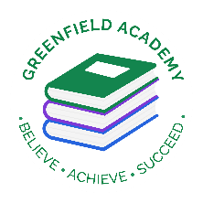
Greenfield Primary Academy
Year 4
Autumn Term 1 Learning Letter 2025
In Maths we are learning to …
In Maths, we will be exploring numbers up to 4 digits and addition and subtraction, and we will be:
Recognise the place value of each digit in a four-digit number
Order and compare numbers beyond 1000
Add and subtract numbers with up to 4 digits using the formal method of columnar addition
Compare and classify geometric shapes, including quadrilaterals and triangles, based on their properties and sizes.
Identify acute and obtuse angles and compare and order angles up to 2 right angles by size.
Read, write and convert time between analogue and digital 12 and 24 hour clocks

In English we are learning to …
Write in different ways: we will be looking at the features of adventure stories, traditional tales/fables, instructions and reports, and writing our own too.
Read more fluently: this term we will continue with whole class comprehension lessons in the same way as Year 3. Your child will have a reading book and will also have access to MyOn – our online reading program.
Understand Grammar: we will learn about:
Noun, verbs, adjectives, Apostrophes (contraction), Prepositions,
Alphabetical order, write different types of sentences (statements, questions, commands) and Find and use synonyms
Our Learning Theme is …
Europe
Rivers, Mountains and Coasts
States of Matter

In Art we are learning to …
- Use different grades of pencil to shade
- To understand different techniques used by artists
- To understand tone and texture
- To make tertiary colours
- To use watercolours in the style of Monet
- Create different effects by using a variety of tools and techniques such as bleeds, washes, scratches and splashes

In RE we are learning to …
What does it mean to be a Hindu in Britain today?
Describe some examples of what Hindus do to show their faith, and make connections with some Hindu beliefs and teachings about aims and duties in life. Describe some ways in which Hindus express their faith through puja, aarti and bhajans. Suggest at least two reasons why being a Hindu is a good thing in Britain today, and two reasons why it might be hard sometimes.

In Geography we are learning to …
Identify the continent of Europe on a world map: name and identify some countries within Europe:
Know some physical and human features of key European capital cities
Be able to identify some similarities and differences between the capital cities they have studied, including why some people might want to live in these cities.
Use geographical words such as valley, erosion, transportation, headland.
Understand how hills, rivers etc. affect where people live.
Develop our orienteering skills
In Science we are learning that …
Materials exist in three ‘States of matter’

In our Autumn 1 topic, we explore states of matter. This starting point allows the children to develop a great foundational understanding of solids, liquids and gases, and how the particles behaved within them. Children obtain the knowledge by carrying out a range of investigations. This is the first-time children will encounter States of Matter, but it builds the foundations for the next unit within Y5. The children also learn about the water cycle, evaporation and condensation.

In RHE/ PSHE we are learning to …
- Understand what rules and responsibilities are and explain the school rules.
- Understand what manners are and courtesy is.
- Talk about democracy and why it is important.
- Understand what respect is and how to treat others with respect.
- Understand what an opinion is and give their opinions on different subjects.

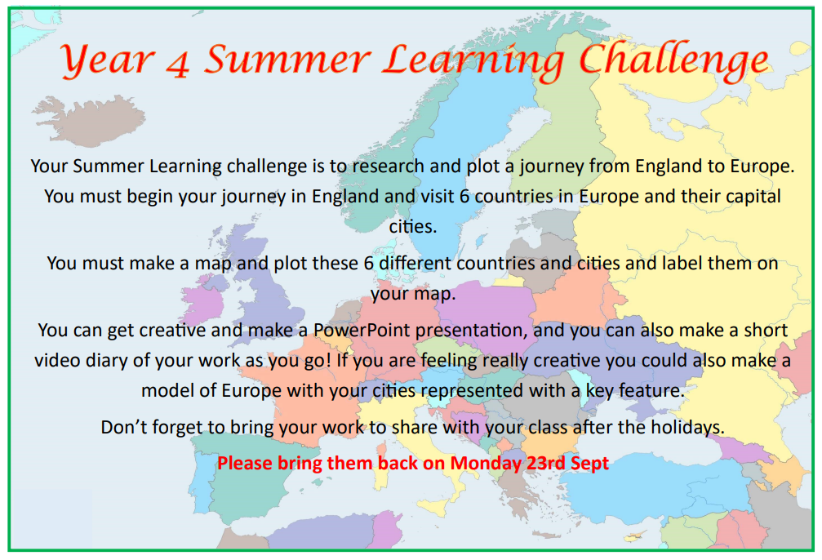
Geography: Europe
Your Summer Learning challenge is to research and plot a journey from England to Europe. You must begin your journey in England and visit 6 countries in Europe and their capital cities. You must make a map and plot these 6 different countries and cities and label them on your map.
You can get creative and make a PowerPoint presentation, and you can also make a short video diary of your work as you go! If you are feeling really creative you could also make a model of Europe with your cities represented with a key feature.
Don’t forget to bring your work to share with your class after the holidays.
Please bring them back on Monday 23rd Sept

Year 4 Summer Learning Project
Year 4 Weekly Home Learning Tasks
READING
Please share your child’s reading book with them, as 10-15 minutes of reading every day at home can make a lot of difference to your child's reading ability.
Your child MUST bring their book bag into school every day so an adult can read with them on their reading day, and any extra days if there is an opportunity.
Each child will have a reading book, and an extra book from the class library.
Every child will have an online MyOn account where they can read books and answer questions. This is in addition to their daily reading book task.
MATHS
Every child has a TTRockstars, they can use these to practise their times tables facts online as it is important times tables are learnt for this year. 10 minutes every day will mean that they are ready for their times tables test in Summer, and will make them much quicker at working things out in class.

