Year 3
Half term project
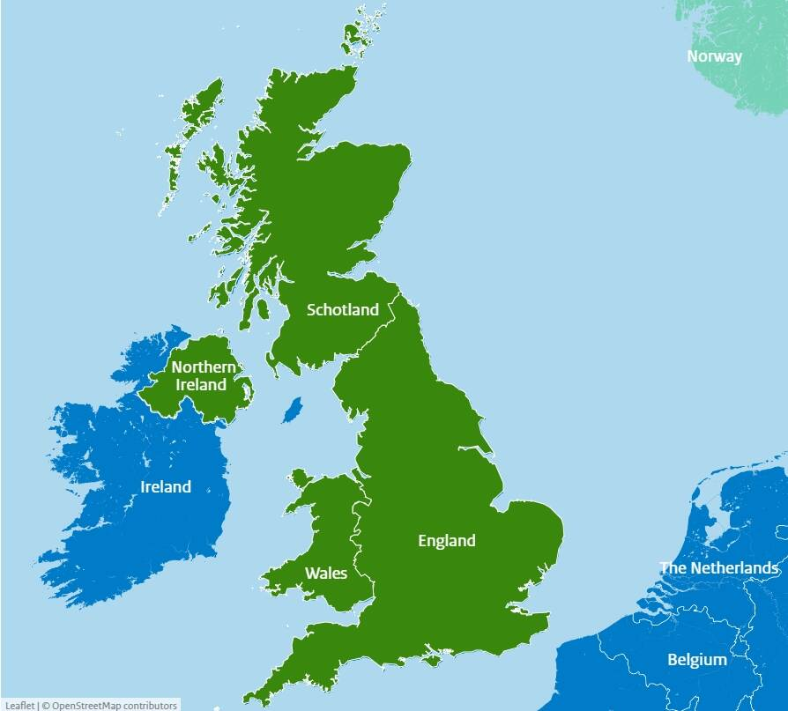
Your Half Term Learning project is to research and plot a journey from one end of the UK to the other. You must begin your Journey at John o'Groats in Scotland and finish at Lands End in Cornwall.
You must make a map and plot at least 6 different cities and label them on your map.
You can get creative and make a PowerPoint presentation, and you can also make a short video diary of your work as you go! If you are feeling really creative you could also make a model of the UK with your cities represented with a key feature.
Don’t forget to bring your work in to share with your class.
Please bring them back on Wednesday 1st October

