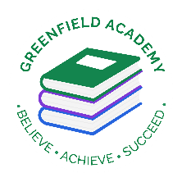
Greenfield Primary Academy
Year 3
Summer Term 1 Learning Letter 2025
In Maths we are learning to …
In Maths, we will be exploring numbers up to 4 digits
- Finding missing numbers on a number line with marked intervals
- Placing numbers on a number line
- Estimating the value of intervals on a number line
- Problem solving with number lines
- Column addition and subtraction
- Giving change practically (shopkeeper method)
- Giving change on a number line
- Name and describe the properties of 3d shapes
- Sort 3D shapes
- Measure mass
- Compare mass
- Add and subtract mass

In English we are learning to …
Write in different ways: Myths and Legends, Instructions and poetry appreciation.

Read more fluently: this term we will continue with whole class comprehension lessons. Your child will have a reading book and will also have access to MyOn – our online reading program.

In RE, we will explore the questions … What do different people believe about God?
- Describe some of the ways in which Christians, Hindus and Muslims describe God.
- Ask questions and suggest some of their own responses to ideas about God.
- Suggest why having a faith or belief in something can be hard.
- Identify how and say why it makes a difference in people’s lives to believe in God.

In Art and Design, we are learning…Egyptian Printing
- To print using different techniques e.g. block, relief and impressed.
- To record different textures and patterns.
- To colour mix through overlapping colour prints.

Our Learning Theme is …
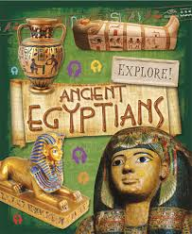

In History, we are learning…Ancient Egypt

- To know when the Ancient Egyptian civilization began in 3100 B.C. and ended in 332 B.C.
- Know about, and name, some of the advanced societies that were in the world around 3000 years ago
- Understand what life was like in Ancient Egypt.

-

​

In Science we are learning… Nutrition and Diet
- To know there are 6 main food groups animals need to stay healthy.
- To know which foods are rich in which nutrients.
- To understand the importance of each nutrient.

In RHE/ PSHE we are learning… Similarities and Differences
The children will:
- respect similarities and differences between people
- know what a healthy family life looks like
- know that other families look different to mine, but they are still based on love and care
- know that marriage is a recognised commitment and is meant to be lifelong
- know stereotypes including gender stereotypes can be destructive and unfair

Year 3 Weekly Home Learning Tasks

READING
Please share your child’s reading book with them, as 10-15 minutes of reading every day at home can make a lot of difference to your child's reading ability.
Your child MUST bring their book bag into school every day so an adult can read with them on their reading day, and any extra days if there is an opportunity.
Each child will have a reading book, and an extra book from the class library.
They all now have access to MyON – the schools online reading app so as to help develop and improve their reading.
MATHS
Each child has received a copy of multiplications to 12. Please use this to work with your child so they become more confident with their times table knowledge.
Swimming/P.E
The children will continue to go swimming weekly on Tuesday and P.E will be on Fridays.

Year 3 Half Term Learning Project

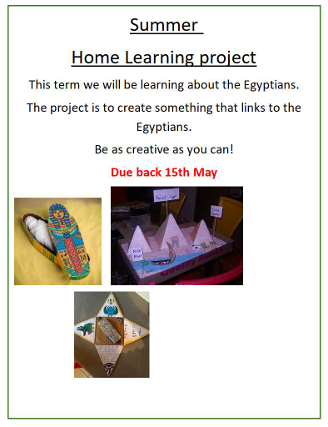
Due back 15th May

