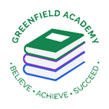
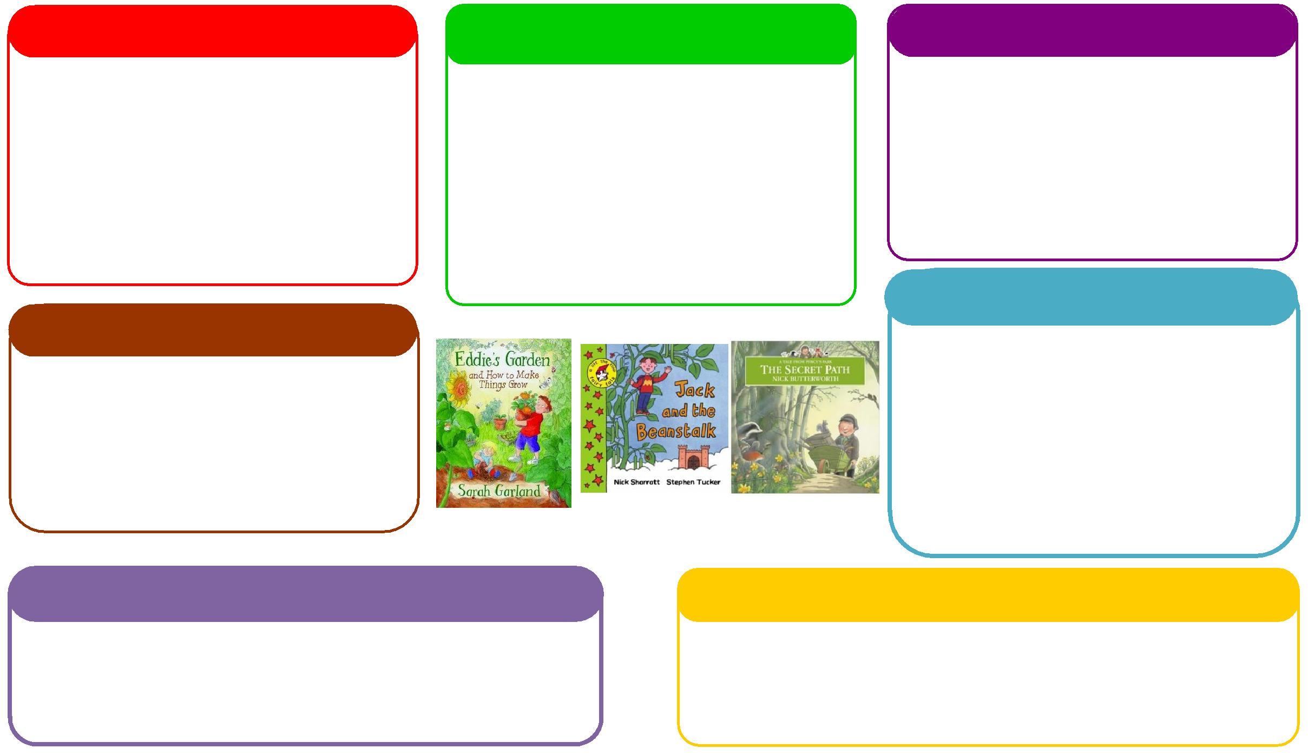
This half term we will be:
- Spatial reasoning - Reception
- Building numbers beyond 10 - Reception
- Doubling and halving – Reception
- Counting to 10 – Nursery,
- Repeating patterns – Nursery
- Learning about more and Less - Nursery

Learning Letter Summer 1 EYFS
Growth and Change
This half term we will be:
- Looking at the key features of the life cycle of a plant.
- Growing our own plants and herbs,
- Planting beans and discussing how they change,
- Comparing different environments.

Expressive Arts and Design
Personal, Social and Emotional Development
Understanding the World
Physical
Mathematics
Communication and Language
English
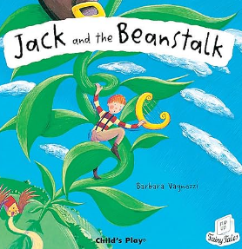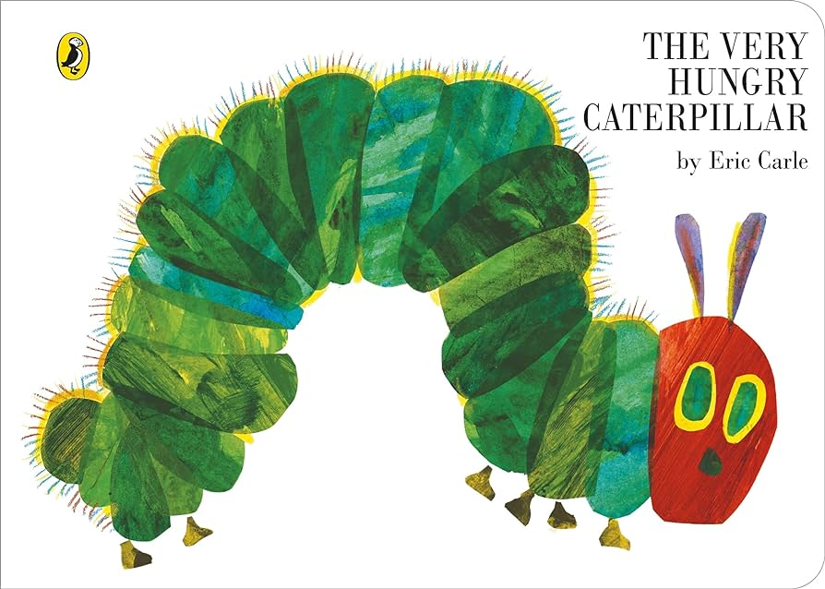
This half term we will be:

- Discussing with our friends what we got up to in the holidays,
- Acting out different stories together,
- Using the language of explanation to explain different animal life cycles,
- Talking about seasonal changes.
This half term we will be:
- Introducing the artist, Andy Goldsworthy.
- Having dance lessons in the hall,
- Making pictures using natural resources. Focusing on cutting and layering techniques.

This half term we will be:
- Discussing what did children did during the holidays,
- Looking at the different characters in the story and how they are feeling,
- Using our Think Equal books during circle time.

This half term we will be:
- Retelling stories,
- Writing instructions on how to plant a bean,
- Writing about the life cycle of a caterpillar and acting out the story,
- Creating Jack and the Beanstalk books.
This half term we will be:
- Exploring healthy and unhealthy foods linked to the text Oliver’s Vegetables,
- Making vegetable soup using simple utensils and equipment to mix, grate and squeeze safely,
- Using our skills from Little Bikers to practice riding our new balance bikes.

EYFS Half Term Learning Project

Can you plant a seed at home? What does the seed need to grow? What have you grown? Can you measure how tall it has grown?

