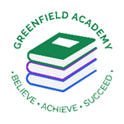
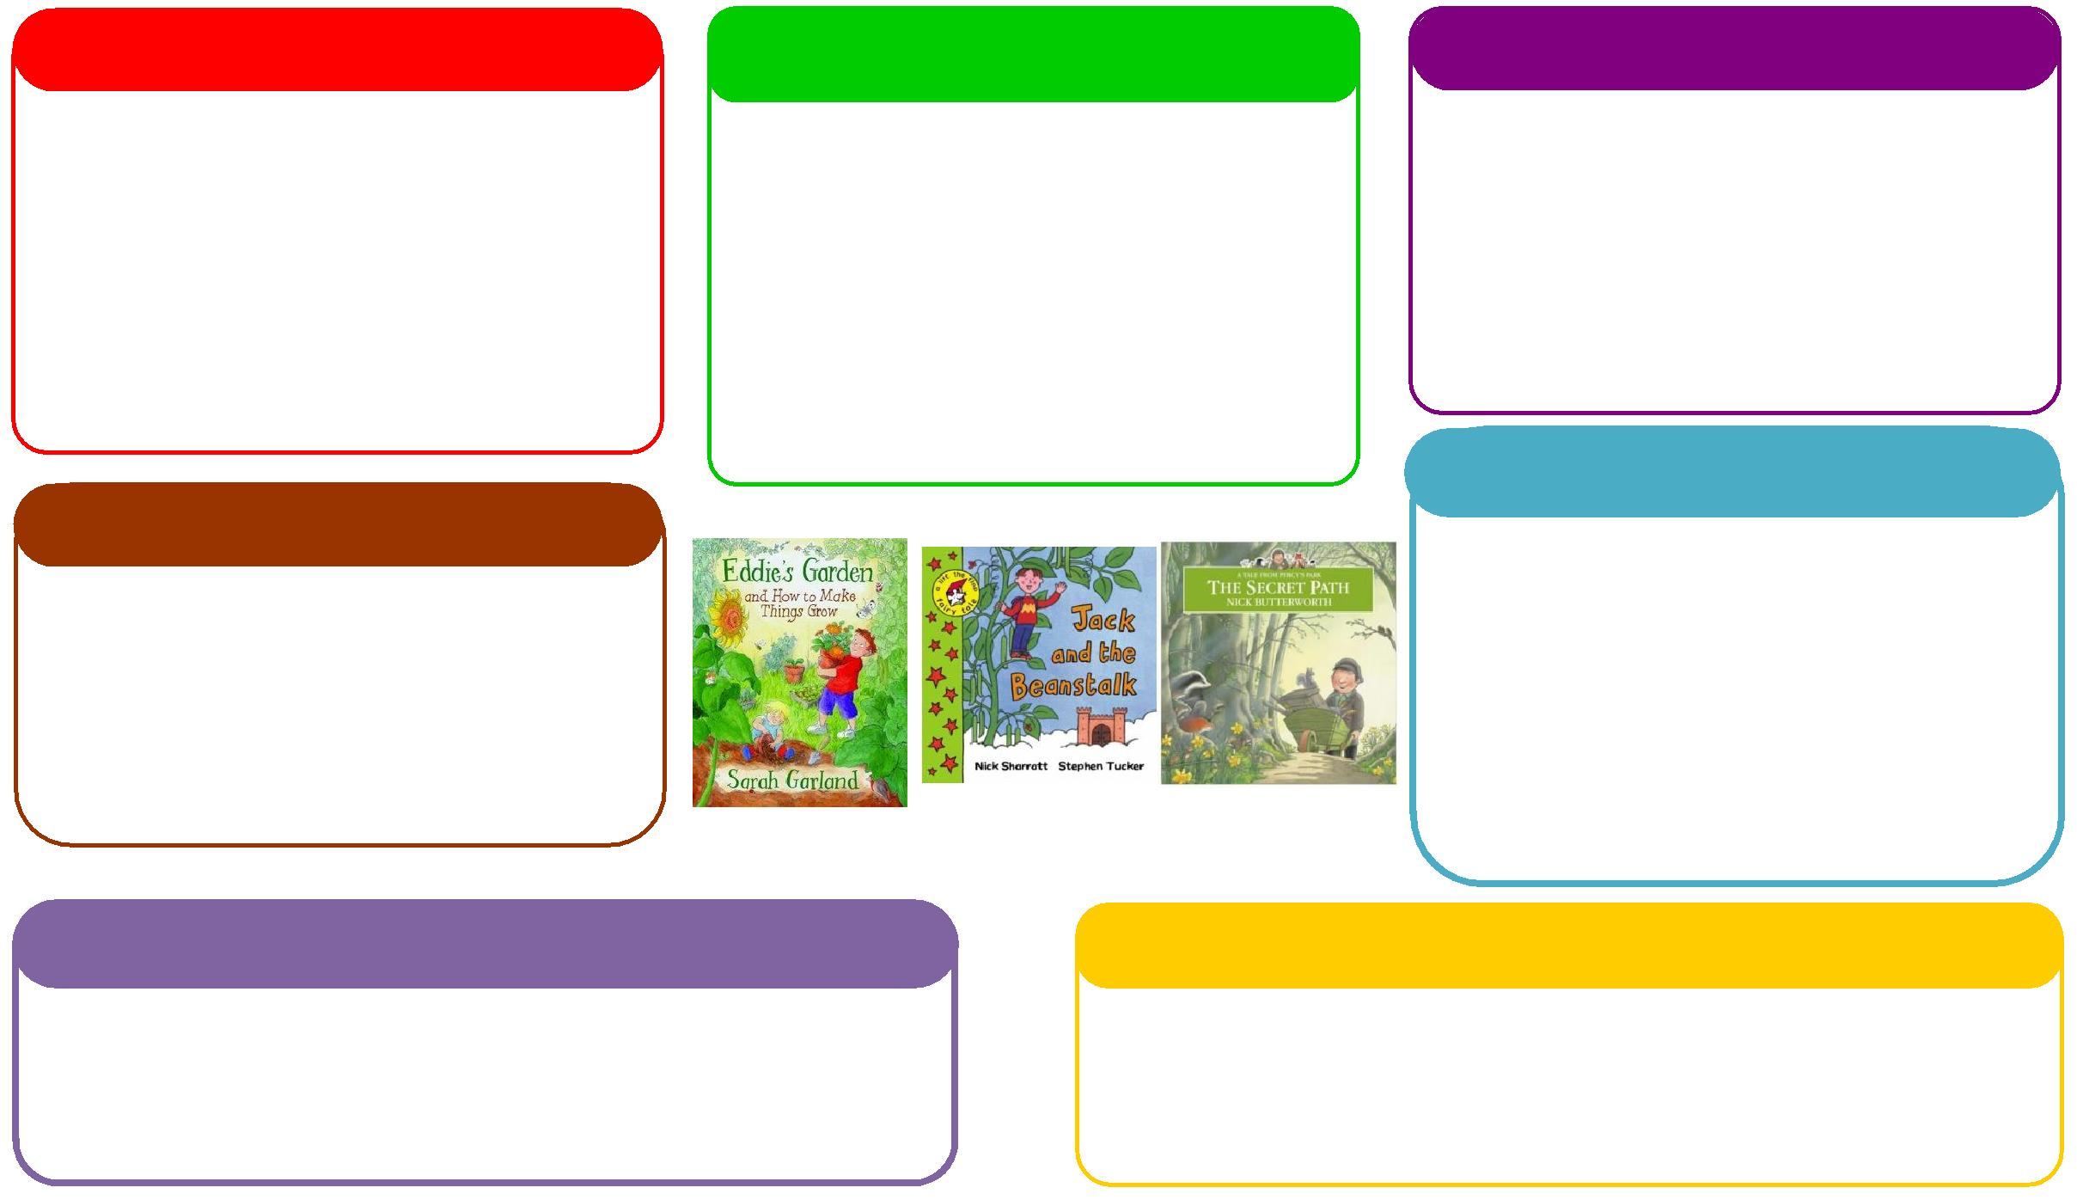
This half term we will be:
- Walking to the woods to explore the changes of the season,
- Discussing and learning all about similarities and differences through festivals and celebrations,
- Exploring different foods linked to Christmas and discussing likes/dislikes.

Expressive Arts and Design
Personal, Social and Emotional Development
Understanding the World
Physical
Mathematics
Communication and Language
English
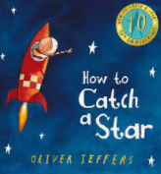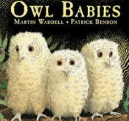
This half term we will be:
- Matching number of feathers to numbered owls,
- Creating shape owls,
- Using the counting bears to find out 1 more,
- Shape composition using the light box,
- Paper chain colour patterns.

This half term we will be:

- Discussing with our friends what we got up to in the holidays,
- Acting out different stories together,
- Discussing different festivals celebrated during this time of year,
- Singing and acting out our school Nativity Performance.
Learning Letter Autumn 2 EYFS
Night and Day
This half term we will be:
- Making water colour star pictures
- Expanding our acting skills through performing the School Nativity,
- Creating Christmas cards using a variety of resources,
- Learning new Christmas songs and rhymes,

This half term we will be:
- Discussing our half term holidays and what we got up to,
- Looking at the different characters in the story and how they are feeling,
- Thinking about how to live a healthy lifestyle.
This half term we will be:

- Using our phonics knowledge to write words and simple sentences,
- Retelling stories,
- Writing a response to our owl visit,
- Creating zigzag Owl Babies books.
This half term we will be:
- Manipulating salt dough to create diva lamps for Diwali,
- Using our scissor skills to create lanterns,
- Going on a local walk to the woods to explore the changes,
- Expanding our fine motor skills by making paperchain decorations for the classroom.

EYFS Weekly Home Learning Tasks

READING
Please share your child’s reading book with them, as 10-15 minutes of reading every day at home can make a lot of difference to your child's reading ability.
Your child MUST bring their book bag into school every day so an adult can read with them on their reading day, and any extra days if there is an opportunity.
MATHS
While at home see how many different objects you can count. How many stairs are in your house? Can you count them as you walk up to brush your teeth? How many toothbrushes can you see? Count everything you can! See if you can find the numeral to match the amount. Where might you find a numeral in your house? The remote control, a clock etc.

EYFS Half Term Learning Project

Create a habitat for a nocturnal animal. What materials might you use? How would the animal keep warm? Bring it in to show the class!

