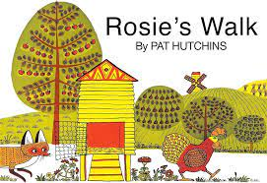
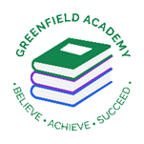
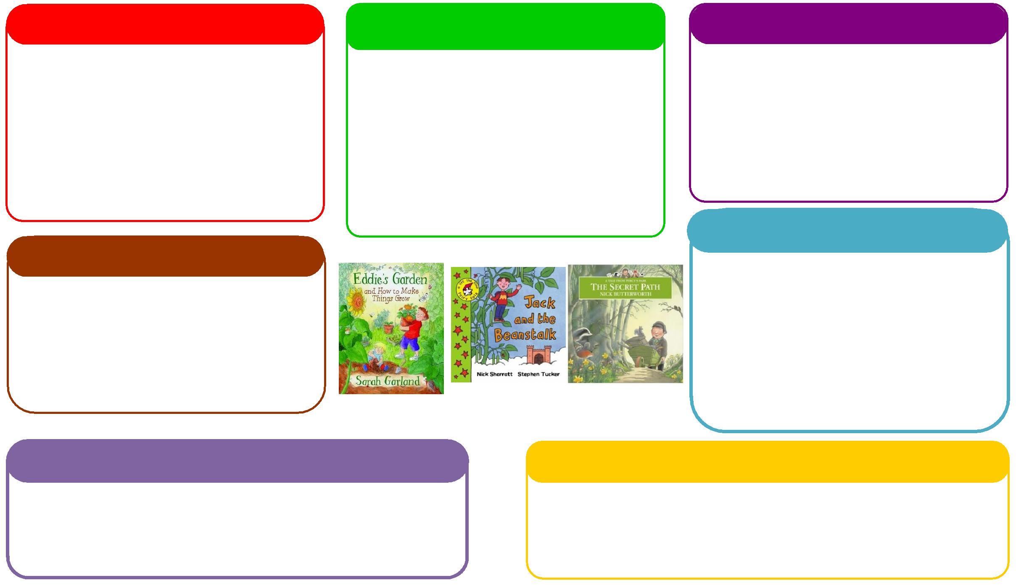
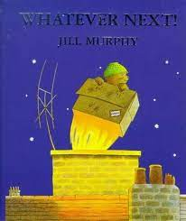vvv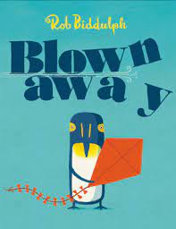
This half term we will be:
- Learning about the difference between farms and cities
- Learning about Space and going on a Space Picnic (All parents are invited to this event).
- Learning about different countries.

Expressive Arts and Design
Personal, Social and Emotional Development
Understanding the World
Physical
Mathematics
Communication and Language
English
This half term we will be:

- Counting out objects from a larger set
- Ordering and writing numbers,
- Learning about positional language,
- Learning how to sequence things.

This half term we will be:

- Acting out different stories together,
- Learning new words about farms, space and hot and cold places,
- Talking about seasonal changes
- Learning to use words to communicate with each other
Learning Letter Spring 2 Nursery
Journeys and Transport
This half term we will be:
- Making farm animals in different ways,
- Making Space Rockets,
- Exploring colour mixing to represent hot and cold.

This half term we will be:
- Discussing how to keep safe when going on a journey,
- Looking at healthy foods
- Talking about respecting other cultures.
This half term we will be:

- Using our phonics knowledge to begin to hear letters at the beginning of words.
- Retelling stories – Rosie’s Walk, Whatever Next, Blown Away
- Writing invitations for our Space Picnic
- Beginning to write our names and some letters.
This half term we will be:
- Learning how to wash & dry our hands, going to the toilet and putting our coats on independently,
- PE sessions in the hall.
- Learn how to take part in team activities.

EYFS Half Term Learning Project

We are learning about Journeys and Transport this half term.
Please can you bring in something that your child can show about a journey they have been on.
You could even do some art and craft about their journey.
We will display their work in school so everyone can admire it.

