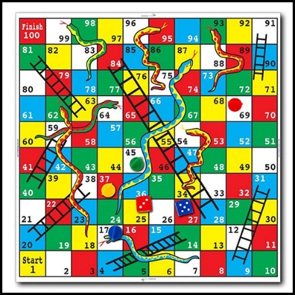
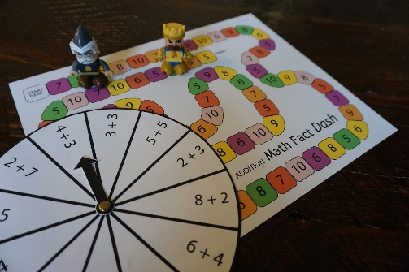
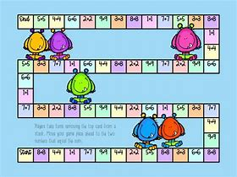
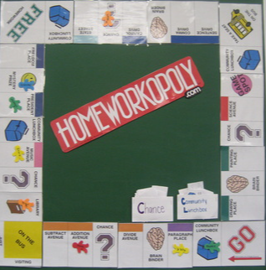
Home Learning Project Autumn 2

Design a Maths board game

Must include:
* A board
* Counters
* Set of instructions
* Extra cards (if needed)

Be creative!

Due back on the Monday 22th November

