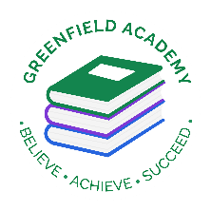
Greenfield Primary Academy
Year 3
Spring Term 1 Learning Letter 2024
In Maths we are learning to …
In Maths, we will be exploring numbers up to 4 digits and addition and subtraction, and we will be:
- Compare and order numbers up to 1000. Solve number problems and practical problems involving these ideas. Recognise the place value of each digit in a three-digit number (hundreds, tens, ones)
- Add and subtract numbers mentally, including a three-digit number and 1s, 10s and 100s. Add and subtract numbers with up to 3 digits, using formal written methods of columnar addition and subtraction
- Add and subtract amounts of money to give change, using both £ and p in practical contexts
- Draw 2-D shapes and make 3-D shapes using modelling materials; recognise 3-D shapes in different orientations and describe them
- measure, compare, add and subtract: lengths (m/cm/mm); mass (kg/g); volume/capacity (l/ml)

In English we are learning to …
Write in different ways: Suspense stories, Imagination stories, Instructions and calligrams.
They will be studying the following book:
Escape from Pompeii
and the film Lava
Read more fluently: this term we will continue with whole class comprehension lessons. Your child will have a reading book and will also have access to MyOn – our online reading program.

In Art we are learning…Collage and textiles (Mixed materials) Volcanoes
-Show an awareness and name a range of different fabrics/ materials
-Use a sketchbook to plan, collect and develop ideas ---Fabric)
Develop skills in cutting and joining
-Use collage as a means for collecting ideas

Our Learning Theme is …
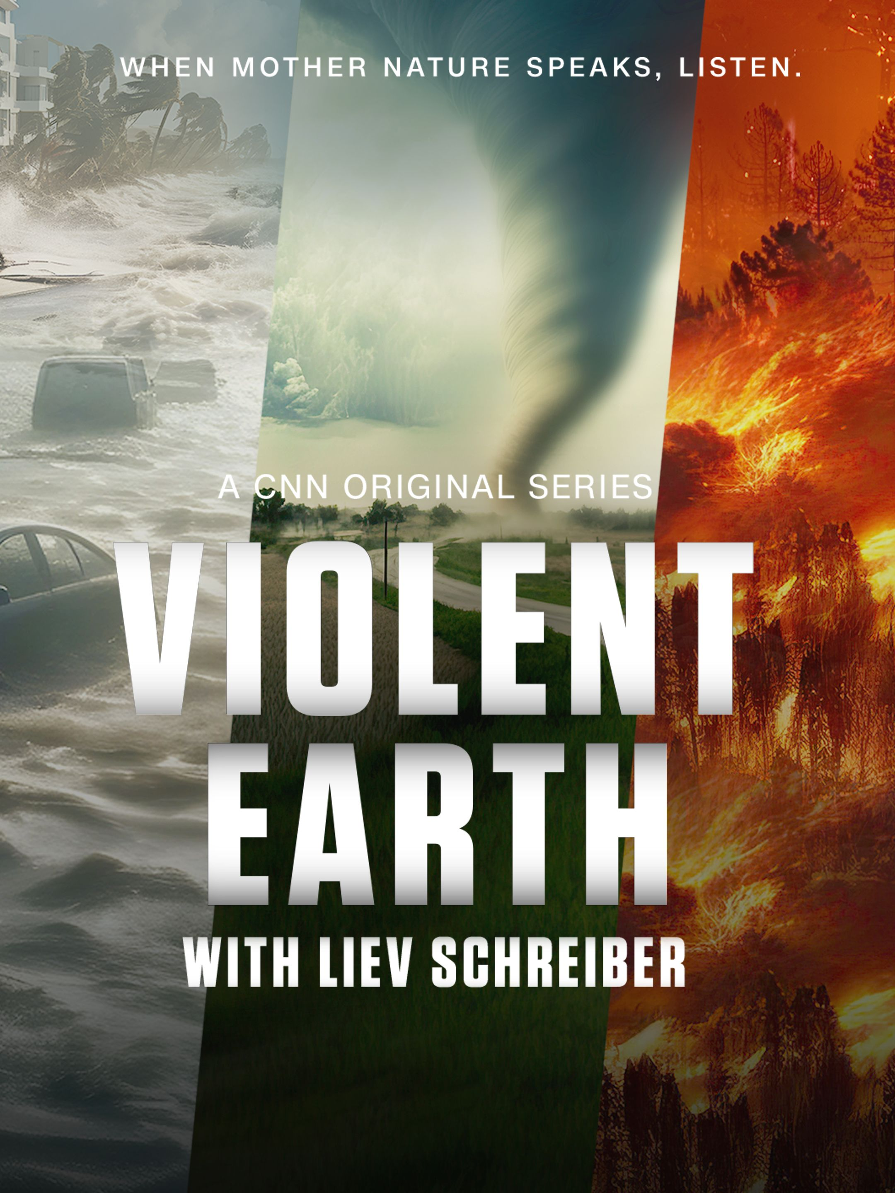
In RE we will explore the questions …
Why is the Bible important to Christians today?
- some Bible stories that inspire Christians.
- at least two ways Christians use the Bible in everyday life. ​
- some ways Christians say God is like, with examples from the Bible, using different forms of expression.

In Geography we are learning to … Earthquakes and
Volcanoes
- Name the features of a volcano ​
- Identify where volcanoes and earthquakes occur ​
- Explain why volcanoes and earthquakes occur​
​

In Science we are learning… Rocks and Soils
-compare and group together different kinds of rocks on the basis of their appearance and simple physical properties
- describe in simple terms how fossils are formed when things that have lived are trapped within rock
-recognise that soils are made from rocks and organic matter.

In RHE/ PSHE we are learning to … Resilience / Keeping safe
- I know that I can get help if I am being bullied
- I know that people can be bullied online, and this can affect my mental health (Cyber bullying)
- I know how to keep safe when using the tram, railway and roads

Year 3 Half Term Learning Project
Year 3 Weekly Home Learning Tasks

READING
Please share your child’s reading book with them, as 10-15 minutes of reading every day at home can make a lot of difference to your child's reading ability.
Your child MUST bring their book bag into school every day so an adult can read with them on their reading day, and any extra days if there is an opportunity.
Each child will have a reading book, and an extra book from the class library.
MATHS
Each child has received a copy of multiplications to 12. Please use this to work with your child so they become more confident with their times table knowledge.
PURPLE MASH
Each week the children will be set several tasks on Purple Mash. They log on to their account and complete their tasks. When they log on, there is a bell at the top of the screen. When they click on this, it will show them all the tasks they need to complete for that week.
Tasks are allocated on a Friday and have to be completed by the following Tuesday. There is usually a grammar, writing, spelling, maths and a Topic task.
Swimming
The children will continue to go swimming weekly.
P.E
P.E kits are needed every Friday.

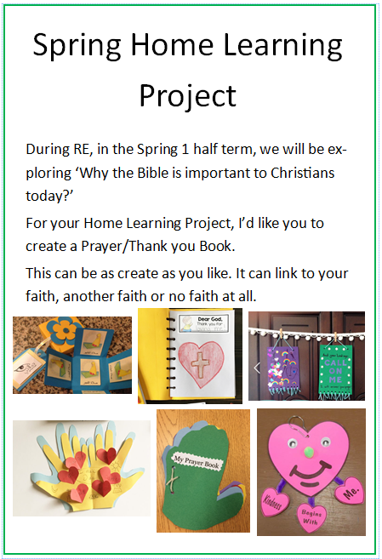
Due back on Monday 27th January

